(Mr. Tenkey #526)
March 26, 2021
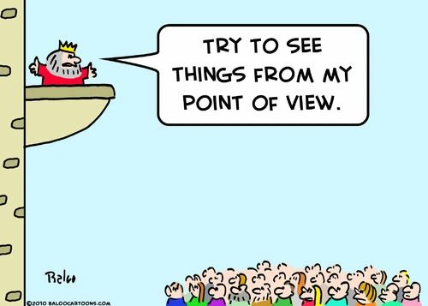
Dear Management: Do you truly value that employee? Or that group of employees, for that matter?
Well... SHOW them in some way? Make them FEEL their value.
Now, that "some way" can be verbal... but please be genuine or not at all. Because everyone sees through a forced verbal queuing to do so.
Other gestures as the environment, compensation, perks, etc... are also other avenues to show appreciation for their value.
But as you're showing them... please meet them on the ground upon which they stand, and not from some perch upon which they need to look up at you.
Because the best way to value an employee is to value them as an equal.
And of course, all your hard work of "showing"... should be done PRIOR to them "forcing" your hand, by announcing they are quitting.
Otherwise, your words/actions...
Will just be seen as synthesized empathy... with an alternative motive.
That whole "a little too late" kinda thing...
My couple pennies...
(More blog posts or find my book @ www.mrtenkey.com)

