(Mr. Tenkey #539)

April 14, 2021

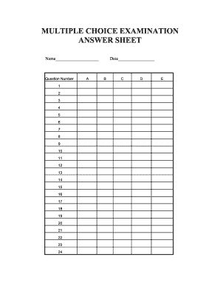

Dear Management: I had to answer this question yesterday... doing some continuing education for my CPA license.  
  
And I just laughed... out loud.  
  
Thinking... of some of my past bosses, who should have been asked this one as well.  
  
  
16. Which of the following is NOT harmful to employee morale?  
  
___ Senior leadership changes their mind throughout a project, rather than thinking things through at the beginning.  
___ Senior leadership hosts a barbeque on a Friday, during working hours.  
___ Senior leadership finds more fault in the person who breaks a procedure, rather than how the procedure was broken.  
___ Senior leadership creates an environment where a dissenting opinion, is made to feel unwanted.  
  
  
If you're senior leadership... I hope you got this one right.  
  
And I'll have a hot dog please!  
  
(More blogs/Find my book @ www.mrtenkey.com)