(Mr. Tenkey #540)

April 15, 2021

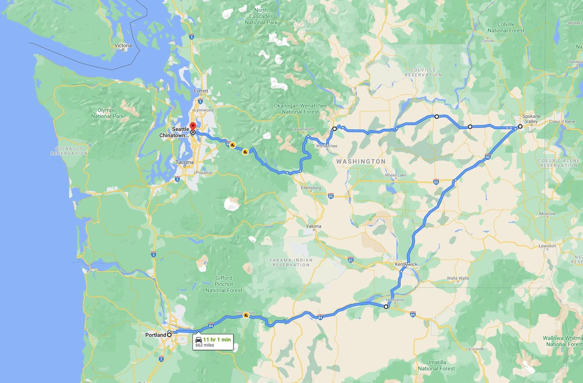

Dear Management: Many companies often find different ways to complete a similar task...  
  
And many... once they find a way that works... stick with it until DEATH DO THEM PART!!!  
  
Well, that's no good peeps.  
  
For example:  
  
A Portland based company found a way to get to Seattle... (through Spokane). A one-way trip of approximately 11 hrs.  
  
When asked, "Why do you go that way?"  
  
They responded, "It works... we've gone this way forever... it gets us there... why change something that works?"  
  
My counterpoint:  
  
BECAUSE!  
  
Because taking I-5 instead, would get you to Seattle in 3.5 hrs... or in other words... 7.5 hrs faster.  
  
Because even taking the 101, would be a beautiful drive along the coast and get you to Seattle in 5.5 hrs... or in other words... 5.5 hrs faster.  
  
Because efficiency DOES NOT come from complacency.  
  
My couple pennies.  
  
(More blogs/Find my book @ www.mrtenkey.com)