
VOLUME I, ISSUE II APRIL 2025

WELCOME TO THE EOHP
NEWSLETTER
The Elgin Oral History Project (EOHP) was created in 2021 as a non-profit organization with the mission of preserving Elgin’s history for the edification of future generations. EOHP’s bylaws state that oral history provides a fuller, more accurate picture of the past by augmenting information provided by public records and historical materials. EOHP aims to demonstrate how physical and social changes have made Elgin an outstanding example of a modern Texas small town through personal interviews with current and former residents, which are maintained electronically and on social media platforms.
The EOHP bylaws require the selection of a board of directors annually. The board is composed of between seven and fifteen directors who are nominated by other board members before the end of each year. Currently, there are nine directors. They are (in alphabetical order): Karen Bernstein, Sonia Browder, Debbie Cartwright, Bob Makela, Tracy Ortiz, Molly Owen, Ruby Simms, John C. Smith, and Andrea Chavarria Taylor.
This issue of the EOHP Newsletter features the three newest directors who were appointed last year to begin their service on January 1, 2025.
_____________________________________________________________________________________
UPCOMING EVENTS:
- PODCAST INTERVIEW OF BYRON MITCHELL BY BOB MAKELA
Watch for an announcement of the date and time of a special live interview that will be broadcast on YouTube soon.
- STORYTELLING EVENT DURING ARTS & CULTURE WEEKEND
Attend a free workshop and presentation about storytelling on Saturday, May 10, at 1:30 p.m. at the Clever Tiger
- SHORT-FORM INTERVIEWS DURING THE JUNETEENTH CELEBRATION
Participate in 5-minute interviews on Saturday, June 14, at Veterans Park with EOHP directors and volunteers

Newly Appointed Directors of the Elgin Oral History Project for 2025
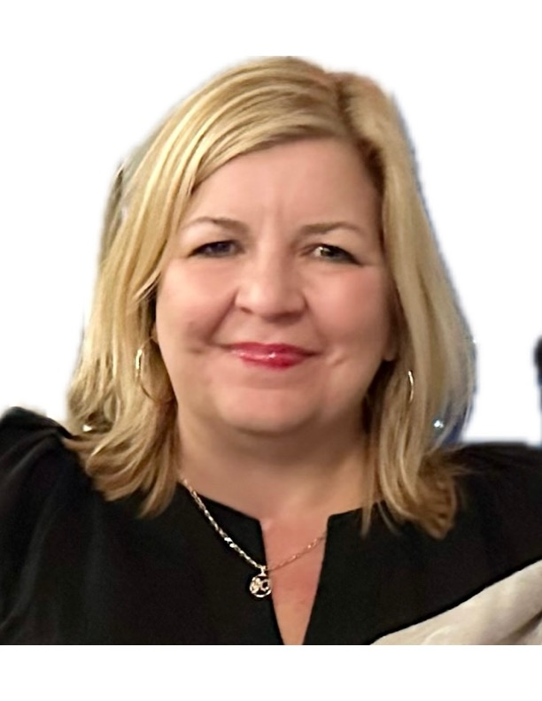
Tracy Snowden Ortiz is a sixth generation native of Elgin. Tracy graduated from Elgin High School in 1987 and attended Southwest Texas State University (now Texas State University). She is the wife of Pascual Ortiz, also a native of Elgin, and the proud mother of two daughters, Charlie and Paloma.
Growing up in Elgin gave Tracy the opportunity to learn about the history of the area, its people, and many family members with whom she came in contact during her youth. A large number of her relatives lived in Elgin and Austin and were business and civic leaders in both communities.
In 2002, Tracy traveled to Sweden with her mother and grandfather to see the country that her Swedish grandfather, Luther Lundgren, had told her about. She currently attends the New Sweden Lutheran Church where her great-great-great grandparents, John Alfred and Mathilda Stenholm, were founding members and where Tracy now serves on the church council. While in Sweden, she was able to visit relatives who she had never met.

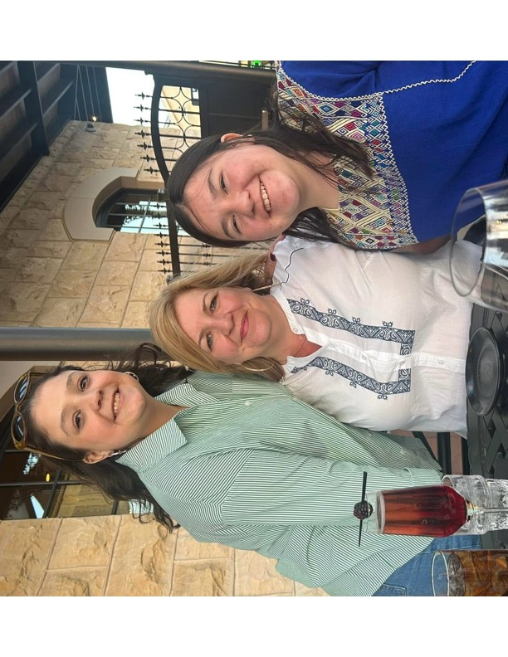
Charlie, Tracy, and Paloma Ortiz

Since childhood, Tracy has been involved with the historic Pleasant Grove Cemetery. Seven generations of her family—Davis, Rankin, Lundgren, Snowden, McGee, Carter, and Stone—are buried at the “Grove.” Her great-great grandfather, Oscar Davis, was a brick mason who built many downtown Elgin buildings, including the First Baptist Church and the former Nofsinger home (now City Hall). The Elgin High School Victory Bell was dedicated to honor her only sibling, Gary Snowden Jr. All of these connections have given Tracy a unique perspective and interest in capturing the oral histories and stories of all Elgin citizens.
Professionally, Tracy served the State of Texas at the Office of the Comptroller of Public Accounts, beginning as a summer job after high school and later as full-time employment. In 1991, she followed Lt. Governor Bob Bullock to the State Capitol and began her career in the Texas Senate. Before her retirement in 2024, Tracy was the Calendar Clerk of the Senate, a job of great responsibility and importance to the Texas legislative process.
Even while living in Austin for several years, Tracy was active in Elgin’s community events with her parents, Donna and Bubba Snowden. She currently participates on the board of the Elgin Livestock Association and the Elgin FFA Booster Club. Tracy is a true asset to Elgin Oral History Project’s Board of Directors.

“”Oral history is not just a method of gathering information; it is a way of honoring those who have come before us.” Linda Shopes
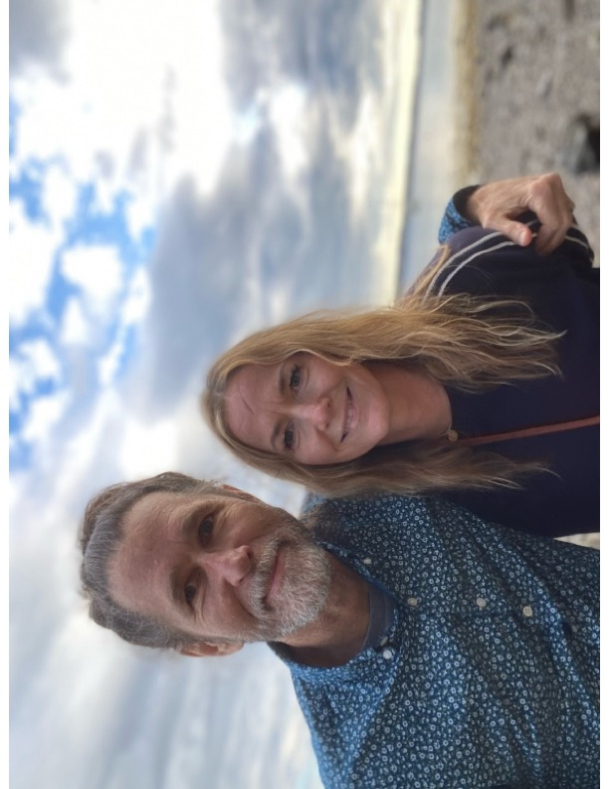
Bob Makela and Molly Owen
Mary Tyne Owen was given her stage name at birth. It was Molly. Her mother thought it would be fun to have a secret name, and in fact, Mary remains fairly secret to this day! And so, Molly, a performer at heart, began her official storytelling in the third grade when she was awarded second prize in the University Scholastic League’s contest category of “storytelling.” The contest included listening to a story just once and then retelling it to the judges. Molly found this competition thrilling!
Introduced at an early age to the love of theatre and dance, Molly pursued the study of acting at The University of Texas at Austin. She received a Bachelor of Fine Arts in 1995 and continued her study at the Circle in the Square Professional Acting program in New York City. Full immersion into the diversity of the city expanded Molly’s understanding of the world and its humanity. Connecting with a wide array of people, she found comfort in the shared experience of her circle.
In 2000, Molly received a certificate of cosmetology, in pursuit of an alternative day job that was creative and social. Opportunities through hairdressing led to fashion styling, then education, public speaking, and leadership. This unexpected role was all about empowering others through listening and education. As a Vice-President of Education and board member of a fast-growing hair care brand, Molly led a field team to recruit, train, and mentor hairdressers. The brand grew over 50% in five years while Molly was with the company.
Molly and her husband Bob Makela moved from Brooklyn, New York, to Elgin in 2019. A quiet intention for community then led Molly to the practice of yoga and teaching. Today, Molly is grateful to be a yoga teacher in her hometown of Elgin, where she is teaching a variety of class types, both in-studio and private in-home.
Molly contributes fully to the Elgin Oral History Project and states that “there is a shared honor and responsibility to preserve our town’s history and document the days of old. I love the present opportunity to listen, capture and give greater voice to our town in this moment. I’m curious to hear the sounds of our shared experience. It’s one of those times that I feel called to listen more deeply. Then, we can tell fuller, truer stories.”

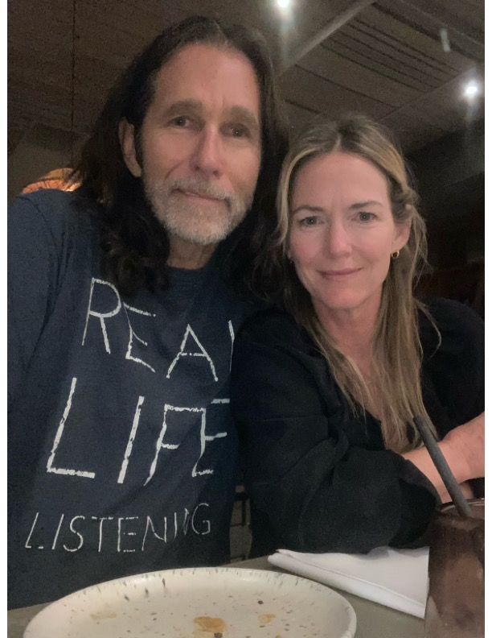
“Real Life Listening”—that is what the Elgin Oral History Project strives to achieve.

See: www.oralhistoryetx.org
www.facebook.com/ElginOralHistory
www.instagram.com/elginoralhistory
or just search @elginoralhistory

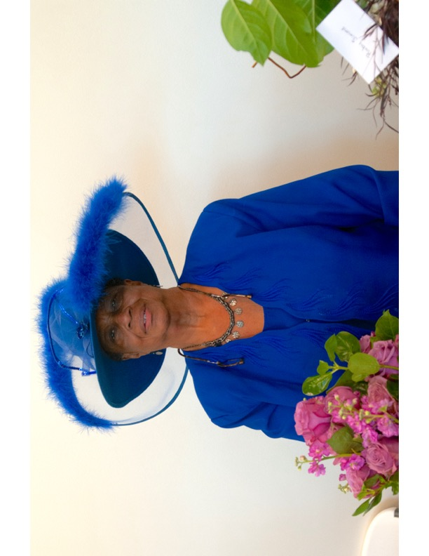
Ruby Meeks Simms is a life-long resident of Elgin, a mother, grandmother, and great-grandmother to nine. She was married to the late Deacon Robert Louise Simms and attended the Booker T. Washington School.
Ruby served on the Housing Authority Board for the City of Elgin and the Board of Adjustment in 1980. She continues to serve her community on the Advocacy Outreach Board of Directors. Ruby has dutifully worked as a judge and election clerk in Bastrop County for over 30 years. It is said that she may be the most recognized face of the voting electorate that Elgin has!
Ruby has been a member of Pleasant Bethany Baptist Church for 50 years. She serves as the Finance Secretary and President of the Mission for the Church. Ruby helped in the creation of the Community Cupboard and volunteers her time there whenever she can.
Ruby is actively involved in planning events for Elgin’s Juneteenth celebrations, as well as the MLK Walk and Conference each year. In 2022, she contributed her oral history to the Elgin Oral History Project. Her involvement as a director of the Project will bring valuable insight to its operations and future.
Honored in 2020 for over 43 years of community service, Ruby is pictured above at Elgin’s annual “Hatitude” event.

