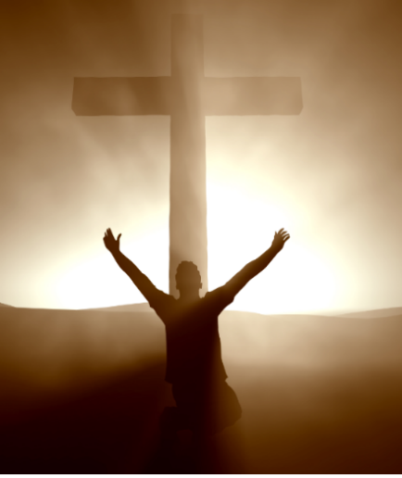
The Alaska Men’s
Conference
Topics: Individual Victory, Successful Living, Missions,
and Leadership
Attend some or all sessions.
All meals, lodging, and speakers for $149 per person. See website below for more Information
When: March 7th,8th, & 9th, Where: Solid Rock Bible Camp, Soldotna, AK
(Thursday night, all day Friday, and Saturday morning.)
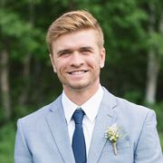
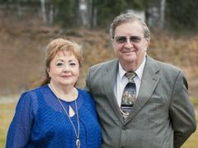
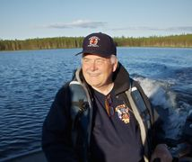
Featured Speakers

Wayne Coggins
Wayne is a noted pastor, counselor, , with a special emphasis on family counseling national speaker, and author.

Bill Pepper
Bill Pepper ministered in the Amazon jungle for 13 years. He currently travels to dozens of countries working with the persecuted church. He is considered by many to be a “pastor’s pastor”

Paul Sliwa
Paul Sliwa is a dynamic youth pastor and assistant pastor in Wasilla. a youth group of over 100 kids, and he also works as an assistant pastor. Paul is involved with his community as a soccer coach for the local high school.

Don’t miss out on this unique opportunity! Mark your calendar.
Question? nkchapel@alaska.net. For more information, and to register either with a downloadable form to mail in, or online, go to https://nkchapel.org/mens-conference.

