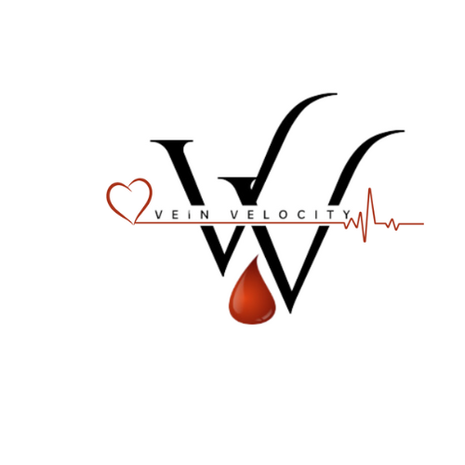 **CONSENT TO HAVE BLOOD DRAW**

Please initial your choice and sign below.

_____ I authorize Vein Velocity to collect my blood and transport to the lab of my choice.

In signing this consent form, I acknowledge that I have been provided with information about this service. I have been given the opportunity to ask questions regarding this information and my questions have been answered.

I have been informed the test results are considered confidential and will be released only to my physician as permitted by law.

_____ I understand that I will be charged a collection fee not billed to my insurance company and it’s my responsibly to pay the fee upfront.

________________________________ _________________________________

Signature of Patient Signature Vein Velocity

Date _____________________________

I have consulted with the above-mentioned person about blood collection, about the availability and necessity of post-testing counseling, and that test results will be handled confidentially as prescribed by law.