**Wedding Videography Pricing and Services by Frank Rohmer**

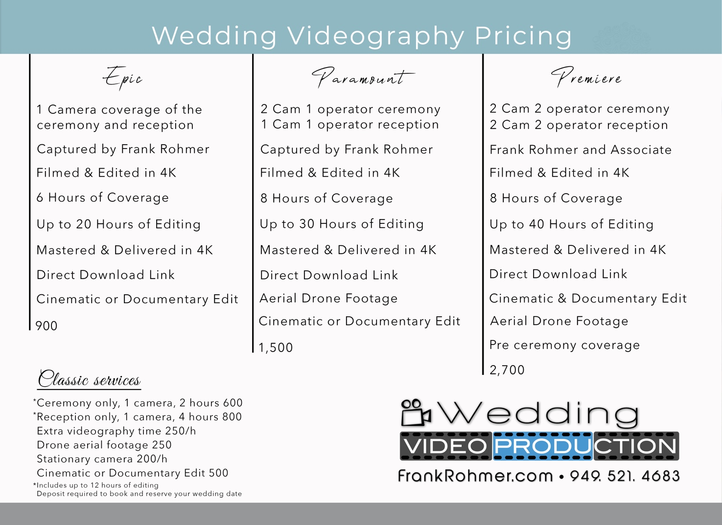

Notes: