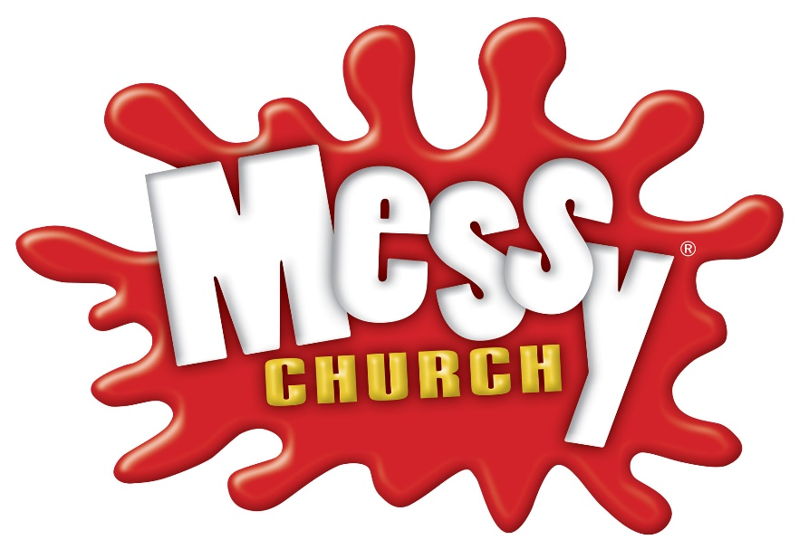

Hi everyone, and welcome to our very own Messy Church page. On this page you’ll find links for craft ideas, songs and stories and any other information you may find helpful.
Our theme for this month of April is Palm Sunday, when we remember Jesus riding into Jerusalem on a donkey and the excited crowds’ reaction.
Here’s a children’s Palm Sunday song. Click on the link and sing along!
https://youtu.be/5jtDqKkdS1M

And a song for all ages:
https://www.youtube.com/watch?v=oAaQ5EEXidc&feature=youtu.be

Here’s the story, in two versions:
https://vimeo.com/59691514 (for children)
https://youtu.be/hU-6FOyM7v8 (for youth)

Our story can be found in the Bible, in the gospel of Matthew. Here it is:
Matthew 21 New International Version (NIV)
Jesus Comes to Jerusalem as King
As they approached Jerusalem and came to Bethphage on the Mount of Olives, Jesus sent two disciples, saying to them, “Go to the village ahead of you, and at once you will find a donkey tied there, with her colt by her. Untie them and bring them to me. If anyone says anything to you, say that the Lord needs them, and he will send them right away.”
This took place to fulfil what was spoken through the prophet:
“Say to Daughter Zion,
‘See, your king comes to you,
gentle and riding on a donkey,
and on a colt, the foal of a donkey.’”
The disciples went and did as Jesus had instructed them. They brought the donkey and the colt and placed their cloaks on them for Jesus to sit on. A very large crowd spread their cloaks on the road, while others cut branches from the trees and spread them on the road. The crowds that went ahead of him and those that followed shouted,
“Hosanna to the Son of David!”
“Blessed is he who comes in the name of the Lord!”
“Hosanna in the highest heaven!”
When Jesus entered Jerusalem, the whole city was stirred and asked, “Who is this?”
The crowds answered, “This is Jesus, the prophet from Nazareth in Galilee.”

And here’s a link to a craft:
http://www.dltk-bible.com/crafts/mpalm.htm

