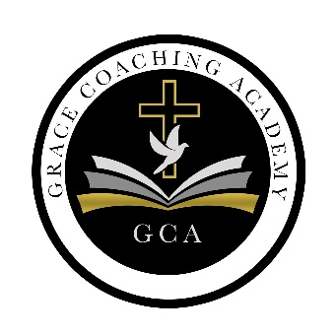

Coaching Services
Initial Assessment Form

Name:____________________ Year: 2022________

Please score your readiness (Have you began processing/working towards a resolution in these areas?)
1= Ready 2= Waivering thoughts 3= Procrastination

Each Category will be scored for readiness- | 1 | 2 | 3
Self-Identity:

Do you know your Purpose,

Do you know your Intentions?

Do you know your Barriers (what’s in the way)

What are your Triggers?

1 is YES
2 is SOMEWHAT
3 is NO

Self-limiting Beliefs:
Does your Past experiences, Childhood structure, and old relationships cause you to think negative about situations and or believe things will not work out for you?

1 is Yes
2 is SOMEWHAT
3 is NO

Confidence :

Do you know: Why can’t you? Why won’t you? Who/what stopped you?

1 is YES
2 is SOMEWHAT
3 is NO
Criticism/Growth Moments:

When you are at work or assigned something to do, are you lead by your heart or do you use your head and do what is right but not necessarily popular to others?

1 is YES
2 is SOMEWHAT
3 is NO

Heart vs.Head, Listening vs. Accepting
Stress Management:

How often do you stop and reflect on negative situations ?
Do you process it and release the negativity?

1 is YES
2 is SOMEWHAT
3 is NO
Relationship Direction:
DO you know the direction your relationships are going?

1 is YES
2 is SOMEWHAT
3 is NO

Are your important relationships good or bad? Yes or NO

Use this space to add your comments on any of the questions above.

