ARDLEIGH PARISH COUNCIL

MINUTES OF THE MEETING OF THE PARISH COUNCIL ANNUAL ASSEMBLY
HELD ON 20th MAY 2019 AT THE VILLAGE HALL AT 7.30PM

PRESENT: | Cllr Barrott (Chair),  Other members of Ardleigh Parish Council  Karen Thompson (Clerk)
IN ATTENDANCE: | Representatives from Ardleigh Pre-School, Jill Hamblin (Archivist), Cllr Keith Thompson for the Millennium Green Trust, Ardleigh Horticultural Society and many members of the public.
Apologies | Apologies were received from Cllr Gugliemli (Essex County Councillor), Cllr Mason and Cllr Culham.
Chairman’s Welcome
The Chairman welcomed everyone to the meeting and reminded the audience of the reason for the meeting
Item 1 - To agree the Minutes of the last meeting of the Council held on 30 April 2018
These were agreed.

Item 2- To receive the Chairs Report

Summary
Councillor Barrott began his report by thanking his fellow Councillors for a full and productive year that relied on Councillors giving up their time to conduct the business of Ardleigh Parish Council. He summarised the year as a full council year with meetings every month including Public Meetings. Cllr’s Carlo Gugliemli and Neil Stock had attended a number of meetings and provided invaluable assistance on matters needing support at either Tendring District or Essex County Councils.

The finances for the year have remained in good order with routine repairs to the Recreation Ground, Millennium Green and Colchester Road play areas. We also improved the cemetery railings which were showing their age. During the year, we reviewed 111 planning applications and commented on a number of appeals for properties along Bromley Rd and Turnpike Close.

We learned that the planned refrigeration unit at Peake Fruit Farm was delayed until a high-pressure mains pipe running through the site could be diverted. The Council has worked with ECC and Peake Fruit to try and resolve the problems caused by HGVs congested in Home Farm Lane causing delays and damage to the road and neighbouring properties. Hopefully the situation should improve now.

The parish has benefitted from grants provided by the GCG Environmental Trust to fund equipment and facilities that the village benefits from and the council is hopeful that we may get funding for additional toilets at the village hall. I am grateful for outstanding generosity of the Trust.

The GCG Environment Trust supported the village Fun Day and events to mark the centenary commemoration of the ending of theFirst World War.

There is a new war memorial on the Millennium Green which shows the contribution and events that Ardleigh played a part in during the wars. The memorial had been a concept of Jill Hambin and I am extremely grateful to her for all her hard work in turning her idea into a reality. The dedication of the plaque took place in September and was attended by the families and friends of those air crew killed when the Halifax bomber crashed in Ardleigh during World War 2. They travelled from around Britain for a service that enabled some recognition of their loved ones. Thank you to the GCG Environment Trust for funding the Memorial.

We also supported the Remembrance Service and the village beacon lighting ceremony. The Fun Day raised over £700 for the Essex Air Ambulance.

The volunteer community speed watch got active in the village and has provided very useful evidence of speeding along the Colchester Rd.

The first Tendring car rally took place, which is generally supported by residents.

We updated the safety fencing around the Colchester Road Play Area. A play area that gets a lot of use.

We met the local management of the local Highways depot to try and get the dazzling lighting issue resolved. We are not there yet but hoping for an improvement soon.

The lay-by in Home Farm Lane, which is a passing place, was being used for overnight parking. The council has worked with Cllr Gugliemli on this and with the involvement of ECC Highways and now the support of Peake Fruit a solution seems to have been found.

The parking up of HGVs and numerous cars on the Old Ipswich Rd has been an increasing problem for Ardleigh. The HGVs generally have an operating base (where they should park up) elsewhere but it is convenient for the drivers to park on the Old Ipswich Rd as it is closer to home than their base. ECC have carried out traffic and speed surveys but the North Essex Parking Partnership have no ability to act in the area as it is a legal matter not a parking one.

On the theme of HGVs, the Council became aware of HGVs unwisely using Spring Valley Lane and getting stuck on the sharp bends. The Council with Cllr Gugliemli and ECC Highways have arranged for better signage at the start of the lane saying it is unsuitable for HGVs.

The Council felt that TDC had been negligent in their duty when considering and permitting the Peake Fruit planning application, but the Ombudsman will not consider a complaint from a Parish Council about a District Council. The Tendring District Association of Local Councils has taken up this issue and hopes to progress a change thus allowing future complaints to be heard.

We accepted a significantly discounted price to replace the wooden knee-high fencing around Plains Farm Close greensward. The original fencing was both an eye-sore and ineffective as it had been broken in several places by people parking at Plains Farm.

After reports of anti-social behaviour in the Recreation Ground Car Park the Council has investigated whether CCTV would help prevent the situation and quotes are being sought.

The Council have decided to investigate whether a Neighbourhood Plan (a legislated document – when adopted) would help Ardleigh prevent ad-hoc and unplanned housing applications that are outside the village envelope, or settlement development boundary. To learn about the process, we booked an information session with a local company, but this was postponed on the day and we hope to have this in the coming Council year. The development of a Neighbourhood Plan is a significant piece of work involving the whole community and not just the Parish Council. If we proceed, we will be looking to recruit a number of volunteers who want to work to protect Ardleigh from the companies like Gladman.

We arranged for the vegetation at the front of the cemetery to be cut back and we discovered long lost headstones and memorials. The work cleared the vegetation away from the railings which we were then able to have shot blasted in-situ and repainted.

We have received funding for the cost of local hand person to complete small jobs around the village. If you have any suggestions for handyman work, then please let us know.

The Ardleigh Highways depot held a charity event and spent a day repainting the bus-shelter and noticeboard, oiled the old bench and cleaned the bollards and rails at the village centre. It looks much better now and we are very grateful for their efforts.

In September, Helen Fontaine was co-opted onto the Council.

In October we noted that a successful litter pick organised by the local churches had taken place. The improvement was noticeable.

Cllr Halsey resigned from the Council. His decision was prompted by the recent approval of the planning appeal made by Gladman for 145 houses on Bromley Road. It would appear that Essex Highways withdrew their objections to the original application leaving TDC with a weakened defence. The Bromley Road is fast moving and putting access to an estate with 145 houses almost on top of a bend has left most people wondering how dangerous a road has to be.

We managed to get the Churchyard War Memorial cleaned in time for Remembrance Sunday and the Millennium Green Trust arranged for the Beacon and Millennium Green Sign to be cleaned and painted.

The lights at the village centre car park were not working and a few people raised complaints. The car park is the responsibility of TDC and therefore getting a cherry-picker in to repair the lights takes a bit of co-ordination as the barrier needs to be opened. All lights were repaired, and the car park is much safer now.

We are about to start planning the VE75 anniversary which takes place on May 8-10 in 2020.

We are hoping to commission additional toilets at the Village Hall which should be accessible to those using the Recreation Ground and Millennium Green.

We re-iterated our objections to a KFC restaurant and drive-thru, Ipswich Road, at the planning appeal but despite strong objections by many the appeal was allowed.

When we agreed our budget in January for the coming year we were, again, able to maintain a zero increase on household Council Tax bills. Our budget has increased slightly but because there are more houses in Ardleigh paying Council Tax. The amount per household has remained at less than £40 per year for some time.

My final words are to thank all those involved with the Parish Council who have given of their time and effort to help make Ardleigh a great place to live.

Item 3 – To receive reports from County and District Councillors

There were no representatives from either District or County Council.

Item 4 – To receive the Ardleigh Millennium Green Trust Annual Meeting Report

Chair of the Millennium Green Trust gave a verbal report summarising the work on the Millennium Green during the year.

Item 5 – To receive the Report from the Ardleigh Parochial Charity
The following report received.

ARDLEIGH PAROCHIAL CHARITY
ANNUAL REPORT 2019

In the past twelve months, fewer applications have been submitted. Of the seven applications considered, four were funded directly, one was referred to another, more specific charity and two fell outside the remit of the fund. Generally, applicants must be Ardleigh residents, there must be no alternative source of funding and there must be a clear need. The APC bought equipment bags for an unfunded youth group, replaced a worn and potentially dangerous hall carpet for a pensioner, replaced a cooker element and fitted a kitchen tap which had been leaking very badly and causing damage. We are always happy to consider applications from people in the village. We have revised the application form which is completed by a committee member with the applicant. This is helping clarify which applications meet the criteria and also enables the committee to discover how people learn about the fund. At the moment, we place a description of our work into the Ardleigh Advertiser at regular intervals and we ensure the Doctor’s surgery, the church and school know of our existence as they may encounter situations of hardship we can help with. We look forward to assisting people further over the coming year so please publicise the existence of the charity wherever you think we might be of help. New committee members would also be very welcome, so if you feel drawn to serve your community in this way, do please get in touch.
Mandy Pratt (Chair)

Item 6 – To receive the Report from the Ardleigh Archivist

Ardleigh Archivist’s Report 2018-9 from Jill Hamblin
I continue to act as Parish Archivist, filing historical material as it is found and helping people, both local and further afield, to discover their own or their families’ histories. This year, as every year, I have people turning up on the doorstep asking for help tracing their relatives. I am also now able to transcribe Ardleigh wills from centuries ago; translation is also required: thank goodness for my Latin studies of so long ago! I also continue as the Secretary of the Tendring Local History Recorders, recording events as they happen now, for they are tomorrow’s history. As I have said before, I do welcome seeing any items pertaining to the village and am happy to help with school history projects.
In 1918 I co-ordinated village events to celebrate the ending of the First World War. The interdenominational Service of Remembrance on Sunday 11th November took place at the church, with wreaths being laid and the customary silence observed at the war memorial at 11 am. Helen Fontaine, who organised the service, managed to involve all faiths, ages and beliefs; moreover, she got Manningtree School pupils, as well as pupils from St Mary’s School, wholly involved. Silhouettes of World War I soldiers sat in the church and stood outside. I mounted an archive display too. In the evening, the beacon on the Millennium Green was lit and the church bells were rung, both part of a nationwide celebration.
Before November, there were other events. In October I mounted a small exhibition as part of the Flower Festival, but before that, I organised two big events in September. The first was the Family Fun Day on 8th September. As we said then, the sacrifice of our airmen, soldiers and sailors ensured that we have the liberty to hold such fun days. Thanks are due to the Parish Council for its support, both in terms of a grant and of personnel; to the sponsors, especially SRC, to the WI and a host of helpers from the village. Reports and photographs of the event now take their place in the Ardleigh Archives.
At the end of September there was a rather more sombre occasion, but with equally good refreshments! This was the unveiling of a new village sign, ‘Wartime Ardleigh’, on the Millennium Green. Commissioned by the Parish Council and funded by the GCG Environment Trust, it shows what went on where in the village during two world wars. This sign, lectern style, of acid etched aluminium, features a map of the parish in the centre, with sketches and numbered points on it. To the sides of the map, there is a short guide. Buildings used during WWI, such as The Ancient House, which was used as the War Depot and the school, where troops were stationed, are identified, together with buildings and areas from WWII. These include Redbury Cottages, where a doodlebug (V1) crashed in September 1944, killing several people, and a field at Badliss Hall, where a Halifax Bomber crashed in February 1944 with the loss of the whole crew. The identities ranks and ages of the crew are on the sign and, to mark their sacrifice, representatives of the British Legion, the RAF and the Air Cadets joined relatives and local dignitaries at the unveiling by Sir Bernard Jenkin MP. I mounted an exhibition which explained the background to each image on the sign. I have been asked to put this material into book form but have yet to do so.
Thank you to the Parish Council for its continuing support which makes all this possible.

Item 7 - To receive reports (written or verbal) on the activities of community organisations meeting in the Parish
There were reports from:
- The Horticultural Society mentioning the 42 members involved in 7 talks and the village horticultural show. They also played a part in the Church Flower Festival and are involved with the school with a strawberry growing competition and the provision of seeds.
- The Speedwatch group reported on a year which has seen 147 speeding occurrences reported and a significant number of uninsured drivers and some stolen vehicles, driving whilst using a phone and non-wearing of seatbelts. The group are looking for additional volunteers to help make Ardleigh safer.
- The Ardleigh Pre-school gave the following report:
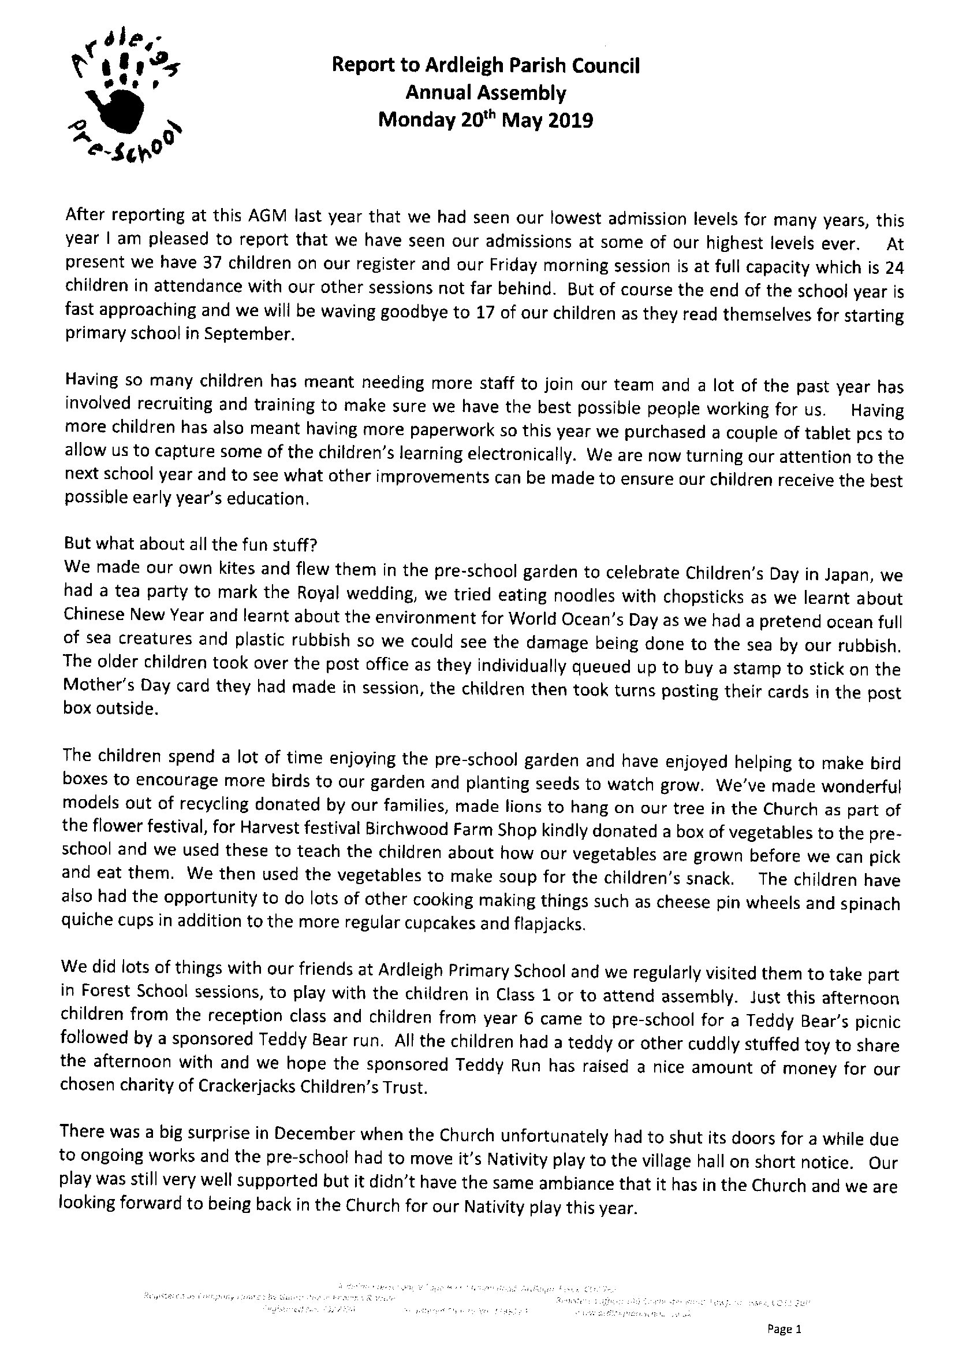
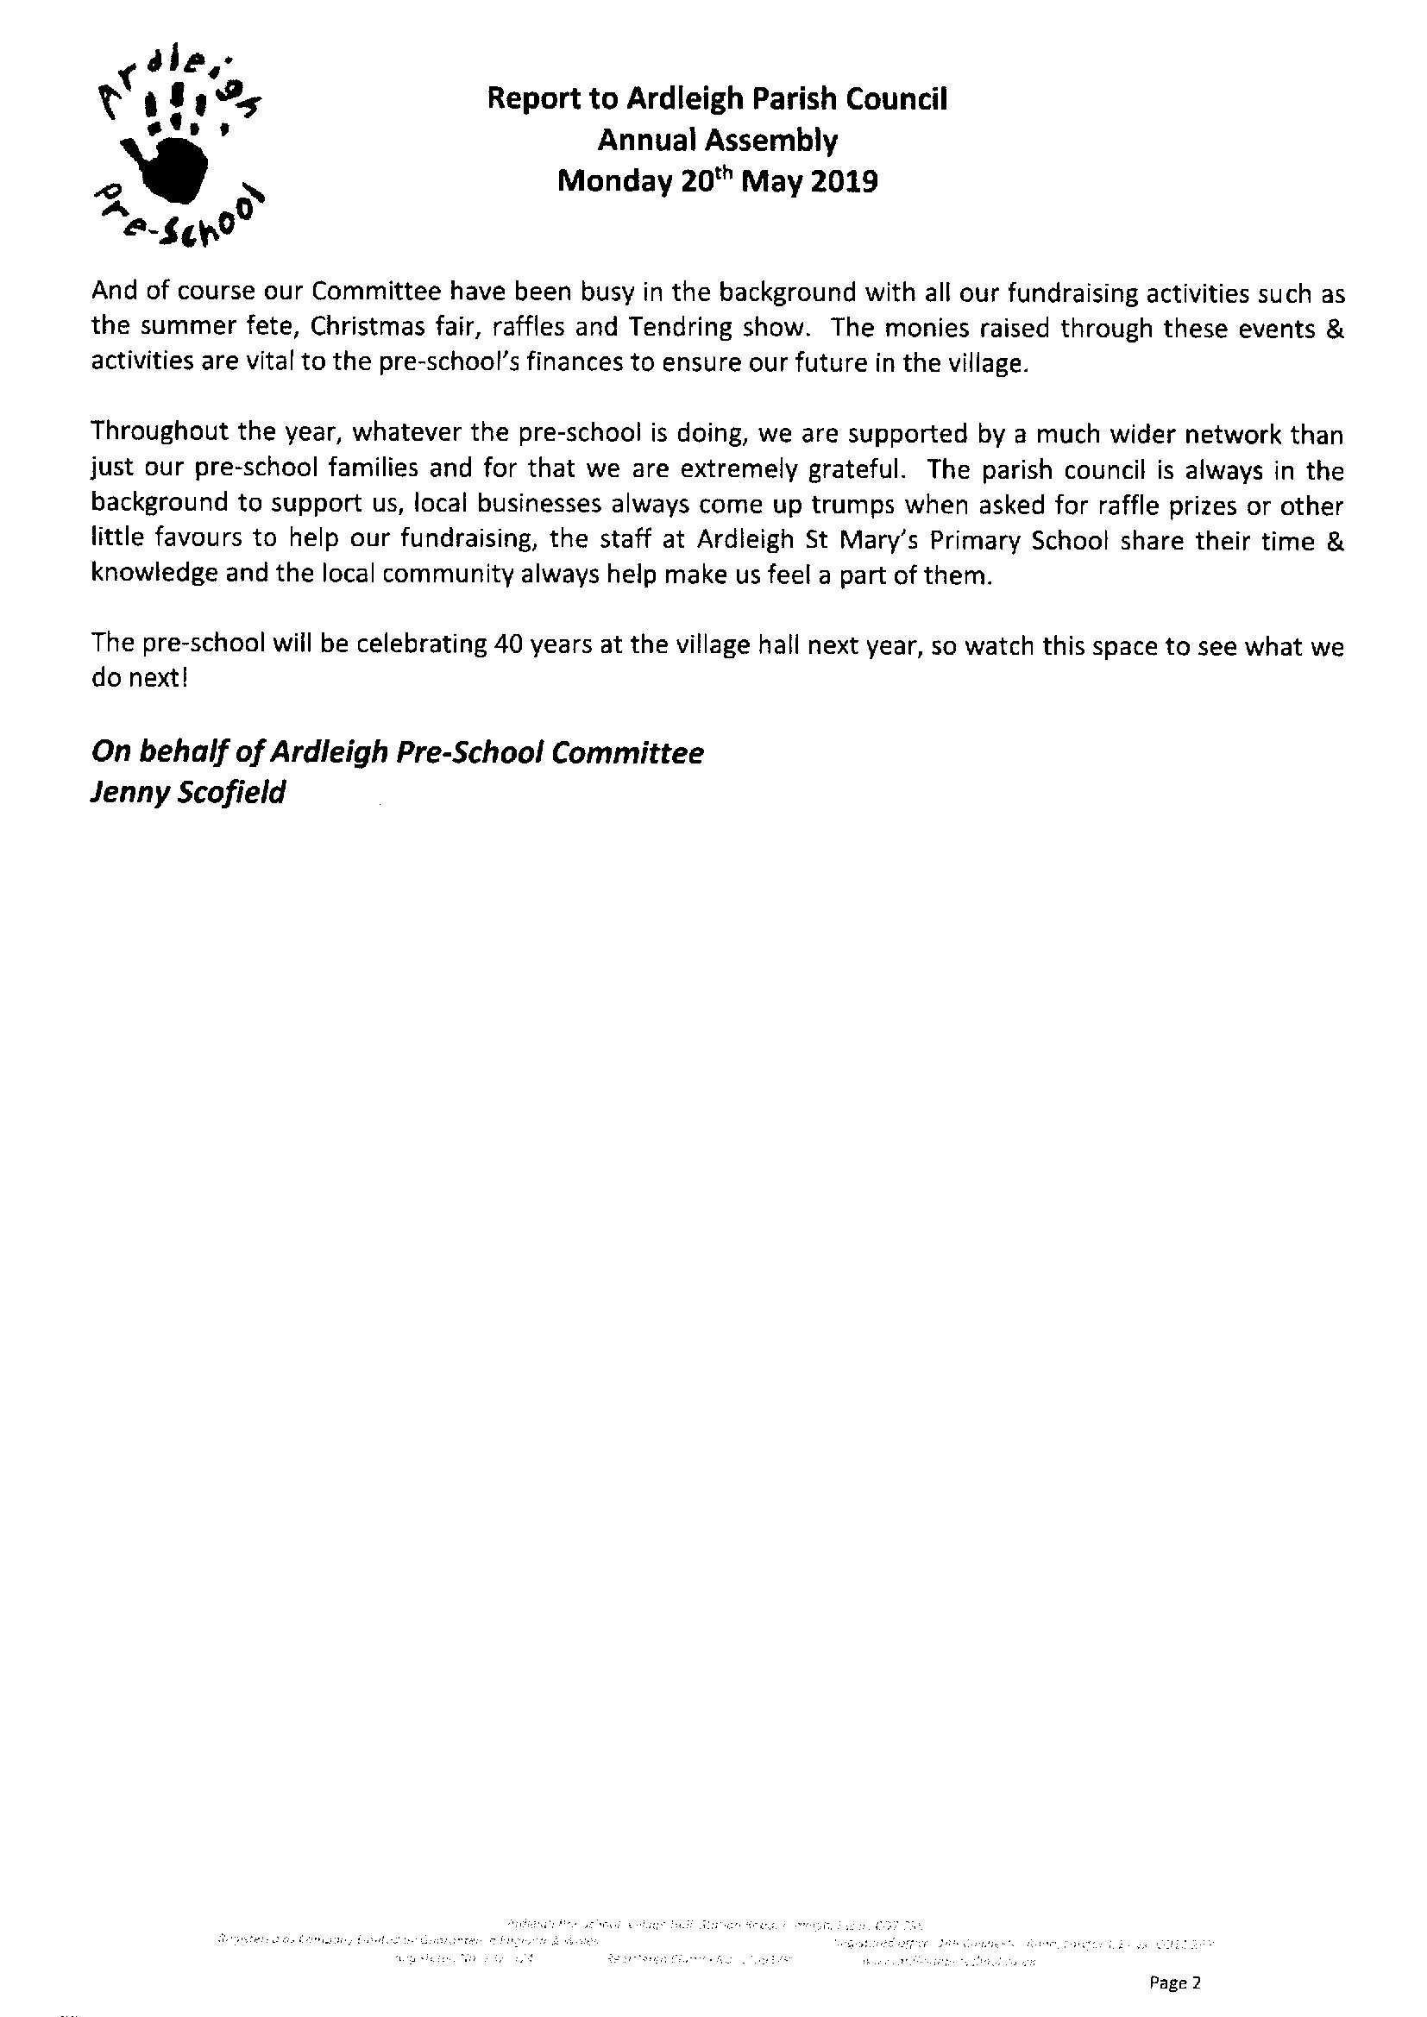
Item 8 To receive the AGM report for Ardleigh Village Hall
The year end financial report for Ardleigh Village Hall was reported as:
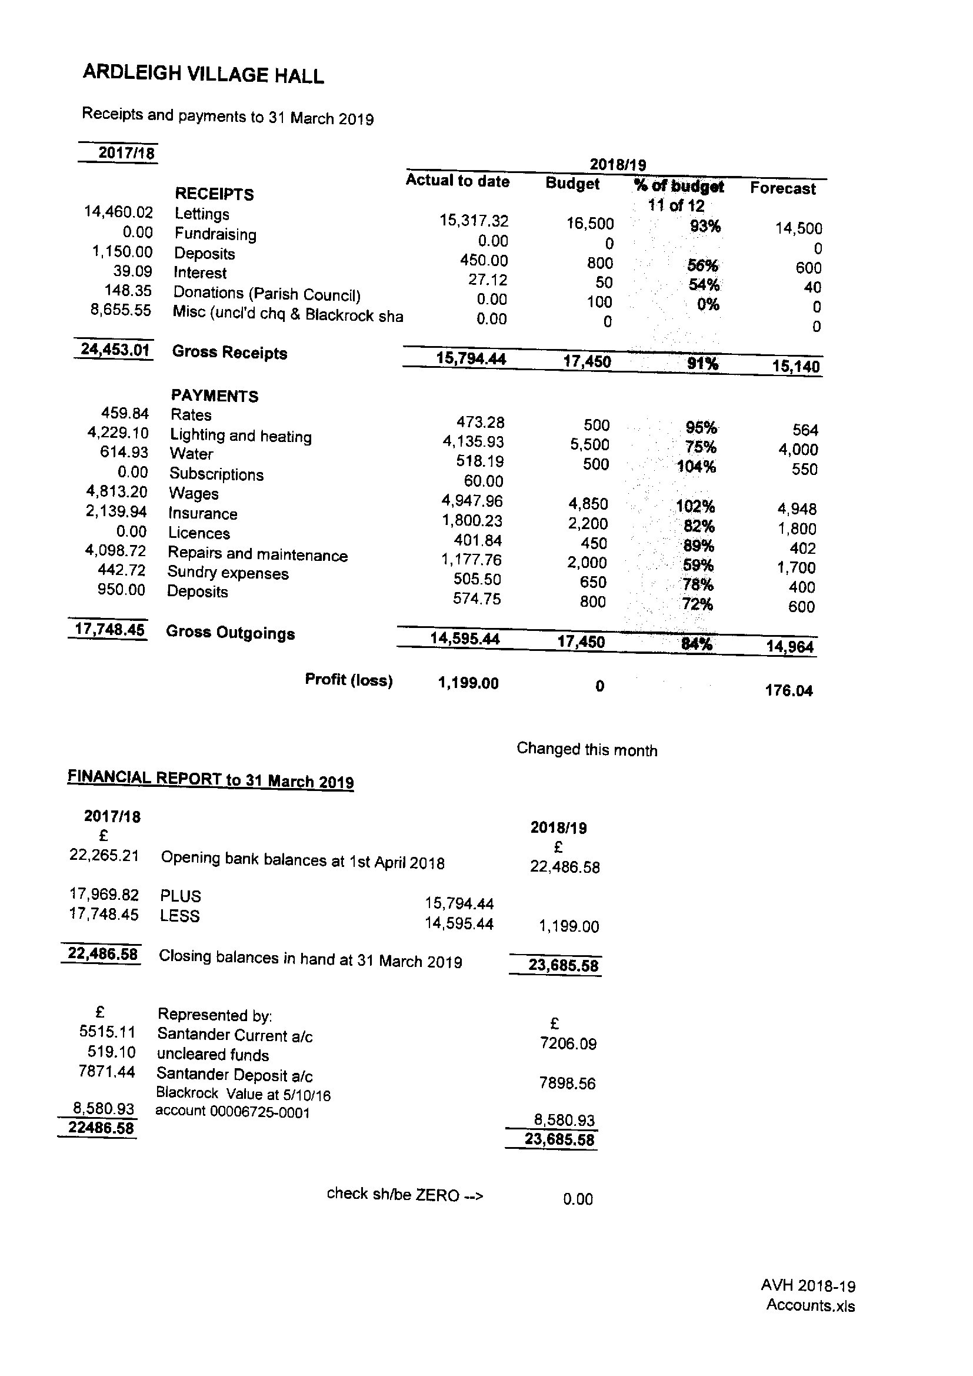
Item 9 To receive the AGM report for Ardleigh Recreation Ground
The Ardleigh Recreation Ground year end financial reported was reported as:
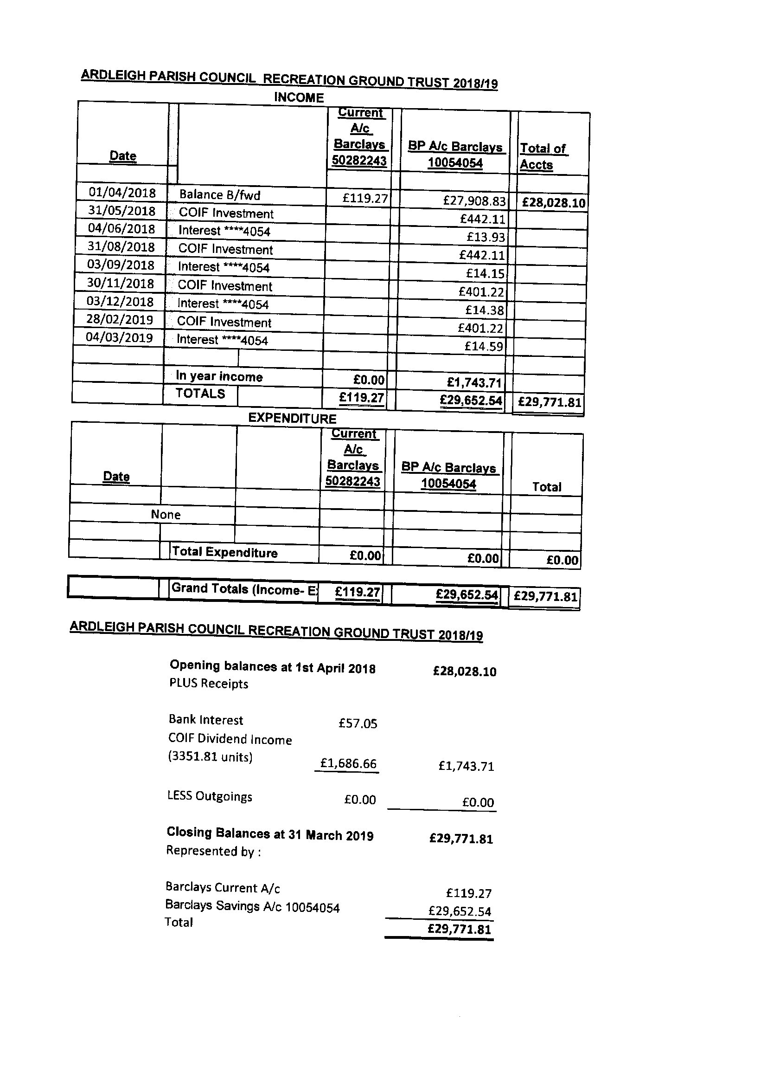
Item 10 – To receive reports on the finances of the Parish Council
The financial statements for the Parish Council and Village Hall were available for inspection and would be on the parish website. The total receipts for the year were £86,434. The spend for the year was £75,176. Of the surplus £8000 would be carried forward to the next year to fund handyman work. The bank holdings were £127,665 which includes funds to acquire a second cemetery site. No questions were raised.

Item 11 Any Other Business
There was no other business.
Meeting close

