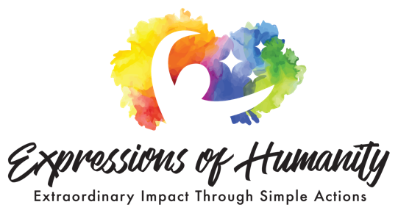
Independent Fiscal Sponsorship Application

How would you like your application processed?  Choose Application Type: | Regular application (10-14 days to process) - $85  Expedite application (10 days to process) - $165
PROJECT INFORMATION
1. ORGANIZATION NAME (organization that will have primary management responsibility for the project): | Title
2. PROJECT NAME:
3. PROJECT PHONE:(or primary contact’s phone number)
4 a. PROJECT MAILING ADDRESS: | Address 1  Address 2 City State Zip Code
4 b. PROJECT TOPIC LOCATION:(list location if not in the U.S.)
5. PROJECT LINKS AND SOCIAL MEDIA:
a. WEBSITE:
b. FACEBOOK:
c. TWITTER:
d. YOUTUBE:
e. INSTAGRAM:
f. OTHER:
6. PROJECT CAUSE: | Select One:  Human Rights Climate Action,  Youth Empowerment Gender Equality,  Health & Well-being Education,  Other (please define)
7. PROJECT TYPE: | Select One:  Storytelling Film Rescue  Community Outreach Enrichment Development  Community Action Prevention Protection  Photography Multimedia Music  Other (please define)
8. STAGE OF DEVELOPMENT: (check one)

Development: Your project is still in the idea phase, developing a strategy, partnerships, and plan of action.
Production: Your project is in the creation phase, producing your work or media.
Distribution: Your framework details such as education, humanitarian or media piece is completed, and you’re now sharing it with the public.
Outreach: You’re engaging partners, general public or specific communities to take action.
Implementation: You’re implementing your action on the ground.

9. PROJECT SUMMARY:

In 400 words or less, provide a project synopsis. If accepted into FSP (Fiscal Sponsorship Project), this text will be used for the copy on your project’s profile page on EOHF’s website. Where possible provide specific data regarding its reach and impact.
Begin Here

TEAM INFORMATION

Project Director: Indicate the main point of contact on the project and include one sentence of bio/qualifications.

1. FIRST NAME:

2. LAST NAME:

3. EMAIL:
4. LOCATION: | Where this person will reside

5. BIO: (200 words or less)
6. TEAM REFERENCES: Please give two references and contact info. | Name Phone #  Email  Name Phone #  Email
FISCAL SPONSORSHIP INFORMATION
(ALL REQUIRED)
(All files along with application send to info@expresshumanity.org Subject:“Project Name”, Please .zip the files together)
1. ORGANIZATIONAL BACKGROUND:
Provide a current copy of Articles of Incorporation, Bylaws, other organizational or governance documents.
Year organization was founded
Board of Directors and/or Board of Advisors (or anticipated directors/advisors)
Please list names & title/affiliations:
2. BUDGET: Include a percentage breakdown of where you expect your donations to come from in these categories in the list below (real or projected).
- Corporate
- Government
- Foundations
- Individuals
- In-Kind
- Earned
- Other
Please include an attachment with your actual results for the current year and the most recent 2 years (or actual period of existence if less) and your current budget including projections for the next 3 years.
3. FUNDRAISING: What are your current fundraising goals and strategies?
4. TAX STATUS:
a. Have you ever been granted or denied tax-exempt status by the Internal Revenue Service or any other state or local tax authority? | No  Yes
b. Have you ever had your tax-exempt status revoked by the IRS or any state or local tax authority? | No  Yes

