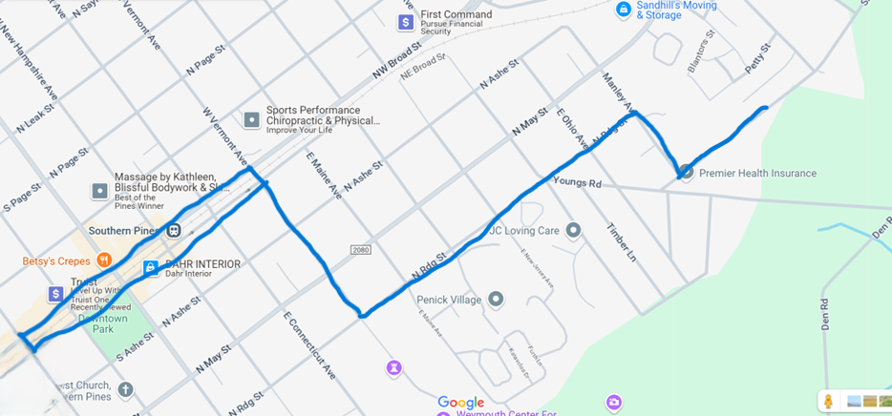
Route
- Start on Sheldon Road
- Turn right on Manley Avenue
- Turn left on Ridge Street
- Turn right on Vermont Avenue
- Turn left on NW Broad Street
- Turn around point is Massachusetts Ave (block past Truist Bank)
- Turn right on Vermont Avenue
- Turn left on Ridge Street
- Turn right on Manley Avenue
- Turn left on Sheldon Road

