
Single day visit [per guest]: $5 can be paid in Cash, Check or Venmo: 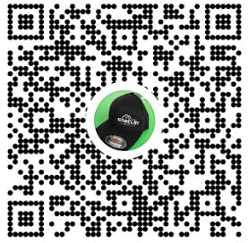@mike-shetler-3
Please drop cash/check in payment box at office with waiver
Guest Name: _________________________ DOB:_________ Member [sponsor] Name: __________________________
Address: __________________________________________ City: _________________ State: ______ Zip: ___________
Email[s]:______________________________________________Best Contact Phone: [______] ________-___________
PLEASE SIGN OFF BEFORE ENTERING ANY ACTIVITY [Under 18 requires parent/guardian signature]:
The undersigned acknowledges that the use of the equipment and services involves an inherent risk of personal injury. The undersigned agrees to assume all risks of personal injury to the undersigned, his or her spouse, children other family members guests or invitees waives any and all claims that the undersigned may have against The Gym or any of its agents or successors and machines and/or The Gym’s facilities. The undersigned also acknowledges receiving and reading The Gym’s Release of Liability Statement in its entirety.
X_____________________________ Date: _____/_____/_____ X_____________________________ Date: _____/_____/_____

Single day visit [per guest]: $5 can be paid in Cash, Check or Venmo: @mike-shetler-3
Please drop cash/check in payment box at office with waiver
Guest Name: _________________________ DOB:_________ Member [sponsor] Name: __________________________
Address: __________________________________________ City: _________________ State: ______ Zip: ___________
Email[s]:______________________________________________Best Contact Phone: [______] ________-___________
PLEASE SIGN OFF BEFORE ENTERING ANY ACTIVITY [Under 18 requires parent/guardian signature]:
The undersigned acknowledges that the use of the equipment and services involves an inherent risk of personal injury. The undersigned agrees to assume all risks of personal injury to the undersigned, his or her spouse, children other family members guests or invitees waives any and all claims that the undersigned may have against The Gym or any of its agents or successors and machines and/or The Gym’s facilities. The undersigned also acknowledges receiving and reading The Gym’s Release of Liability Statement in its entirety.
X_____________________________ Date: _____/_____/_____ X_____________________________ Date: _____/_____/_____

