Risk Assessment Policy
Beacon Independent School



Approved by: | John Page | Date: March 2025
Last reviewed on: | March 2025
Next review due by: | March 2026

History of Changes/Reviews
Author: John Page

Date | Page | Change

Contents
1. Policy Statement 4
2. Objective 4
3. Procedure 4
4. Risk Assessment Number 4
5. Monitor and Review 4
6. Risk assessement 5

Policy Statement

As an employer Beacon Independent School is committed to minimising or eliminating risks that may arise for staff and pupils, either within the school grounds or any activity undertaken away from the premises.

Objective

Risk Assessment is a means by which an organisation can demonstrate that it has control over its activities and premises and possible hazards that may occur.

Procedure

For each work/teaching area, teaching activity undertaken or general task, the associated hazards are established and noted.

The control measures required are then listed. These measures are required to ensure that injury from the hazards are minimised.

The final requirement is to identify the person/s at risk from these hazards. This can vary from an individual employee, pupil or visitor to a larger number of people either on or off the premises. e.g. school trips.

Risk Assessment Number

This is a means of establishing the likelihood of an injury occurring and if an injury should occur, the likely severity. The product of one multiplied by the other gives a Risk Assessment Number which establishes whether the risks are high or low.

Monitor and Review

Following the establishment of these Risk Assessments, there is a requirement for them to be monitored and reviewed on an ongoing basis.

Risk Assessment

When we make a formal Risk Assessment we:

- Decide the nature of the hazard.
- Decide who is at risk from the hazard.
- Estimate the likelihood of an accident happening.
- Estimate how serious such an accident would be.
- Judge the acceptability of the risk.
- Accept the risk or alter the procedure.
- Ensure everyone knows what the Risk Assessment says.
- Ensure that everyone knows what to do if an accident occurs.

When you consider Risk Assessments, do remember that accidents are caused by people and what they do. They do not “just happen.”

Remember that what is safe for you to do may not be safe for a young pupil.

Remember that what is safe for an experienced teacher with a good class may not be safe for another teacher with another class.

To estimate the likelihood of an accident happening the following calculation is used. For each hazard you should decide if the chance of an accident is high, medium or low and the possible severity, should that accident occur. To help us do this we calculate the possible outcome by giving a number to each variable and then using this to calculate the risk before any control measures are put into place and then recalculating the risk after the control measures are applied. Likelihood x Severity = Rating result

LIKELIHOOD
- = Unlikely
This means that there is a very small chance of an accident happening.

- = Possible
This means there is a reasonable chance of this happening.

3= Will happen
This means that an accident is almost certain.

SEVERITY
1= Minor Injury | 2= Major Injury | 3= Death

THE RATING TABLE.
RISK RATING = LIKELIHOOD X SEVERITY |  | RATING RESULTS
LIKELIHOOD | SEVERITY | RATING RESULTS
- = Unlikely  - = Possible  - = Will happen | - = Minor Injury  - = Major Injury  - = Death | 1 – 3 = Low Risk. Monitor and Review periodically  4 – 6 = Medium Risk. Implement Further Control  Measures  7 – 9 = High Risk. Not Permitted Until Risk Rating Reduced.

An example risk assessment is attached:

Beacon Independent School
Risk Assessment for Visit Travelling by Foot

Class/Pupils | Numbers on Trip/Ratios | Destination | Date of trip
Teacher in Charge |  | Teacher/Assistant Second in Sharge | Additional Adults on Trip

RISK RATING = Likelihood x Severity RATING RESULTS

LIKELIHOOD SEVERITY 1 – 3 = Low Risk. Monitor and Review periodically. 1 = Unlikely 1 = Minor Injury 4 – 6 = Medium Risk. Implement Further Control Measures 2 = Possible 2 = Major Injury 7 – 9 = High Risk. Not Permitted Until Risk Rating Reduced. 3 = Will happen 3 = Death

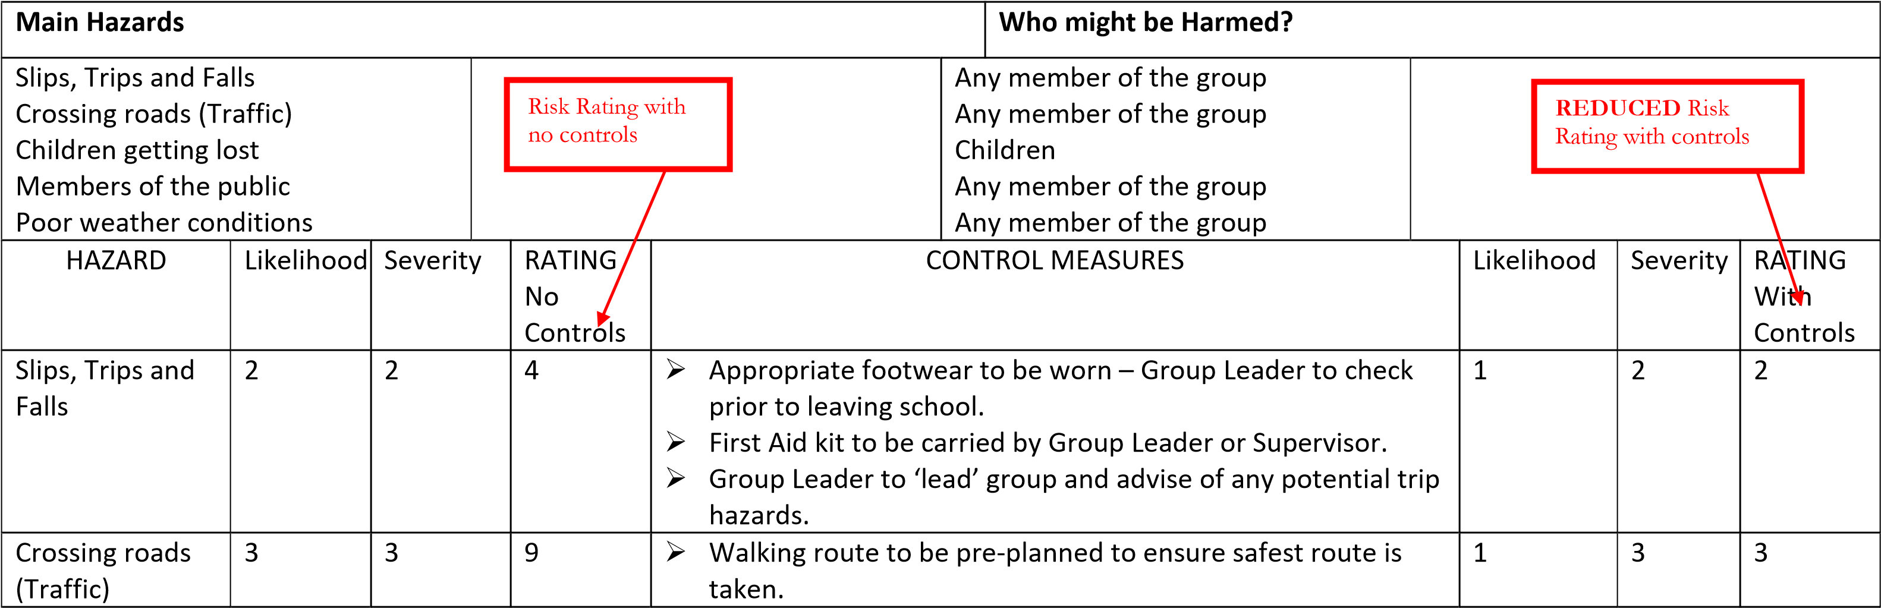

- Group Leader to give strict instructions to group.
- Children to walk in twos at all times and to hold hands with ‘buddy’.
- Group Leader to ‘lead’ group, Supervisor to bring up the rear and other responsible adults to be throughout the group, subject to group size.
- Group Leaders and all Supervisors to wear hi-visibility bibs whilst walking children.

Children getting lost | 3 | 2 | 6 | - Clear instructions as to expectations of behaviour and responsibilities to themselves and to one another.  - Group Leader to have list of group names.  - Periodic check of numbers.  - Educate pupils on what to do in the event that they become separated from the group | 1 | 2 | 2
Members of the public | 2 | 2 | 4 | - Supervision ratios to be acceptable – 1 adult to 6 pupils maximum for years 1 to 3. 1 adult to 10-15 pupils years 4 – 7.  - Clear instructions as to expectations of behaviour and responsibilities to themselves, to one another and to members of the public.  - Group Leader to have mobile telephone for use in emergencies.  - Group Leader to have the authority to ‘abort’ the trip if safety is compromised. | 1 | 2 | 2
Poor weather conditions | 2 | 2 | 4 | ➢ Ensure children are wearing adequate clothing for prevalent weather conditions. | 1 | 1 | 1
Please also consider any additional risks pertaining to the venue, plus location of fire |  |  |  | ➢
doors & medical room, meeting place, etc.

I have read and understood the Risk Assessment above.

Signed_____________________________________ Date___________________

