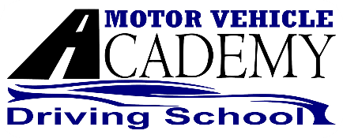

**Motor Vehicle Academy, LLC**

PARETN/GUARDIAN NAME

STUDENT NAME

I _________________________________ parent or guardian of ______________________________ give permission to the employees of Motor Vehicle Academy, LLC to provide Behind –the-Wheel instruction to ______________________________ during the COVID-19 state of emergency.

STUDENT NAME

STUDENT NAME

During each lesson __________________________ will follow the PPE guidelines;

* I will wear face covering (mouth and nose covered) at all times.
* Eye protection (indirectly vented goggles) is strongly recommended.
* I will use Hand Sanitizer before and after each lesson.
* Windows will be rolled down, whenever safe to do so, to maintain fresh air circulation
* I understand that training vehicles will be cleaned and sanitized after every training session.



____________DATE



_____________DATE

1398 Cape St Claire Rd.

Annapolis, MD 21409

Phone: 443-937-5488

MotorVehicleAcademy@gmail.com

1398 Cape St Claire Rd.

Annapolis, MD 21409

Phone: 443-937-5488

MotorVehicleAcademy@gmail.com