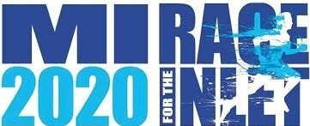

**Meredith Harrison,  
Murrells Inlet 2020 Executive Director**

Finisher’s Certificate CCertificateCertificate

successfully completed**The MI2020 Race for the Inlet**

during the week of Oct 4-10, 2020  
in ___________________________.

this is to certify that

_________________