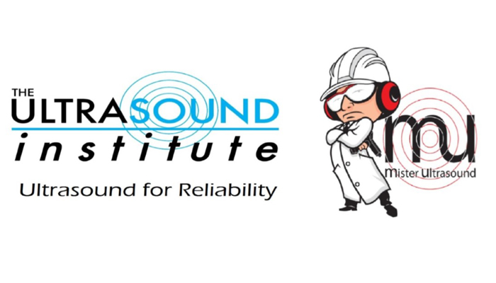
The Ultrasound Institute, LLC / 309 Woodridge Pass, Canton, GA 30114-4391 / Ph:(770) 517-8747 / fax: (678) 880-8936

jim@theultrasoundinstitute.com

24 HOUR SECURE FAX MACHINE
ONCE REGISTERED HOTEL INFORMATION WILL BE SENT TO YOU
The Ultrasound Institute Ultrasound Level I Course
TUI-Level I is $1,499.00 per attendee*
OR $1095.00 IF YOU REGISTER BEFORE JUNE 15, 2021
Location: Hilton HOME 2 Suites, Cartersville, GA
Date of Class: AUGUST 10, 11 & 12, 2021 City: CARTERSVILLE State: GA

Attendee No.1:________________________________ Title:________________________
Company:___________________________________ Workshop or Level I or Level II (circle one)
Address:__________________________________________________________________
City: ___________________________ State:_____________ Zip Code:_______________
Phone: _____________________Fax:_________________________

Email: ________________________________________________

Attendee No.2:________________________________ Workshop or Level I or Level II (circle one)
Email:________________________________________________ Ph: 1 ( ) _______________________
IF PAYING BY CREDIT CARD, FAX THIS REGISTRATION TO ME ON MY SECURE MACHINE
(Credit Card Payments Due 14 days in Advance, Must Cancel One Week in Advance, If not, a Credit Only Will be Given)

Name on Credit Card:___________________________________________________________

Card No:________________________________Exp:_______ / _______ CCID: _______
(name as it appears on card) (3/4 digit security code)
The Ultrasound Institute, LLC (678) 880-8936 24 Hour Secure Fax
Or, Call To Register by Phone: (770) 517-8747 (7-10pm EST, M-F)
(All Major Credit Cards Accepted) (Visit our website for the Remainder of the Dates)

Jim@TheUltrasoundInstitute.com

Or… “ON-YOUR-SITE” TRAINING IS AVAILABLE, CALL FOR A QUOTE TODAY!

