From: visualartleagueoflewisville+yahoo .com@ccsend.com ,
To:
Subject: VAL Artist Notes - May 2021
Date: Fri, May 7, 2021 7:01 am

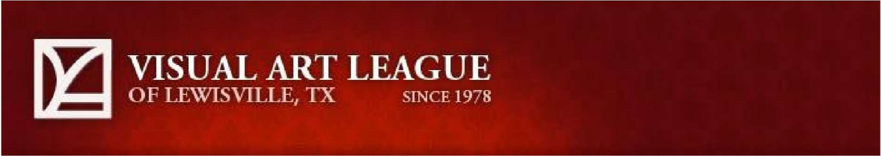

Member News & Notes

To have your event included in "Member News" please email the information
to VALMemberNews@gmail.com no later than the 25th of the month before your event. In the subject line, state "Newsletter ." If you would like to alert members of an event before the newsletter comes out, such as a reception, please put "Email Blast" in the subject line. Thank you!

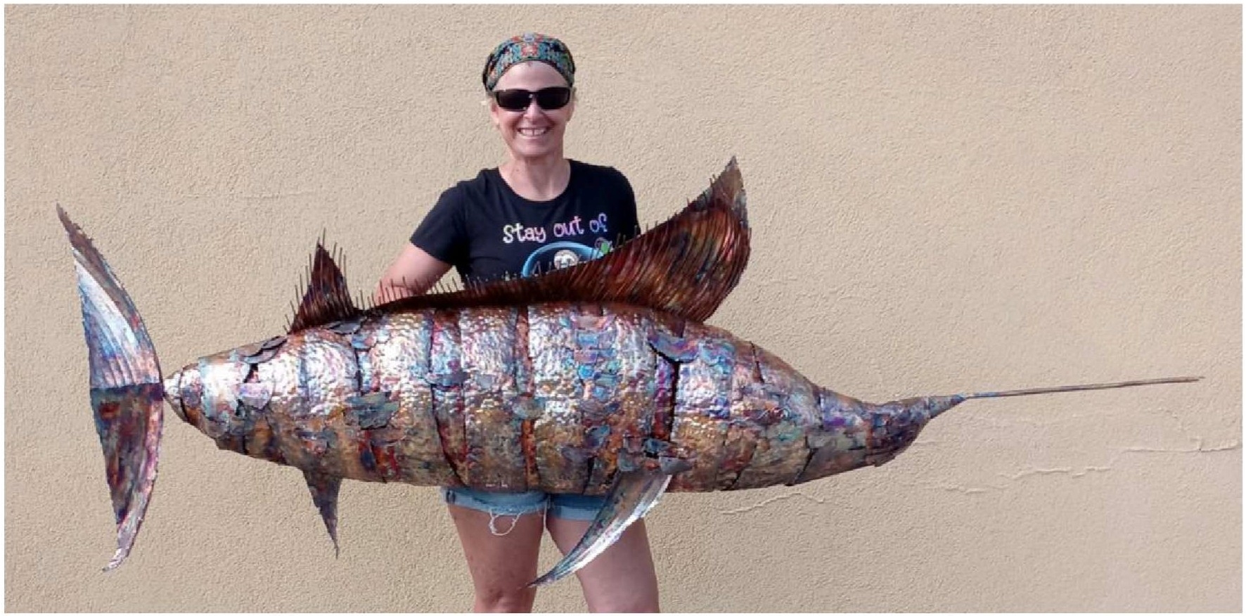

Kathleen Mekailek
Kathleen's sculpture "The One That Got Away" has been accepted into the Art Center of Corpus Christi for the Go Big Exhibit. Opens Saturday, May 8.

Chuck Hendrickson
Chuck has had two watercolor paintings accepted into the RCAS (Richardson Civil Arts Society) 2021 Regional Show. The paintings are titled "Goin' On A 'Venture" and "Eye Spy." This is an online show that is available in RCAS's website starting May 1.

Dulce Ruque
Dulce recently participated in a Bluebonnet Arts & Craft - Women in Arts panel discussion.

David Blow
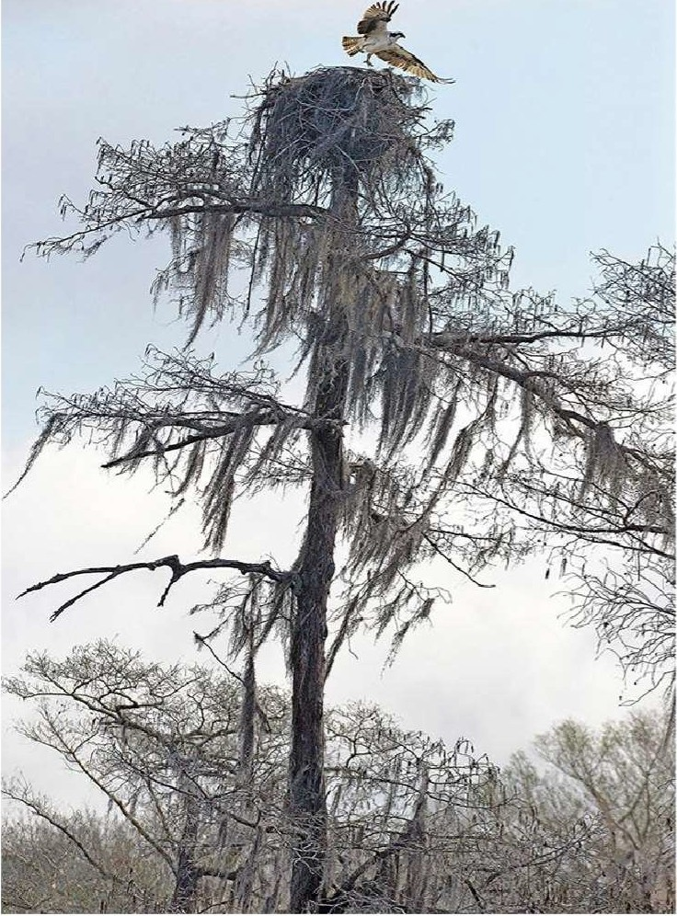David's "Osprey Nest" won Best of Show in the Call Of The Wild (International) SCORE (Southern California Open Regional Exhibitions). Exhibit is May 1-31, 2021 . Exhibit will remain on view on the SFVACC website .
Other artwork included: Wooded Vibrations Spirit lives...

David also had his work "Comanche Country" accepted into the Richardson Civic Art Society 55th REGIONAL EXHIBITION,
which is online May 1-15.

Nancy Sterling Tyler
Nancy is one of 44 Juried artists in the 2021 Plein Air Southwest Competition this first week of May in Galveston Texas. The weeklong outdoor competition is the premier event of the Outdoor Painters Society with an exhibit of wet paintings on Saturday May 8 at the Historic 1859 Aston Villa Ballroom.

Kimberly Dietrich
Kimberly will be in an artist reception with two other artists for Artists Enclave of Denton County at Mulberry Street Cantina, 110 W Mulberry St, Denton, May 22, 4-6 p.m.

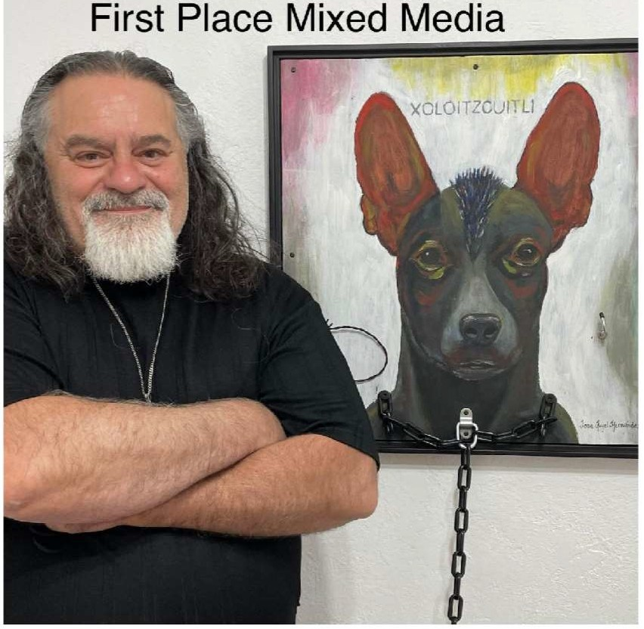Jose Angel Hernandez
Jose's artwork titled "Xoloizcuintli" won first place in the Mixed Media category at the Dallas Metro Art Contemporary Gallery, 1412 14th Street, Plano. The show theme was Animals , Minerals, and Vegetables.
The award ceremony was held on April 24.

Jose will also have a booth at the Allen Arts Festival 2021, May 7-9. The festival features juried artists, from across the country, showcasing original art in a wide range of media. Live music, dance, children's art activities , and much more all weekend .

Darla Bostick
Just found out I was accepted by juror , Judy Crowe to the Richardson Civic Art Society Juried Regional with my mixed media collage, "Two Inch Orbit." There is a gresentation

online.

Darla's June Ghost Ranch art workshop/retreat is postponed to next year, but the Sept./Oct. UNconditional Watercolor program is now accepting registrations. Details are on her website www.darlabostick.com .

On May 8, from 11 a.m. to 1 p.m., Darla will be working outdoors at an Artist Pop Up in Wayne Ferguson Plaza in Lewisville. She will have art to share and sell. Come visit and watch her sketch plein-aire across from the Lewisville City Hall at 151 W Church Street. This is a program made available by VAL.

Jerry McKay
Jerry had the image "The Storyteller" recently published in Living the Photo Artistic Life Magazine (page 29). The magazine promotes photography based digital art.

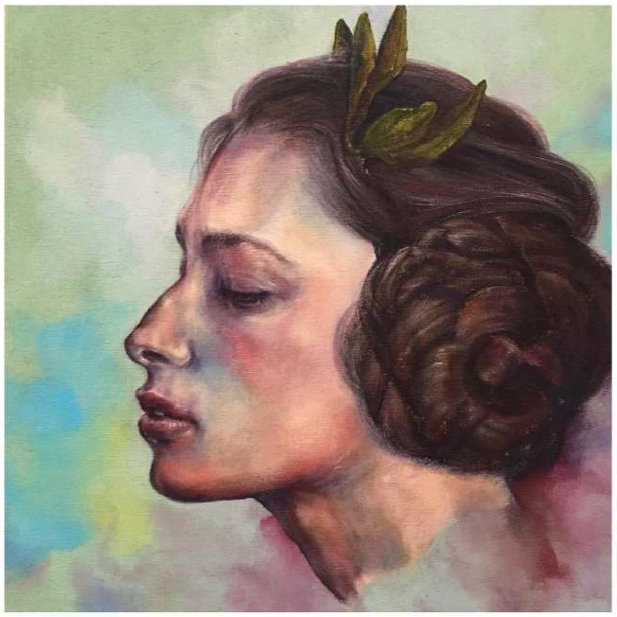Adam Lancaster
One of my paintings ( Cassandra, 20x20 , Acrylic on Canvas) has been invited to participate in Richardson Civic Arts Center 55th Annual Regional Juried Exhibition, May 1 - 25.

Tina Alvarez
Her photograph, "Say What" was accepted into the Irving TX & Neighbors Art Show. Show is at the Irving Arts Center May 15 - June 12.

Tina also received a second place award at the Richardson Civic Art Society Spring Show for her photograph "Rebirth." This was a Virtual Show and is online at the RCA website.

She received a third place at the Art House (in Highland Village) "Off Center" show with her photograph "Gentle Giant." Art exhibited at the Art House April 10 - May 22

Her photograph "Ascension" was accepted into the 55th Annual Regional Juried Art Exhibition sponsored by the Richardson Civic Civic Art Society. This a Virtual Show and entries will be on RCA's website May 1-15.

Lorraine Hayes - Moving Sale (Art Supplies & Equipment)
Neil and I have decided to move to a senior living complex. I am giving my art friends first choice on what I have and anything that remains will go into an estate sale. I am selling all my art supplies and art equipment at bargain prices. Please give me a call or send me an email and we can get together here at my studio.
Prices are negotiable and everything is cut rate. I have LOTS OF STUFF!!

972-742-7155

Lorraine Hayes 750 Greenway Ct.
Highland Village , TX 75077

Jjhayes750@gmail.com
oe

Follow us on Facebook & lnstagram!

Corporate Sponsors

The Visual Art League of Lewisville would like to thank our sponsors for their generous support:
BLI CK.art materia ls 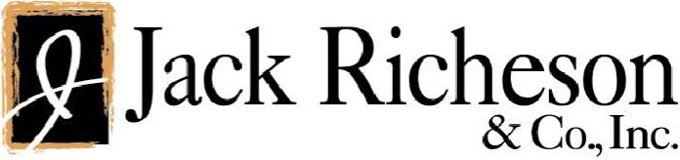

www.dickblick.com

Visual Art League of Lewisville I MCL Grand Theater, 100 N. Charles St., Lewisville, TX 75029-9002 Unsu bscribe rugue@verizon.net
Constant Contact Data Notice
Sent by visualartleagueoflewisville@yahoo.com powered by

& Constant
Contact
Try email marketing for free today!

