From: visualartleagueoflewisville+yahoo .com@ccsend.com, To:,
Subject: VAL May 2021 Member Newsletter Date: Thu, May 6, 2021 7:02 am

(gi VIEWPOINTS MAY 2021
NEWSLETTER

Letter from VAL's President

Hello VAL members!
It's already time to start planning for 2022! As the pandemic slowly eases we should begin to see more opportunities for in person meetings, so I am hopeful that we can get committee meetings going soon. I am currently putting together committee member lists according to interests checked on membership applications, responses to my letter in January and what members have done in the past. The goal is to get 2022 planned out before October. Being on a committee means you will have first-hand knowledge of what's happening and be able to voice your ideas. We are an organization of creative people; let's take advantage of that!

The committees currently forming are: Exhibitions Committee , Member Meetings Committee, Workshops Committee and Promotions/Communicat ions Committee. If you have been assigned to a committee, you will receive an email letting you know. Then
watch for an email regarding a meeting. It's entirely possible to plan out 2022 with no more than two meetings per committee! If you have questions or concerns, please feel free to email me at dmwright75028@gmail.com .

Viva la VAL! Diane Wright, President

VAL Members' Monthly Meeting

April Meeting
Palette Knife Paining
Christina Sanders
Tuesday, May 11 • 6:45-9 p.m.

Christine Sanders is Executive Director of Greater Denton Arts Council. Christine has a degree from UNT in Visual Arts and taught middle and high school art for 15 years as well as years of
teaching workshops on numerous topics in art.

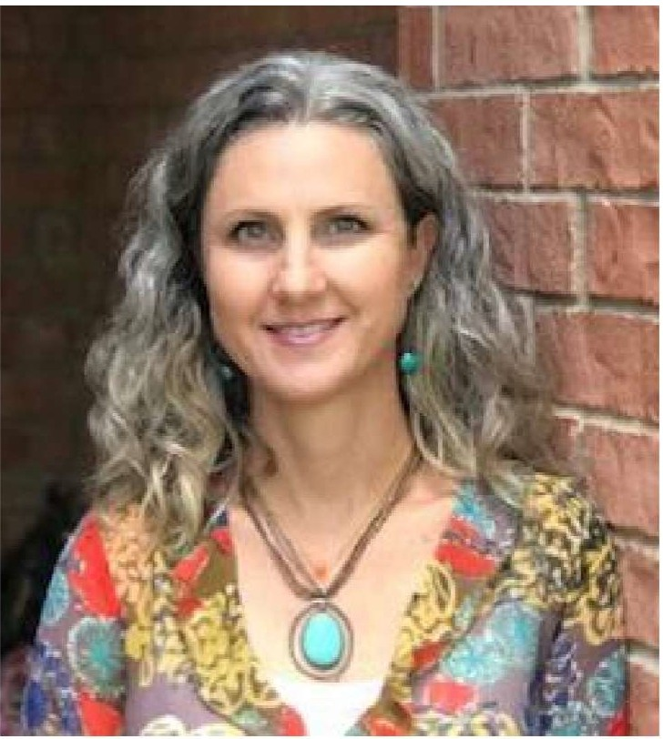Click here to join the meeting at May 11, 6:45 p.m.

Meeting ID: 853 1967 9531
Passcode: 435682

Note: Last month we had unwelcome visitors to our Zoom meeting. This month, all attendees will be in a waiting room until the host lets you in. This is why the meeting will start at 6:45 p.m. instead of 7 p.m. to allow time to admit everyone in before any unauthorised guests. Please join before 6:55pm, so the host knows you are not a "Zoom crasher." After 7pm, if the host thinks an attendee is a not a serious attendee, they will not be
admitted.

Fresh Ideas 2021

The Visual Arts League of Lewisville proudly announces our premiere, annual art show, Fresh Ideas 2021. Artwork juried into the exhibit will be showcased in the beautiful Lewisville Grand Gallery Saturday, July 17 through Saturday, August 14.
Every year we are amazed as the level of talented artists and are excited to announce the juro r for Fresh Ideas 2021 , John Cook . He is a world renown painter, water colorist, and teacher who "see's beauty in God's creation, and strives to capture a glimpse of that perfection in paint."
Artists can sign up through the CaFE entry website www.callforentry.org . starting in April. Please read the prospectus as there are a few changes .

Awards for this years show include:
First Place - $ 1000 and a Solo Art Show in Summer of 2022 Second Place - $500
Third Place - $250
Four Honorable Mentions - $ 100 People's Choice - $ 100

VAL Notes

Nominations are Open for VAL Officers
Officer elections will be held at the September Members Meeting. If you'd like to put your name in for an officer position or would like to nominate someone else, send an email with name and officer position to visualartleague@outlook.com . Officer positions: President, 1st Vice President, 2nd Vice President, Secretary, Treasurer . Questions?

email dmwright75028@gmail.com .

Updated Bylaws
The VAL Board of Directors and Officers approved an updated version of the VAL bylaws. Anyone interested can download this latest version at visualartleague.org .

Please Note
Personal communication information (email addresses, phone numbers) available on the VAL membership list is to be used for VAL and art related purposes , and must not be used to promote political or religious agendas , or for advertising purposes.

United We Stand - Hallway Show

As visual artists, creating art is what we do. No matter what style or theme you prefer: the canvas, your composition , and your chosen colors is your artistic voice. "United We Stand" is an art call to express what you stand for in unity with others. As the curator of this show, I invite you to a collaborative exhibition creating a work of art depicting ways we stand united. My name is Jose Angel Hernandez, and my email
is contactjoseangel@gmail.com . Let's get our hands painted. Prospectus can be found on VAL's website .

VAL @ Flower Mound Festival

Flower Mound Art in the Park Festival
May 8, 10 a.m. - 5 p.m. • Heritage Park, 600 Spinks Rd., Flower Mound
Join us for a day of celebrating the arts at our inaugural Art in the Park Festival with over 45 local artists exhibiting and selling their work! There will be musical and dance performances , including The Bobby Falk Group, Sacred Ground Dance, Bach to Rock, traditional Indian dancers , and headlining act, Vocal Trash. There will also be a community mural painted onsite at the event as well as other hands on activities to create some of your own unique artwork. Additionally , there will be a caricature artist , a henna artist, food trucks , a "find Bob Ross" scavenger hunt, a kidz art zone, and much more!

VAL will have an informational booth at the event as well as artist trading cards activity booth.

Chalk This Way Scholarship Winners

Congratulations to the winners of of the 2021 Chalk This Way Scholarship contest!
1st Place: Campbell Tippett , Flower Mound HS - Sunflower Mother
2nd Place: Jacalyn Olson, The Colony HS - Leaning Tree
3rd Place: Kenneth Pham, The Colony HS - Exhale
Honorable Mention: Corbin Kostal, The Colony HS - Peaceful Kai Pond
Thank you to all who participated in a wonderfully successful festival and a special thanks to our Visual Art League Judges David Mask and Diane Wright and our guest judge , Wilma Barclay (Christi's mom)!

March 2021 Artists of the Month

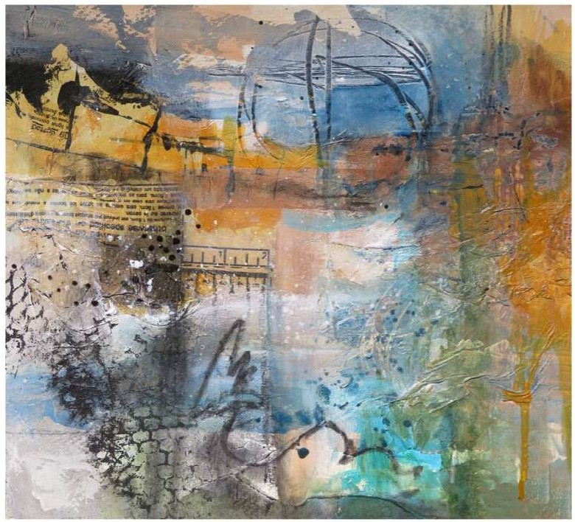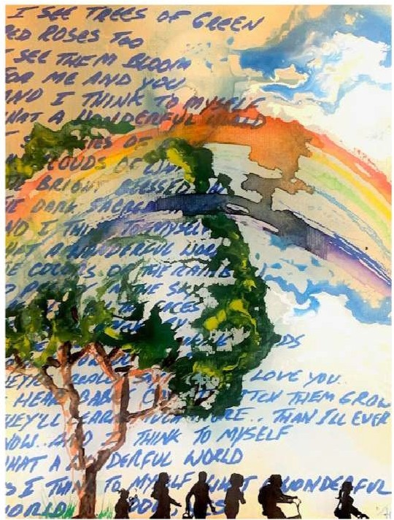

First Place "Two Inch Orbit" Darla Bostick
Second Place "What a Wonderful World" Christine "Tiny" Irizarry

Artist Pop-Ups

VAL is setting up a series of "Artist Pop-Ups" this Spring in conjunction with the Grand Theater. The plan is to have these from 11am to 1pm on Saturdays: May 8 and May 15, weather permitting.

It involves having an artist "pop up" in Wayne Ferguson Plaza (across the street from the theater) and create art for about two hours. The City is offering a $50 honorarium to
the artist for each event. The type of art is open: painting, clay, collage, sketching , stamping/printing, ATCs, woodcarving, acoustic instrument, etc. It could also involve passerby participation if you want. Further, the artist(s) can display artwork for sale while she/he/they create art (10% commission to City applies).

Note that 7 Mile Cafe, Perk, and Wine House there are getting busy. There are a variety of sun or shade locations in the park for the artist to work .

If you're interested, please contact Chuck Hendrickson (chuckh816@gmail.com ) so he can set up the schedule.

June Workshop

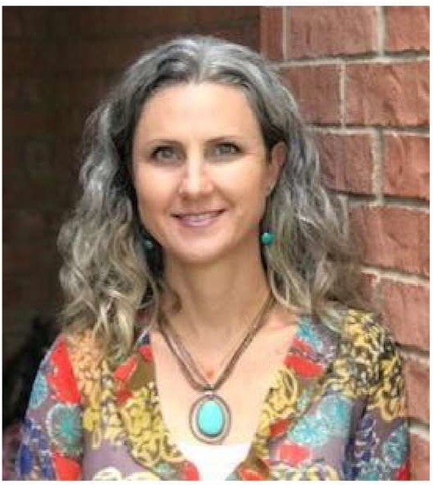Knife Painting with Acrylics
We will host a one day workshop on the topic of Palette knife painting with acrylics at MCL Grand. Our Instructor is Christine Sanders who is Executive Director of Greater Denton Arts Council. Christine has a degree from UNT in Visual Arts and taught middle and high school art for 15 years as well as years of teaching workshops on numerous topics in art. During the workshop, participants will complete a canvas.

Supplies you will need to bring:
- Pallet knives: one angled straight edge, one round or
a spoon, one oval and one triangular. Plastic or metal is fine, but the metal is easier to clean and bends without breaking.
- Acrylic Paint: minimum of three colors, with black and white . Suggested yellow oxide or ochre crimson or magenta, your choice of blue.
- A sketchbook or 5 loose unlined pieces of paper min. 8"x11"
- A primed canves no larger then 18"x24"
- 3 photos to choose from as refernces. Suggested a landscape, flower, single animal or architectural image.

Workshop will be June 14, 10 a.m. to 4 p.m. Cost is $100 for members and $125 for non­ members. Due to the restrictions of Covid and spacing, we will only have eight students in the classroom unless the City of Lewisville lifts restrictions. More news to come on opening of registration. For other questions contact Jackie Haugen, paid workshop chair, at waterjourney_@verizon.net.

Artist Bio: Christine is a married, mother of two, with one grandson , and a host mom to 15 international students , and counting . She loves art of all mediums, traveling , and helping others. Christine grew up in San Antonio Texas and graduated with a Visual Art Studies degree from the University of North Texas . She and her family reside in Denton Texas where she is the Education Coordinator for the Greater Denton Arts Council, and the Regional Coordinator for EF High School Exchange Year students and families.
- 15 years experience teaching art at the middle and high school level.
- 25 years experience painting murals
- 24 years experience in interior design and remodeling work.
- 20 years experience in teaching art camps and various workshops for all ages

Area Event

Visual Arts of Prosper - May Meeting
Jackie Haugen will give a presentation on beginner's watercolor. Her presentation will include a brief discussion of supplies she likes to use and the set up in her art studio. She will also be doing a live demo. More information can be found on the Visual Arts of Prosger website .
About Jackie: She is a prolific watercolor artist who challenges herself to paint nearly every day. A resident of Highland Village , TX, Jackie is an artist who experiments in a lot of different media, but loves to look at works on paper, and create with paper. Collage is one of her favorite means to give the painting life and another layer of texture. She truly enjoys commissions and working with people to help tell their story of their favorite places and memories . Her art is frequently described as energetic and imaginative.

VAL Show Schedules

2021 Show Schedules
May 4 - July 3: Artist Trading Cards - North Display Case
May 8 - June 5: Lost in a Garden - North Corridor
June 12 - July 10: Fresh Ideas 2020 Winner Barbara Oliver Hartman Solo Show - Gallery
June 12 - July 10: Common Threads - Gallery
June 12 - July 10: United We Stand - North Corridor
July 6 - Aug. 28: Artists ' Choice - North Display Case
July 17 - Aug. 14: Fresh Ideas 2021 - Annual Premier Juried Exhibition - Gallery
Aug. 31 - Oct. 30: Self Portrait - North Display Case Sept. 25 - Oct. 23: Western Round Up - North Corridor Oct. 30 - Nov. 27: Call of the Wild - Gallery
Oct. 30 - Nov. 27: Day of the Dead - North Corridor
Nov. 2 - Dec. 31: Holiday Magic - North Display Case

About VAL

The Mission of the Visual Art League of Lewisville
The Mission of the Visual Art League is to promote the visual arts through education and exhibitions for the enrichment of the individual and the community. The Visual Art League supports the visual arts by providing the facilities for instruction in wide-ranging aspects of the arts such as drawing , painting, sculpture , and fine crafts, and providing gallery space for exhibitions in a variety of media.

LEWISVILLE
Deep Roots Broad Wings Bright Future

The MCL Grand is made possible through the generous support of the Greater Lewisville Arts Council and the City of Lewisville.

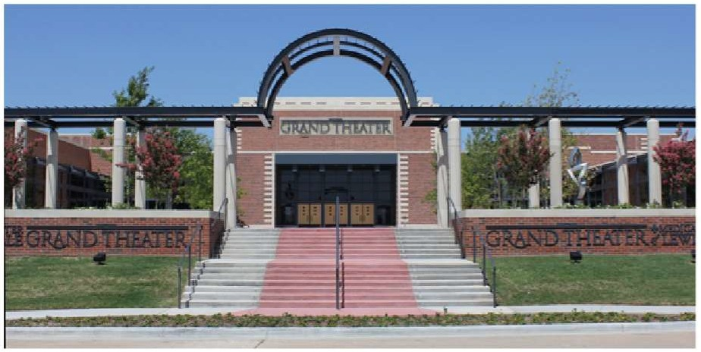MCLGrand.com Facebook.com/mclgrand Twitter.com/Lewisville Texas lnstagram.com/cityoflewisville

VAL Board

President: Diane Wright
1st Vice President: Vacant
2nd Vice President: Lisa Chittenden
Treasurer: Jerry McKay
Secretary: Christine Irizarry

Directors:
Chuck Hendrickson Dulce Ruque
Mary Carradine R'Lene Winters Paula Haynes

Important Emails You Need to Know

R'Lene Winters handles all of our press releases. Please contact her with your newsworthy items by calling 972-874-3919 or email win86f@y:ahoo.com .

To get into the rotation for the Main Street Cafe (formerly Tierney's) please contact Darla Bostick: darlabostickart@gmail.com

If you have news about your art - exhibits you're in, prizes you've won for your art or any other news you'd like to share with VAL members, email Ricky Sanders at VALMemberNews@gmail.com
Follow us on Facebook & lnstagram! oe

Corporate Sponsors

The Visual Art League of Lewisville would like to thank our sponsors for their generous support:

BLI CK.art materia ls

www.dickblick.com

Visual Art League of Lewisville I MCL Grand Theater, 100 N. Charles St., Lewisville, TX 75029-9002

Unsu bscribe rugue@verizon.net Constant Contact Data Notice
Sent by visualartleagueoflewisville@yahoo.com powered by

/; Constant
Contact
Try email marketing for free today!

