**Prospectus**

**Exhibition Theme Name**

A Visual Art League of Lewisville Member Show

Lewisville Grand Theater North Corridor

**Theme Prompt:** Insert a short description explaining the theme. Insert a short description explaining the theme. Insert a short description explaining the theme.

Insert a short description explaining the theme. Insert a short description explaining the theme. Insert a short description explaining the theme. Insert a short description explaining the theme. Insert a short description explaining the theme. Insert a short description explaining the theme.

**Curator**

Curator’s Name

**Questions:** Curator’s Email

**IMPORTANT DATES AND TIMES**

|  |  |
| --- | --- |
| **Exhibition Dates:**  *(Gallery Hours: Tues. - Sat. 10am - 5pm)* | Insert Date |
| **Submission Deadline:** | Insert Date, 11:59 p.m. |
| **Intake:** | Insert Date,Time |
| **Hanging Art:** | Insert Date |
| **Conversations with Artists: what were they thinking?** | TBD |
| **Strike:** | Insert Date, Time |



**2025 UPDATE. Maximum artwork dimensions have changed. Please review entire document before submitting artwork.**

**SPECIFICATIONS**

1. This is a VAL member-only show and only 2 works of art can be submitted. All current members must meet our guidelines to have their artwork displayed in the gallery.
2. All media accepted. (2-D and 3-D)
3. Only original art created within the last 24 months will be accepted. No digital reproductions of paintings, drawings or prints will be accepted. No AI generated work will be accepted.
4. **No installations.**
5. The building is owned by the City of Lewisville and is considered family-friendly, so no explicit nudity, confrontationally political, or disrespectful religious images allowed.
6. No collaborative artworks. All art submitted must be an original composition of an individual artist.
7. Artworks previously exhibited in a VAL exhibition are not accepted.
8. No artwork submitted may have been created in an instructional setting, including but not limited to workshops and art classes.
9. Any canvas less than 1.5 inches in depth must be framed.
10. Entries must conform to the Updated VAL Hanging Guidelines (pdf) at <https://visualartleague.org/val-documents>
11. All pieces to be hung on a wall must be properly wired for hanging with D rings and wire with ends covered to avoid injury when handling.
12. No sawtooth hangers or uni-frames allowed. **NO CLEAT** hangers.
13. Framed artwork larger than 16” x 20” must have acrylic glazing**. NO GLASS, NO EXCEPTIONS!**
14. Acrylic artworks and photography on metal cannot have sharp edges. If they do, they must be framed.
15. Place the entry tags securely to the back of your artwork in ADVANCE of intake day.
16. Artwork must be submitted during the designated intake times.
17. Any special requirements for hanging or displaying artwork must be **approved by the curator** **IN ADVANCE of submission deadline.**
18. VAL reserves the right to reject any works not meeting eligibility requirements or deemed inappropriate even after the image has been accepted.
19. **2025 UPDATE Maximum Size Accepted**: 24” x 30”. **NOT ACCEPTED**: 30” x 24”

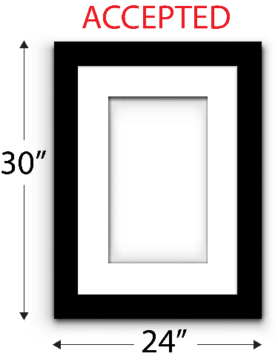 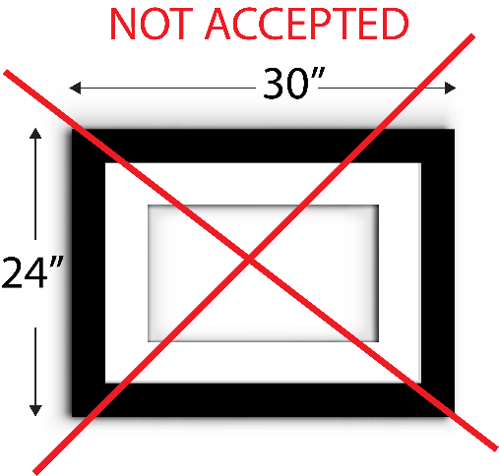

1. If your art sells during this show, it must remain at the Lewisville Grand until strike date, a 20% commission is to be paid to VAL, half of which will go to the Lewisville Grand. Download the [Commission Form](https://visualartleague.org/val-documents) from the VAL website.
2. Your art **MUST** be picked up on the strike date. If you are unable to pick up your artwork, make arrangements for a proxy to pick up on your behalf. Notify the curator in advance that arrangements have been made. **(Art not picked up at intake is subject to a daily storage fee payable to The Grand.)**
3. Artists retains all copyrights to their work but agree that the artwork on display may be photographed and reproduced in print and/or digital form solely for the purpose of promoting either the Lewisville Grand Theater or the Visual Art League of Lewisville without compensation to the exhibiting artist.
4. Works are not insured while on display. The Visual Art League of Lewisville and the Lewisville Grand Theater will take precautions to protect the artwork at all times but will not be responsible for loss or damage during installation or while on display.

**ENTRY PROCEDURES**

1. **Fee:** None. All artists must have active VAL Memberships.
2. Submissions for this exhibition should be emailed to:  
   Curator’s Email Address. Subject Line: “Insert Exhibition Name Submission”.   
   1. Your email must include the following for each entry:

* + 1. Artist’s Name
    2. Title of Work
    3. Medium
    4. Dimensions
    5. Price
    6. Description
    7. Image of each entry
    8. Cell phone number

1. The Description is **limited to 30 words**. Your statement should only be about how your artwork relates to the theme. (Count the words and spellcheck before submitting.)
2. Verified member artists may enter up to 2 pieces of art.
3. **Not a VAL Member?**Become a member on the VAL website:  [Pay Membership Fee](https://visualartleague.org/become-a-member). Complete the two-step process of paying the Membership Fee and submitting the Membership Application Form.
4. **NO WALK- IN ENTRIES ACCEPTED.**

**Image Requirements:**

* Include an image of your artwork. **Name the image file using the following format:** LastName_FirstName_TitleofWork.jpg
* 2D artwork must be photographed without frames, in focus and level. This is your chance to shine, photograph your artwork to its best advantage.
* 3D artwork should be photographed with no background distractions.
* Please limit the size of your images to 1MB or less. The images will be used for the online exhibition on the VAL website and for marketing purposes as needed.

**Contact the curator if you have questions:** Curator’s Email Address **PRINT AND ATTACH ENTRY TAGS TO THE BACK OF YOUR ARTWORK BEFORE DROPPING OFF AT INTAKE.**

**ENTRY TAG #1**

**Artist Name__________________________________________**

**Title________________________________________________**

**Medium_____________________________________________**

**Size (incl. frame) _________W x _________H**

**Price_________________**



**ENTRY TAG #2**

**Artist Name__________________________________________**

**Title________________________________________________**

**Medium_____________________________________________**

**Size (incl. frame) _________W x _________H**

**Price_________________**

**SOCIAL MEDIA & PROMOTIONS**

* Be sure to Like / Follow the Visual Art League of Lewisville on Instagram and Facebook. @visualartleagueoflewisville
* Use the following hashtags when promoting THIS exhibition:
  + #visualartleagueoflewisville
  + SOCIAL MEDIA CHAIR TO ENTER INFO HERE