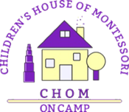

**FREQUENTLY ASKED QUESTIONS**

**What to Wear**

Comfy clothes that the child can remove independently

Play clothes that can get dirt or paint on them

Seasonably appropriate outerwear, as we go outside in all weather

**What to Bring to School**

Lunch (heated items in thermos, cold items w/icepack)

Small blanket and cuddle object for nappers

Portable crib sheet for nappers

(Bedding will go home weekly for laundering)

**What to Leave at School**

Slippers

1-2 Pictures of loved ones

Extra change of clothes (updated seasonally)

Many extras (pants, undies, socks, slippers) for those learning toilet independence

**What NOT to Bring to School**

Toys

Breakfast or Snack Food or Drink (just lunch please)

Water bottles or sippy cups

Electronics

Weapons