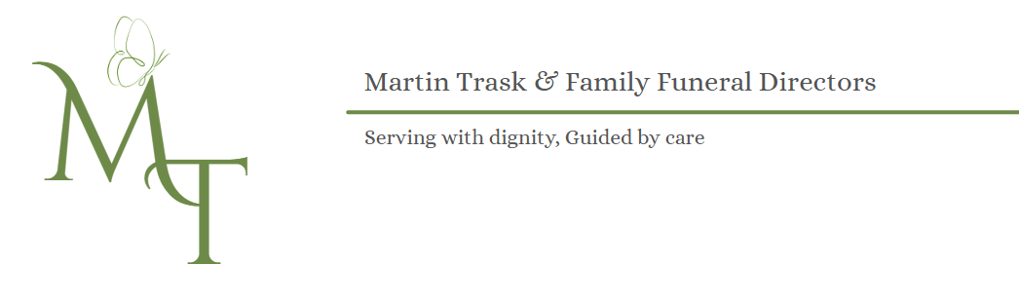
FUNERAL WISHES / FUNERAL INSTRUCTIONS

Instructions for Completion

- This form has been designed to be completed by one person
- Enter as much or as little information as you wish
- Once completed, please return the form to us, we will securely retain a photocopy and return the original to you
- Please be assured all information within this form will be held with the strictest of confidence
- Make your Executor or persons taking charge of your wishes, know where this form is stored

______________________________________________________________________________________________

Personal Details

My Full Name: _________________________________________________________________________________

My Address: _______________________________________________________________________________________________________________________________________________________________________________________________________________________________________________ Postcode:_________________________________

My Date of Birth: ____________________________________

My Next of Kin Name & Address: ________________________________________________________________________________________________________________________________________________________________________________________________________________________________________________Postcode:_________________________________

My GP Name & Address:
________________________________________________________________________________________________________________________________________________________________________________________________________________________________________________Postcode:_________________________________

My Latest Will is Located: ______________________________________________________________________________________________

My Choices / Funeral Service

Cremation:

I wish to be cremated: ☐ YES ☐ NO Family to Attend ☐ YES ☐ NO

My preferred Crematorium is: __________________________________________________________________

I would like my Ashes to be: ____________________________________________________________________________________________________________________________________________________________________________________________

Burial:

I wish to be Buried: ☐ YES ☐ NO Family to Attend ☐ YES ☐ NO

My preferred place of Burial is: __________________________________________________________________

I wish to be Buried With (name and date of death): ____________________________________________________________________________________________________________________________________________________________________________________________

Grave Details if Known / Plot Number: ____________________________________________________________________________________________________________________________________________________________________________________________

Is a Service to take place before Cremation or Burial: ☐ YES ☐ NO

Service prior to be held at: ☐ Crematorium ☐ Church ☐ Graveside ☐ Other (please specify)

____________________________________________________________________________________________________________________________________________________________________________________________

My Religion is: _________________________________________________________________________________

My preferred person(s) to officiate the service ( Vicar, Priest, Celebrant, Other):

Name:_______________________________________________________________________________________

Address: __________________________________________________________________________________________________________________________________________________________________________________________________________________________________________________________________________________________

Telephone Number:_____________________________ Email: ________________________________________

Do you wish Service Sheets to be printed for Funeral Service: ☐ YES ☐ NO

I would like the following Music / Hymns:

- ________________________________________________________________________________________
- ________________________________________________________________________________________
- ________________________________________________________________________________________
- ________________________________________________________________________________________

I would like the following readings / Poems:

- ________________________________________________________________________________________
- ________________________________________________________________________________________
- ________________________________________________________________________________________

I would like Flowers at my Funeral: ☐ Family Only ☐ Everyone ☐ No Flowers

I would like Donations to be taken for: ____________________________________________________________________________________________________________________________________________________________________________________________

I would like an Obituary placed in Newspaper: ____________________________________________________________________________________________________________________________________________________________________________________________

I would like to be dressed in: ☐ My Own Clothes ☐ Shroud ☐ Something Else

I would like people to Visit me in Chapel of Rest: ☐ YES ☐ NO

I would like any Jewellery im wearing to be: ☐ Returned to my Family ☐ Left with me
____________________________________________________________________________________________________________________________________________________________________________________________

The Coffin:
In addition to traditional veneered or Solid wood coffins, there are many other options i.e.: Bamboo, Wicker, Seagrass, Cardboard, Colourful and Personalised. Please ask Funeral Director for different options.

I would like my Coffin to be: ____________________________________________________________________________________________________________________________________________________________________________________________

I would like the following Funeral Vehicles:

☐ Traditional Hearse ☐ Limousines ☐ Horse Drawn Hearse ☐ Something Else

__________________________________________________________________________________________________________________________________________________________________________________________________________________________________________________________________________________________

