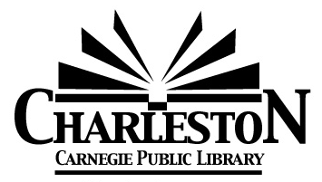

**Charleston Library Board Agenda**

**Monday, Sept. 8, 2025—6:30 pm**

**A Summer Read Presentation will precede the Library Board Meeting at 5:30 pm**

1. **Call to Order** at 6:43 pm
2. **Roll Call**

Burnham_X__ Chiritescu_O__CuddyX___Curry_X__Doughty_O__Ferguson_X__Looby__X_Olsen_X__Viertel_O__

1. **Public Comment**
2. **Board President’s Comments**
3. **Omnibus Agenda**
4. Acceptance of the August 4, 2025 Meeting Minutes
5. Acceptance of the Director’s Report
6. Acceptance of Statistics Report
7. Acceptance of Grant & Donation Report
8. Acceptance of Financial Reports—provided at the meeting
9. Approval of the bills payable—provided at the meeting

Motion to approve:_BC__ Seconded_DC___

BurnhamY___Chiritescu__0_Cuddy_Y__Curry_Y__Doughty0___Ferguson_Y__Looby__Y_Olsen_Y__Viertel_0

1. **Discussion Items**
2. UBI Landscaping Updates

Brandalyn Curry said that she, John Curry, and Kattie Livingston met on 9/2/2025 to discuss Phases I and II of this project. Plantings will be intentionally and thoughtfully chosen, and at later stages it is hoped that the public, especially children/students, can be involved with planting.

1. Illinois Public Library Standards Review

CCPL Director Chris says that ILA has redone the Standards, which are now in table form (instead of chapters). The Board discussed tables that were included in the Sept. packets, and will continue these discussions in subsequent months.