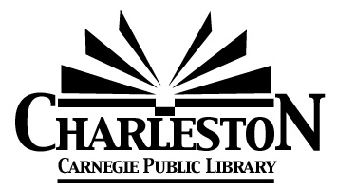
Charleston Library Board
Monday, May 4, 2026

- Call to Order
6:30pm
- Roll call
Burnham_A__ Chiritescu_P__ Cuddy_P__ Curry_P__ Ferguson_P__ Looby_P__ Viertel_A__

Joshua Craig was also present.

- Public Comment

- Board President’s Comments

- Omnibus Agenda
- Acceptance of the April 6, 2026 Meeting Minutes
- Acceptance of Director’s Report
- Acceptance of Statistics Report
- Acceptance of Financial Reports- provided at the meeting
- Approval of the bills payable- provided at the meeting
Motion to approve: _DC___ Seconded: _BC___
Burnham___ Chiritescu_Y__ Cuddy_Y__ Curry_Y__ Ferguson_Y__ Looby_Y__ Viertel_Y__
Chris ran a Library table at Carl Sandburg Art & Reading Night. The problem with the leak in the lobby vestibule is ongoing. DHM was able to repair the part on the RTU, and it is now functioning properly. The Butterfly Bench was installed on the brick patio, and NAC Equipment has been planting the UBI plants along the north side of the building. The work in the parking lot for the EV chargers continues. Chris submitted the IL State Library Security Grant application. The Library received $2,319 in replacement taxes. There was an issue with IL Funds, in which they mistakenly began putting a school district’s funds into our account. Chris worked with Mike White, City Comptroller, to coordinate with IL Funds and transfer the funds back to the correct account.

- Discussion Items:
- Literature & Libations
There were 90 in attendance. Total revenue was $10,352. We are still waiting on the liquor invoice to know the true net amount. Chris estimates it around $7,000. This was a great event, and next year’s event will be on Saturday, April 17, 2027. Chris has already secured Sarah Bush Lincoln as a First Edition sponsor.

- Library Board Recruitment
- Next Board Meeting – Monday, June 1, 2026 at 6:30PM.
- Agenda Building
- Other?

- Adjournment
7:11pm

