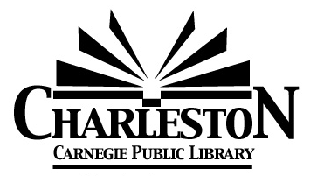
Charleston Library Board Agenda
Monday, January 12, 2026 – 6:30 pm

- Call to Order
- Roll call
Burnham___ Chiritescu___ Cuddy___ Curry___ Ferguson___ Looby___ Olsen___ Viertel___

- Public Comment

- Board President’s Comments

- Omnibus Agenda
- Acceptance of the December 8, 2025 Meeting Minutes
- Acceptance of Director’s Report
- Acceptance of Statistics Report
- Acceptance of Grant & Donation Report
- Acceptance of Financial Reports- provided at the meeting
- Approval of the bills payable- provided at the meeting
Motion to approve: ____ Seconded: ____
Burnham___ Chiritescu___ Cuddy___ Curry___ Ferguson___ Looby___ Olsen___ Viertel___

- Discussion Items
- Literature & Libations – April 25, 2026 (We need to discuss possibly changing the date.)
- Fiscal Year 2027 (A reminder to turn in budget binders for me to update.)
- Library Board Recruitment (I have not yet reached out to the contact Andreea provided.)
- Next Board Meeting – Monday, February 2, 2026 at 6:30PM.
- Agenda Building
- Other?

- Adjournment

