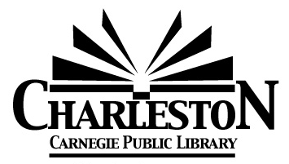

**Charleston Library Board Agenda**

**Monday, October 6, 2025** – **6:30 pm**

1. **Call to Order**
2. **Roll call**

Burnham___ Chiritescu___ Cuddy___ Curry___ Doughty___ Ferguson___ Looby___ Olsen___ Viertel___

1. **Public Comment**
2. **Board President’s Comments**
3. **Omnibus Agenda**
4. Acceptance of the September 8, 2025 Meeting Minutes
5. Acceptance of Director’s Report
6. Acceptance of Statistics Report
7. Acceptance of Grant & Donation Report
8. Acceptance of Financial Reports- provided at the meeting
9. Approval of the bills payable- provided at the meeting

Motion to approve: ____ Seconded: ____

Burnham___ Chiritescu___ Cuddy___ Curry___ Doughty___ Ferguson___ Looby___ Olsen___ Viertel___

1. **Action Item: 2025-10:** Vote to authorize the Library Director to coordinate with City of Charleston Officials in the preparation of a land donation to the City of Charleston for the purpose of Electric Vehicle Charging Stations.

Motion to approve: ____ Seconded: ____

Burnham___ Chiritescu___ Cuddy___ Curry___ Doughty___ Ferguson___ Looby___ Olsen___ Viertel___

1. **Discussion Items**
2. Collection Survey Results
3. Literature & Libations – April 25, 2026
4. Illinois Public Library Standards Review
5. Next Board Meeting – Monday, November 3, 2025 at 6:30PM.
6. Agenda Building
7. Other?
8. Adjournment