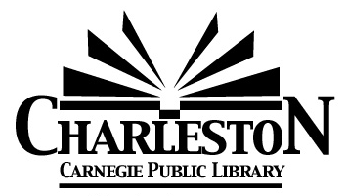
Charleston Library Board Minutes
Monday, January 12, 2026

- Call to Order at 6:30 p.m.
- Roll call
Burnham_A__ Chiritescu_P__ Cuddy P_ Curry_P__ Ferguson P___ Looby_ P_ Olsen_P__ Viertel_P__
(A = Absent; P = Present)

- Public Comment

- Board President’s Comments

- Omnibus Agenda
- Acceptance of the December 8, 2025 Meeting Minutes
- Acceptance of Director’s Report
- Acceptance of Statistics Report
- Acceptance of Grant & Donation Report
- Acceptance of Financial Reports- provided at the meeting
- Approval of the bills payable- provided at the meeting
Motion to approve: _BC___ Seconded: _BF___
Burnham_A__ Chiritescu_Y__ Cuddy_Y__ Curry_Y__ Ferguson_Y__ Looby_Y__ Olsen_Y__ Viertel__Y_
(A = Absent; Y = Yes)
Library Director Chris stated that the Janitor position is open and posted.
He also shared with the Board some highlights from his 20- minute presentation he shared at the annual City Retreat.
The library will have its full audit report by February.

- Discussion Items
- Literature & Libations – April 25, 2026
This year, The Charleston Chamber of Commerce Dinner is being held on the same date as Lit & Libations. Board members discussed the feasibility of switching the date of L& L to the previous weekend, or keeping the date as is (4/25). We agreed to keep the original date for L & L, and, in future, perhaps communicate with the Chamber early to avoid both events occurring on the same date.
- Fiscal Year 2027
Chris collected budget binders in order to update them.
- Library Board Recruitment
- Next Board Meeting – Monday, February 2, 2026 at 6:30PM.
- Agenda Building
- Other?

- Adjournment

