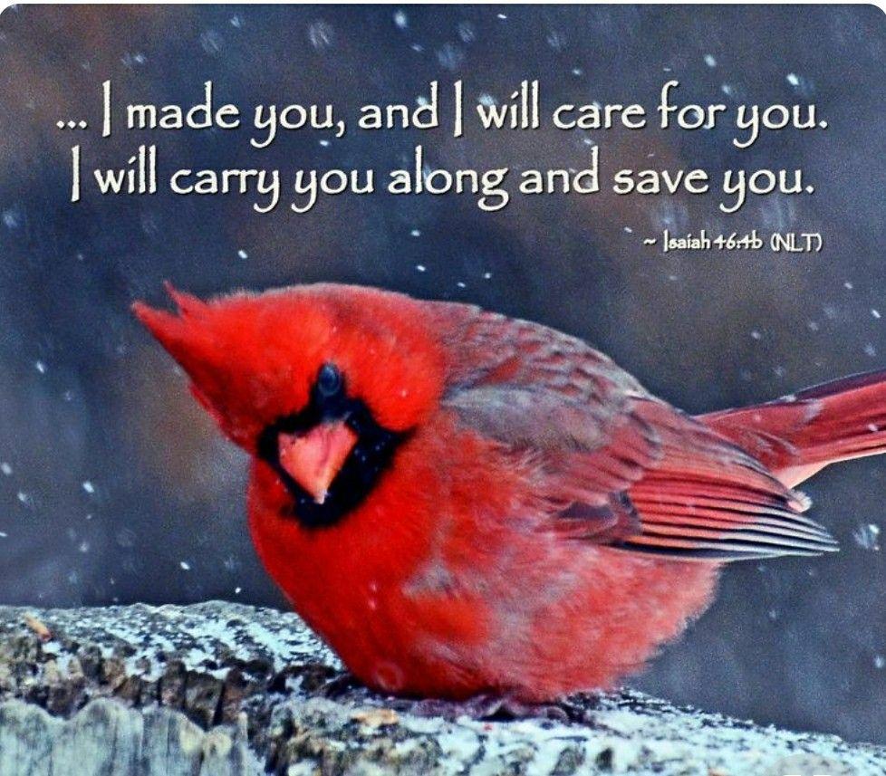

March 12, 2023

THIRD SUNDAY IN LENT

**FIRST CONGREGATIONAL UNITED CHURCH OF CHRIST**

**An Open and Affirming Church**

Church and Algiers Streets

PO Box 48

Murphys, CA 95247

209-728-3141

email: nugget@fccmurph.org

[www.fccmurph.org](http://www.fccmurph.org)

Third SUNDAY IN LENT

RINGING THE CHURCH BELL

WELCOME & TEACHING MOMENT

PRELUDE *Andante Tranquillo* F. Mendelssohn

ENTRANCE OF LIGHT

*CALL TO WORSHIP (responsively)

One: We gather with the disciples and the enthusiastic crowds.

**ALL: God fills us with thankfulness for Jesus; skilled healer, wise teacher, close friend.**

One: The highway to Jerusalem stretches ahead of us.

**ALL: God gives us courage to walk the challenging Lenten Way with Jesus.**

One: At the end of the journey there is a hill and a cross.

**ALL: God calls on us to wonder what love will do and to respond in practical ways. We will worship with our hearts open!**

*OPENING PRAYER (unison) based on Matthew 6:25

**ALL: God, we come bringing our worries and troubles to you. Remind us today that you walk beside us on the journey, you hold us and give us strength. Open our hearts so we will see you clearly on this path. Amen.**

*GATHERING HYMN  *We Gather Here* D. Hollinger

One: We gather here;

**ALL: We gather here;**

One: in the stillness of this hour;

**ALL: in the stillness of this hour.**

One: We gather here;

**ALL: We gather here;**

One: to walk the inward way;

**ALL: to walk the inward way:**

One: Come meet our Savior here.

**ALL: Come meet our Savior here.**

CALL TO CONFESSION

PRAYER OF CONFESSION

**ALL: Loving God, we are often silent in our sins, forgetting to be thankful, making our lives too busy for you and others, and hoarding our money, forgive us and hear our cries. Amen.**

SILENCE FOR PERSONAL REFLECTION

ASSURANCE OF GOD’s GRACE

*HYMN OF RESPONSE *O God Our Help verse 6 #25*

***O God our help in ages past, our hope for years to come.***

***Still be our God while troubles last, and our eternal home!***

**\***PASSING OF CHRIST’S PEACE

**The Peace of Christ be with you all.**

**And also with you.**

FAMILY TIME (children and families of all ages are invited to come to the altar area with Pastor Bonnie)

SCRIPTURE Psalm 15 OT, p.469, pew Bible

ANTHEM *Seek Ye First* arr. D Wagner

Choir

SCRIPTURE Matthew 6:25-34 NT, p.6, pew Bible

SERMON *Letting Go of Worries* Pastor Bonnie

*HYMN *Do Not Worry*

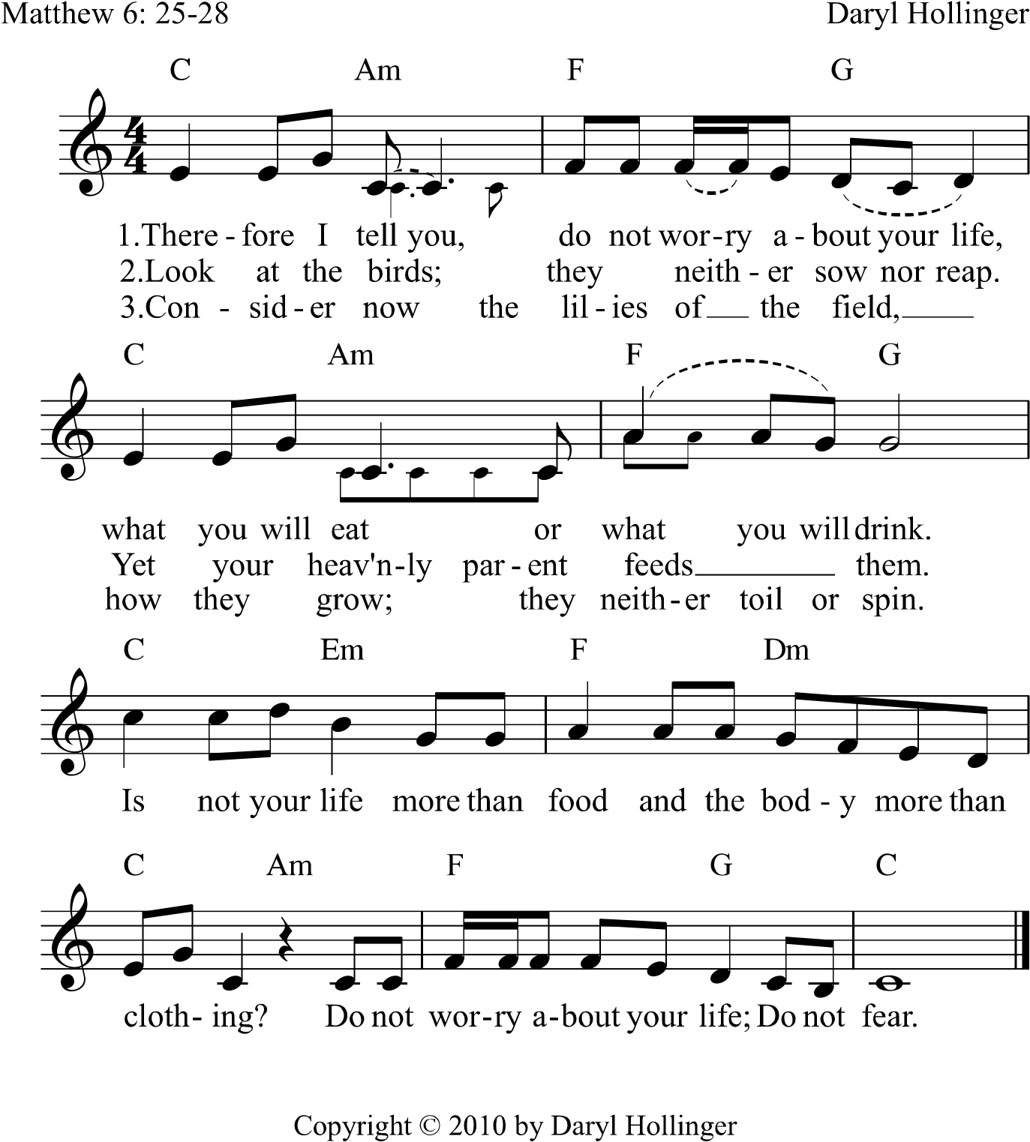

PRAYERS OF THE PEOPLE & THE LORD’S PRAYER

*Our Father, who art in heaven, hallowed be thy Name.*

*Thy Kingdom come. Thy will be done on earth as it is*

*in heaven. Give us this day our daily bread. And forgive us our trespasses as we forgive those who trespass against us. Let us not fall into temptation but deliver us from evil. For thine is the kingdom, and the power, and the glory, for ever and ever. Amen.*

ONE GREAT HOUR OF SHARINGHelen Yost

CALL TO THE OFFERING

OFFERTORY *Nobody Knows the Trouble I’ve Seen* arr. Larry Shackley

*OFFERING RESPONSE #539 (verse 2)

*We are pilgrims on a journey,*

*We are travelers on the road;*

*We are here to help each other*

*Go the mile and bear the load.*

*PRAYER OF DEDICATION (unison)

**ALL: Loving God, take these gifts and use them to heal the wounded and comfort those who are sad. Take our lives and give us boldness to proclaim your love to those we meet. Hold us and lead us to those who are weary that we may walk with them on this journey. In the name of Jesus who walks beside us. Amen.**

*HYMN *I’ve Got Peace Like a River* #478

BENEDICTION

*BENEDICTION SONG Music by Imogene Whipple

***May the Lord, Mighty God, Bless and Keep you forever;***

***Grant you peace, perfect peace, Courage in every endeavor.***

***Lift up your eyes and see God’s face, And God’s***

***grace forever;***

***May the Lord, Mighty God, Bless and Keep you forever.***

DISMISSAL:

One: Go in peace serving others.

**ALL: We go forth in joy!**

🙛🙙

Pastor: Rev. Dr. Bonnie Hollinger

Pastor Emeritus: Rev. Dr. John Randlett

Music Director: Dr. Daryl Hollinger

Liturgist: Sanders LaMont

Ushers: Karl Graves and Crew

Audio/Visual: Shad Sundberg

Sunday School: Tanya Sundberg

Childcare: Shayanna DuCharme

🙛🙙

**PRAYERS:**

Please continue to pray for Hilary Oldenkamp. She is home from the hospital but continues to face health challenges.

**ANNOUNCEMENTS:**

**Today:** Retirement celebration for Rev. Liz Armstrong at Union UCC in Angels Camp at 11:30 am.

**Today at 5 p.m**. Zoom congregational Meeting to vote on Merger with Union UCC

**Tuesday, March 14 at 5:30 p.m. Lenten Soup Supper**

Pastor Bonnie and Dr. Daryl are on vacation March 14 through March 20.

**March 18**: Irish Day Pancake Breakfast 8:30 – 10:30am

**

