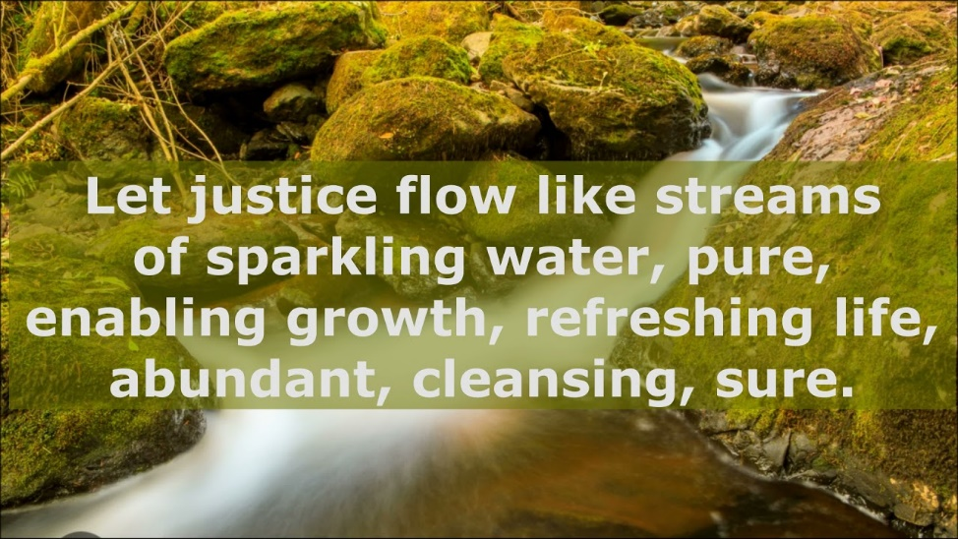

September 25, 2022

FIRST CONGREGATIONAL UNITED CHURCH OF CHRIST
An Open and Affirming Church

Church and Algiers Streets
PO Box 48
Murphys, CA 95247
209-728-3141
email: nugget@fccmurph.org
www.fccmurph.org

Sixteenth SUNDAY after pentecost

* Indicates congregation may stand.

RINGING THE CHURCH BELL

WELCOME

PRELUDE Ode to Joy; Russian Folk Song; Allegro
Organ Duet: Stella Sundberg & Daryl Hollinger

Silence …the prelude is the time when we turn our thoughts to God. Let us use the music to guide us and allow the Holy Spirit to clear our minds so we are open to hear God speaking to us.

ENTRANCE OF LIGHT

*CALL TO WORSHIP (responsively)
One: The word has come for us from God:
ALL: who promises to shelter us under the wings of hope and grace.
One: The word has come to us from Jesus:
ALL: who encourages us to remember the good news we have received.
One: The word flows to us from the Spirit:
ALL: who reminds us to place our hope and trust in God.
*OPENING PRAYER (based on Pslam 91)
ALL: Cherishing and Reassuring God, we come to worship and thank you for your goodness to us as individuals, and as a community of faith.
Each of us, at various times, have gratefully found shelter under God’s wings. May we continue to seek security in YOU our loving God and experiences that are of profound peace and sanctuary, Amen.
*GATHERING HYMN This Is the Day #84
Verse 1 & 3

PRAYER OF AWARENESS
ALL: Teaching God, When the world silences our hope, you give us the words to make the good confession of faith.
When we have lost our way and can no longer endure the emptiness of our lives, you satisfy us from the abundance of God's grace and joy.
Sheltering Spirit, we seek your peace. Guide us this day, Amen.
SILENCE FOR PERSONAL REFLECTION
ASSURANCE OF GOD’S GRACE
*SONG OF RESPONSE Glory, Glory, Hallelujah

- Glory, glory hallelujah, since I laid my burdens down. (repeat)
- I feel better, so much better, since I laid my burdens down. (repeat)
- Feel like shouting “Hallelujah, since I laid my burdens down. (repeat)
PASSING OF CHRIST’S PEACE

The Peace of Christ be with you all.
And also with you.

FAMILY TIME

SCRIPTURE Psalm 91:1-6,14-16
ANTHEM What Does the Lord Require? Jim Strathdee
Pick-up choir
SCRIPTURE Luke 16:19-31
SERMON Where is the Redemption in the Lazarus Story? Pastor Bonnie

*HYMN O For a World #575

PRAYERS OF THE PEOPLE

THE LORD’S PRAYER

Our Holy Parent, who is in heaven, hallowed be thy Name.
Thy Kingdom come. Thy will be done on earth as it
is in heaven. Give us this day our daily bread. And
forgive us our debts, as we forgive our debtors. And do not let us fall into temptation, but deliver us from evil. For thine is the kingdom, and the power, and the glory, for ever and ever. Amen.

NEIGHBORS IN NEED Connie Cook
CALL TO THE OFFERING
OFFERTORY Make me a Channel of Your Peace arr. Jane Holstein
(Prayer of St. Francis)

OFFERING RESPONSE Thank You, We Thank You God
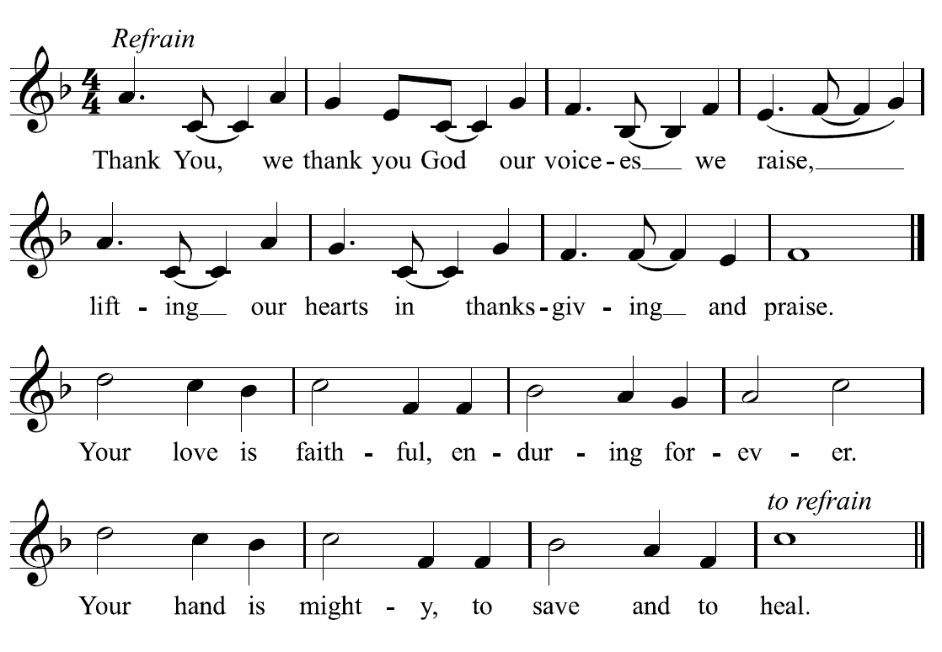
Copyright ©2018 Hope Publishing. All rights reserved. Reprinted under Onelincese.net #A725100

*PRAYER OF DEDICATION (unison)
ALL: Faithful God, when we are tempted by wealth, you point us to those who have nothing but share everything.
When we are eager to grasp senseless lies, you wrap our hands around God's promises. Servant of the poor, we follow you and the reward is great. Accept now our gifts with our love and praise, Amen.
*HYMN Lord, Dismiss Us with Your Blessing #77

SHARING THE LIFE AND WORKS OF OUR
CHURCH FAMILY

BENEDICTION

*BENEDICTION SONG Music by Imogene Whipple

May the Lord, Mighty God, Bless and Keep you forever;
Grant you peace, perfect peace, Courage in every endeavor.
Lift up your eyes and see God’s face, And God’s
grace forever;
May the Lord, Mighty God, Bless and Keep you forever.

POSTLUDE O For a World John Carter
One: Go in peace serving others
ALL: We go forth in Joy!
*Call to worship and prayers based on liturgy by Thom Shuman.

Pastor: Rev. Dr. Bonnie Hollinger
Pastor Emeritus: Rev. Dr. John Randlett
Music Director: Dr. Daryl Hollinger
Liturgist: Jeri Carson-Hull
Ushers: Karl Graves and Crew
Sound Technician: Shad Sundberg
Audio/Visual: Matt Graham
Children’s Sunday School Teacher: Carrie Shinn & Tanya Sundberg

Please join us for a time of fellowship and refreshments in the Social Hall following the service.

FIRST CONGREGATIONAL CHURCH OF MURPHYS MISSION STATEMENT – 2015:
We believe that all people are beloved by God, and we strive to serve as a welcoming and nurturing church community to discern the Bible with insight for today
and to live out Christ’s teachings.

ANNOUNCEMENTS:

Today: Worship team meeting 1:30 @ EEC
Sept. 26: Outreach & Social Justice meeting 9:30 @ EEC
Sept. 27: Family Program 5:30 @ EEC & Social Hall
Oct. 2: Holy Communion at worship

PRAYERS
Gail Withuhn as she has been diagnosed with Leukemia and will be undergoing intensive chemotherapy
Tabitha Kremesec as she recovers from pneumonia

