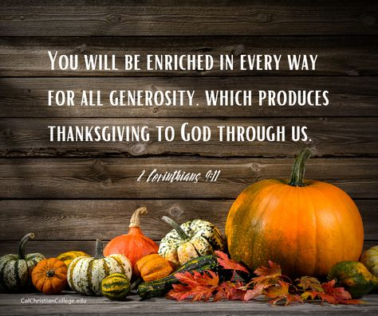

November 5, 2023

**UNITED CHURCH OF CHRIST**

**An Open and Affirming Church**

Church and Algiers Streets

PO Box 48

Murphys, CA 95247

209-728-3141

email: nugget@fccmurph.org

[www.fccmurph.org](http://www.fccmurph.org)

RINGING THE CHURCH BELL

WELCOME & TEACHING MOMENT

PRELUDE *Let All Creation Dance* M. Burkhardt

ENTRANCE OF LIGHT

*CALL TO WORSHIP (responsively)

One: We gather in awe,

**ALL: standing in the presence of the One who crafted the stars, the mountains, the seas.**

One: We gather in faith,

**ALL: trusting that the One who has held little**

**children holds our lives in the heart of God.**

One: We gather in need,

**ALL: seeking the One who longs for justice to grace each and every person in creation.**

One: Let us praise God with our hearts and voices!

PRAYER (in unison)

**ALL: Creating God, You stirred the dust and created us for service; you breathed into our lungs so we could share your good news; you shaped our hearts with the tools of compassion so we will seek justice for all. We thank you, God of gifts. Use us now to bring hope and peace to our world, Amen.**

*GATHERING HYMN

*God, Whose Giving Knows No Ending* #565

CALL TO REFLECTION

SILENCE FOR PERSONAL REFLECTION

**ALL: Holy One, forgive us when our hearts fail to see your face in ALL people. Cradle us in your peace and awaken us to the light and the warmth of your gentleness. Walk with us through each day, nudging us to be that blessing we are called to be to others. We thank you, Surprising Spirit, for opening us to new possibilities, Amen.**

ASSURANCE OF GOD’S GRACE

*SONG OF RESPONSE

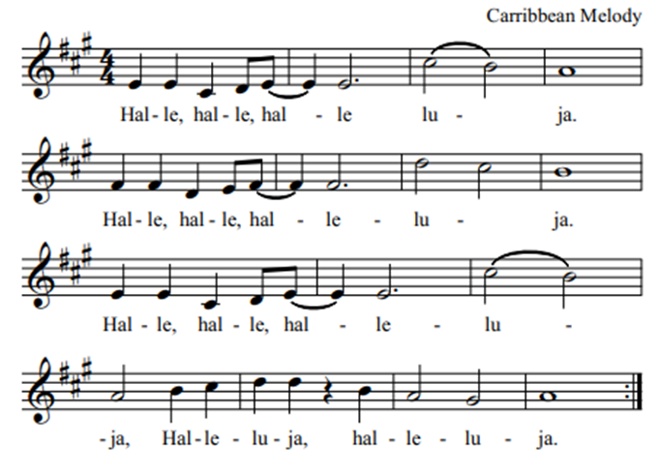

PASSING OF CHRIST’S PEACE

**The Peace of Christ be with you all.**

**And also with you.**

FAMILY TIME RECEPTION OF NEW MEMBERS

SCRIPTURE Psalm 107:1-7

ANTHEM *Let Us Walk This Road Together* John Carter

SCRIPTURE II Corinthians 9:7-15

SERMON *The Gifts of Generosity* Pastor Bonnie

*HYMN *Jesu, Jesu, Fill Us with Your Love* #498

PRAYERS OF THE PEOPLE

THE LORD’S PRAYER

*Our Loving God, who is in heaven, hallowed be Your name. Your kingdom come, Your will be done, on earth as it is in heaven. Give us this day our daily bread. And forgive us our trespasses, as we forgive those who trespass against us. Let us not fall into temptation, but deliver us from evil. For thine is the kingdom, and the power and the glory, for ever and ever. Amen.*

STEWARDSHIP MOMENT Vicky Oneto

CALL TO THE OFFERING

OFFERTORY *Now Thank We All Our God* M. Burkhardt

*OFFERING RESPONSE *Take My Gifts* Verse 1 #562

***Take my gifts and let me love you, God who first of all loved me.***

***Gave me light and food and shelter, gave me life and set me free.***

***Now because your love has touched me, I have love to give away.***

***Now the bread of love is rising, loaves of love to multiply.***

*PRAYER OF DEDICATION

HOLY COMMUNION

SONG FOR COMMUNION *Come to The Table of Grace*

***Come to the table of *grace.***

***Come to the table of *grace.***

***This is God’s table, it’s not yours or mine.***

***Come to the table of *grace.***

*\*Additional stanzas:*

*2 peace; 3 love; 4 joy; 5 hope*

*HYMN *Take My Life, That I May Be* seeinsert

SHARING THE LIFE AND WORKS OF OUR

CHURCH FAMILY

*BENEDICTION SONG

***Let there be peace on earth, and let it begin with me; let there be peace on earth, the peace that was meant to be.***

***With God our creator, we’re one family.***

***Let us walk with each other in perfect harmony.***

***Let peace begin with me; let this be the moment now.***

***With every step I take, let this be my solemn vow:***

***to take each moment and live each moment in peace eternally.***

***Let there be peace on earth, and let it begin with me.***

BENEDICTION

POSTLUDE

*Guide Me, O My Great Redeemer* Paul Manz

Dismissal

One: Go forth serving God and others!

**ALL: We go with joy!**

🙛🙙

Pastor: Rev. Dr. Bonnie Hollinger

Pastor Emeritus: Rev. Dr. John Randlett

Music Director: Dr. Daryl Hollinger

Liturgist: Gary Carson-Hull

Ushers: Karl Graves and Crew

Audio/Visual: Shad Sundberg

Children’s Sunday School Teacher: Patty Haskell

Child Care: Shayanna DuCharme

*Please join us for a time of fellowship and refreshments in the Fellowship Hall following the service.*

🙛🙙

**PRAYERS:**

**\* Bill Jennings,** Judy Regalia’s brother just broke his back and she has gone to be with him for a few weeks. Please pray for both of them.

\***Shirley Soderer** will be at Golden (formerly Avalon) in Sonora for 6-8 weeks. She is in room 7-B, near the window in the 3rd building. She welcomes visits and cards and is making progress daily!

\***Hilary Oldenkamp** is now in Golden in Sonora. She appreciates visits. She is in Room A-37.

**\*Margaret White** asks for prayers for her son-in law as he recovers from a recent surgery. Also, she says many thanks for the cards as she heals from a broken right arm. She is not able to write thank you cards just yet.

**\*Joan Thorsen** continues to recover from a broken hip at Avalon in San Andreas. She appreciates visits very much and will probably be there another two weeks.

\***Gail Williams** is recuperating from a torn bicep. Calls and visits are very welcome. Please call before visiting.

**ANNOUNCEMENTS AND EVENTS:**

**Today:** STEWARDSHIP SUNDAY Pledge cards due.

Stewardship Brunch and New Member Reception

after worship

**Tuesday, November 7:** 5:30pm Family Program

**Wednesday, November 8:** 9am recycling pick-up

10am Executive meeting in Fisk

11am Budget meeting in Fisk

5pm Worship meeting via ZOOM

**Thursday, November 9:** 2pm Book Study in Eastman

4pm CE meeting via ZOOM

**Friday, November 10:** 10am The Wanderers small group

**Saturday, November 12:** 9am Church Clean Up

10am Bell Choir rehearsal

**Sunday, November 12:** 9am Adult Choir rehearsal

11am OSJ meeting in Eastman

**\*Please note there was a mistake in the Nugget about the Brown’s baby shower. It will be on November 26, NOT tomorrow, November 6th.**