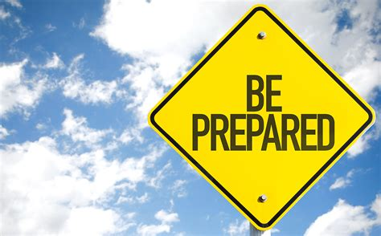
FCN Thoughts: Are You Ready?

Those of us at lower elevations watched and prayed as we saw so many struggle with the implications of a storm that took out trees and electrical lines, preventing them from getting out and us from getting in to assist. It brought home to us the urgency of preparing for weather disasters, as many of us began the “if only” discussion with ourselves. For that reason, I am challenging each of our households during March to seek our “inner squirrel” to begin the process of preparation for the future.

There is a vast amount of information on the internet. This article could simply become a list of links. Instead, I will provide you with a few and let you do the deep dive. But here are a few principles to guide you:
- Determine the kinds of disasters are you likely to face? For most of us, these are Winter Storms, Wildfire, and Power Outages.
- Know evacuation routes and how to find where shelter locations may be. Consider evacuation routes in your house, as well as your neighborhood and community.
- Plan for meeting with family members and connecting with loved ones. Make communication plans. Include what to do if you are not at home.
- Determine special disaster plans for children, pets, those with limited mobility or special needs. Many of these sources include how to help children with the stress of weather-related events and plans for each of these groups. Remember dietary and medication needs or specialized equipment.
- Discover how to obtain emergency information from official sources and heed them. Sign up for emergency alerts on your phone. Check the CDC website for COVID considerations.
- Prepare a kit, know how to use contents and keep it up to date. Consider taking a CPR/First Aid class, when available. Include masks, gloves and hand sanitizer.
- Get to know your neighbors in advance. Many discovered a new dependence on their neighbors during this past storm. Develop neighborhood relationships now.
- Make a list of safety skills for everyone. Simple things such as learning to shut off water, safe ways to shut off electricity and gas, learn to use a fire extinguisher and keep a How To list in your kit.

As promised, these are some links to begin your journey:
https://www.ready.gov/plan https://www.ready.gov/kids
https://www.ready.gov/winter-weather https://www.cdc.gov/disasters/winter/index.html?cid=EPR-homepage
https://www.ready.gov/power-outages https://www.cdc.gov/disasters/poweroutage/needtoknow.html
https://www.ready.gov/wildfires https://www.cdc.gov/disasters/wildfires/index.html
https://mwgjlaw.com/wildfires/grab-and-go-checklists/
https://mwgjlaw.com/wp-content/uploads/2021/01/bbcb23_6bc45e87968a4c7aa5bd2bcb7373d0c8.pdf
Check out these useful Red Cross apps: (Emergency app, First Aid app, Pet First Aid app, Monster Guard App for kids). I have also order materials from FEMA for all of us and will let you know when these are available. Use the month of March to ensure you are, indeed, ready for the severe weather events we are all experiencing. Please drop me a note to let me know when you have prepared your plans and kit and I will let you know about mine.
“So be on your guard, not asleep like the others. Stay alert and be clearheaded.” 1 Thessalonians 5:6

