February, the month of Valentine’s day and love is the month we focus our attention to heart related care and health problems. Blood pressure is one way of telling how healthy our circulatory systems are and provides us the opportunity to focus on those things we can change.
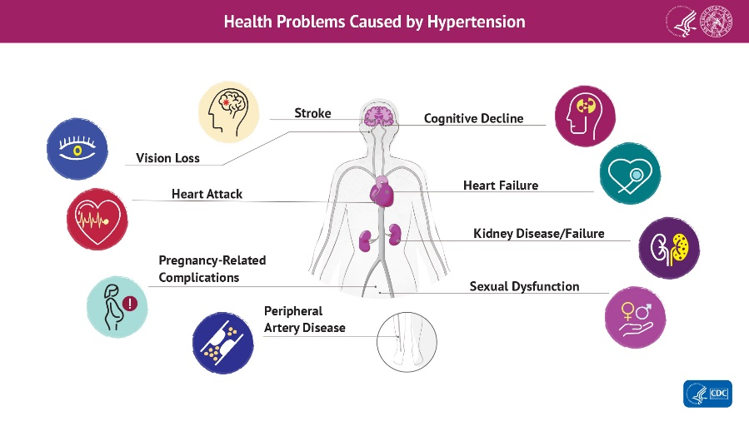
Hypertension (high blood pressure) is known as a “silent” condition because you aren’t likely to be aware of it until it causes a problem. Heart disease and stroke are the most well known of the problems cause by hypertension, but others can be profoundly serious. The only way to know is by taking your blood pressure. In these days of social distancing, we have been unable to have blood pressure clinics at church and you may not be at the doctor’s office as frequently as you may have in the pre-COVID days. Your doctor may recommend you obtain a blood pressure machine to do blood pressures at home. But did you know there are right ways and wrong ways to do a blood pressure? Recent activities, when and what you eat, exercise, being nervous and your position during the reading may all affect your blood pressure.
- Don’t eat or drink anything 30 minutes before you take your blood pressure.
- Empty your bladder before your reading.
- Sit in a comfortable chair with your back supported for at least 5 minutes before your reading. Do some slow, deep breathing and relax.
- Put both feet flat on the ground and keep your legs uncrossed.
- Rest your arm with the cuff on a table at chest height.
- Make sure the blood pressure cuff is snug but not too tight. The cuff should be against your bare skin, not over clothing.
- Do not talk while your blood pressure is being measured.
If you find someone is not following these above rules, ask that they do. Some recommend taking your blood pressure 2-3 times and record it. If you do, be sure to wait a few minutes between readings. Try to take your blood pressure at the same time of day. You may find your provider follows newer guidelines of 130/80, rather than the older 140/90 that was previously considered high blood pressure. New research brings updated guidelines. Check this link to understand blood pressure readings https://bit.ly/3sxcqC1.
Many things which affect our blood pressure are not things we can change. Genetics, family history, age, race and ethnicity are our lot in life. The CDC has developed a tool My Family Health Portrait to help you examine those risks at http://bit.ly/2N3NXnu. Eating healthy food, becoming more active, not smoking, and limiting alcohol and getting enough sleep are all things we can work on to improve our heart health. Your body will thank you for it. “So, whether you eat or drink, or whatever you do, do all to the glory of God.” 1 Corinthians 10:31 ESV

