For Sale
612 Wilkinson Lane White House TN 37188

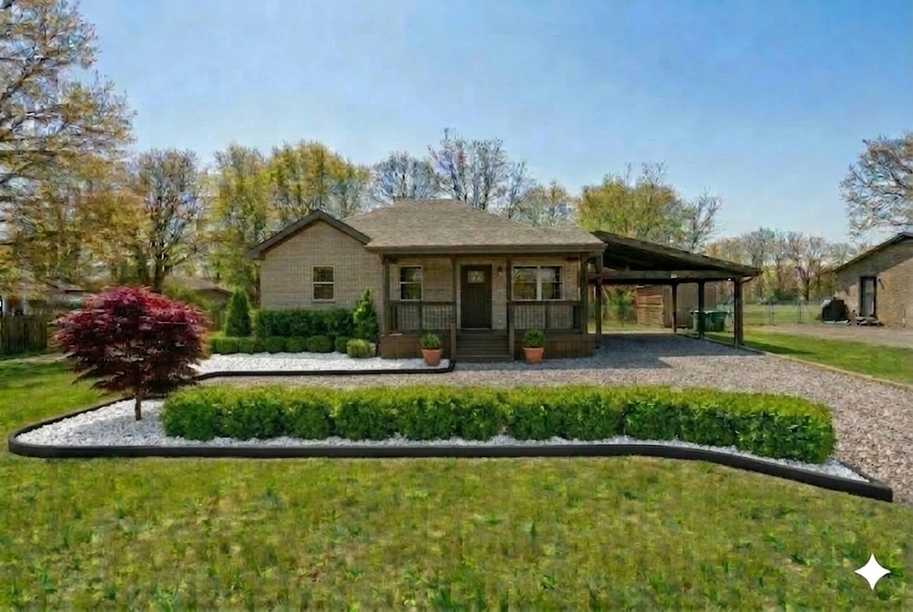
Artist Conception of Home after improvements to property

3 bedroom 2 bath, nearly all brick home, screened back porch, versatile utility building with .6 acre premium lot.

ZILLOW Value as of 3.11.26 at $281300, before 90k remodel, upgrades and improvements.
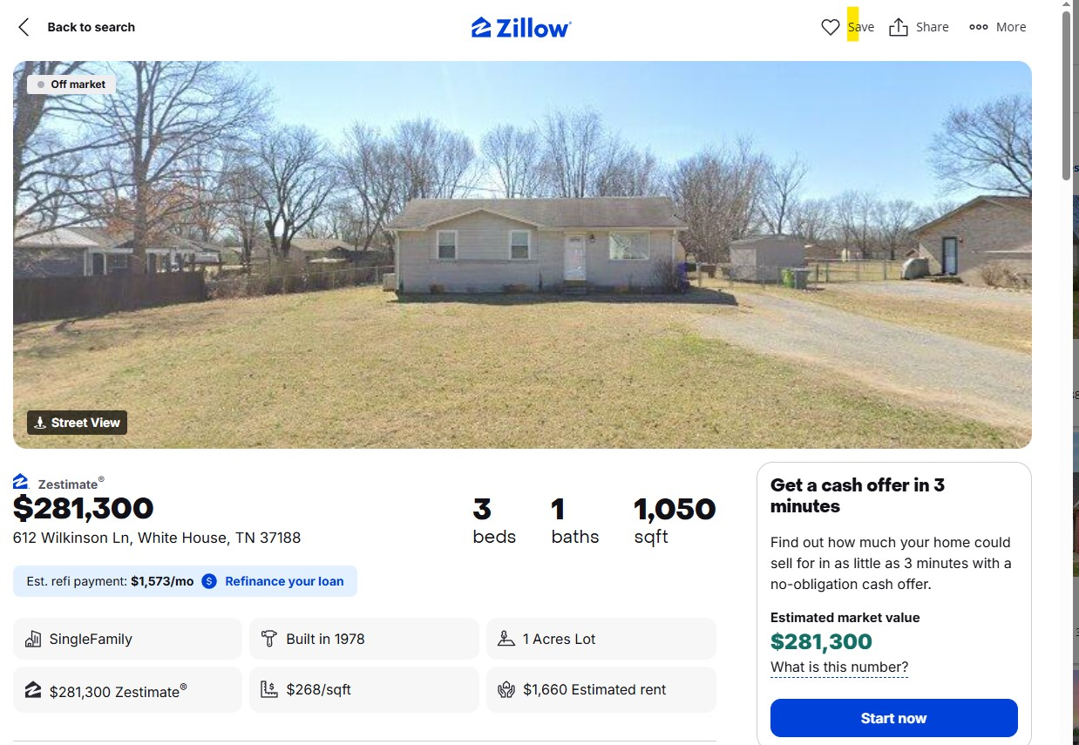

I am selling home with personal property included due my wife passing away in Nov. 2025.
1. New roof
2. New kitchen with adjustable cabinets, solid surface countertops.
3.Nearly New washer dryer & tankless water heater
4. Updated electrical panel
5. New flooring
6. RV Parking in several areas
7. Premium lot~1/2 lot 2 min from Walmart, I-65, completely fenced
8. Best school district, Heritage
9. Exceptional neighborhood and neighbors
10. NO HOA fees and much more
Value of Property
Valuation and Future Worth
The pricing of 612 Wilkinson Lane is a combination of factors.
Zillow gave us a reference point for range at $283,000.

This home needed work, being 50 yrs old. We have solidified and upgraded every area of the home, the foundation, dated electric, installed a tankless water heater, optimized premium backyard with better kitchen door access, completely redone kitchen with solid surface countertops and upgraded , expanded adjustable shelving, included stainless appliances including double door refrigerator, tore out old primary bath, redone all dated ceilings, installed current wood grained vinyl flooring, completely repainted interior and exterior, added a second shower, upgraded landscape and lighting, run electrical to utility building and updated details like thermostat, security, installed 5 DC fanlamps throughout home and porches plus other work to accomplish the current 612 Wilkinson.
High energy efficiency was accomplished with DC motors and remotes for each fan and remote, an electric based Master Queen, Broyhill furniture thoughout, as well as other custom features.

We are spending $75,000+ out of pocket to match the home with its wonderful .6 acre, totally useable, completely fenced back yard.

I am offering home when finished at $344,950.

Advise – There are many older homes for sale. Be careful, unless you have a master framer, brick mason, electrician, plumber, HVAC, Drywall finisher, and Landscape company available fr the job.

Utility Building and potential flexibility
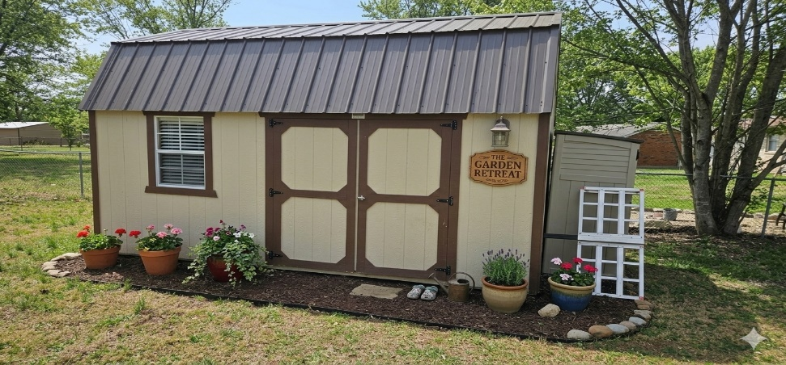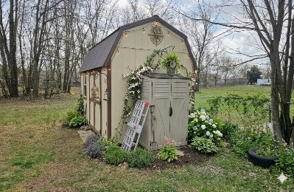
Excellent construction including multiple windows, high grade metal roof, double door entry and loft area for additional storage.

Utility Building access from Screened in porch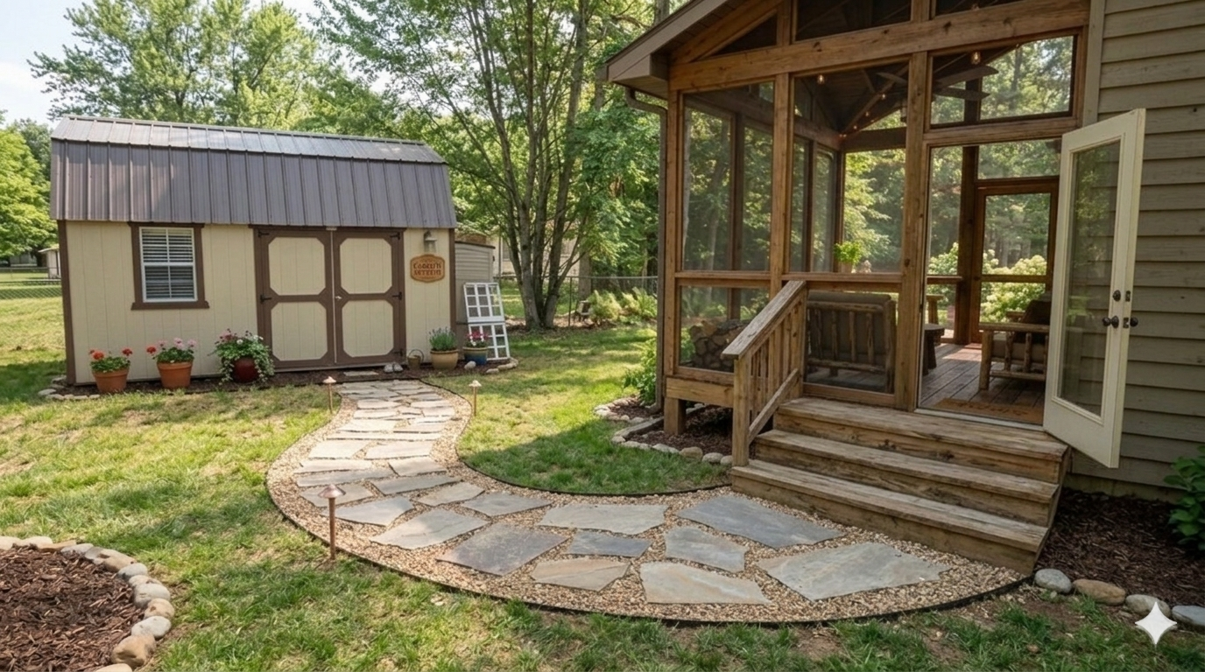
Artist conception
The Utility Building has as many potential uses as your imagination has. With electrical run to the building, plugs in place, and capacity for small air conditioner, consider the possibilities.
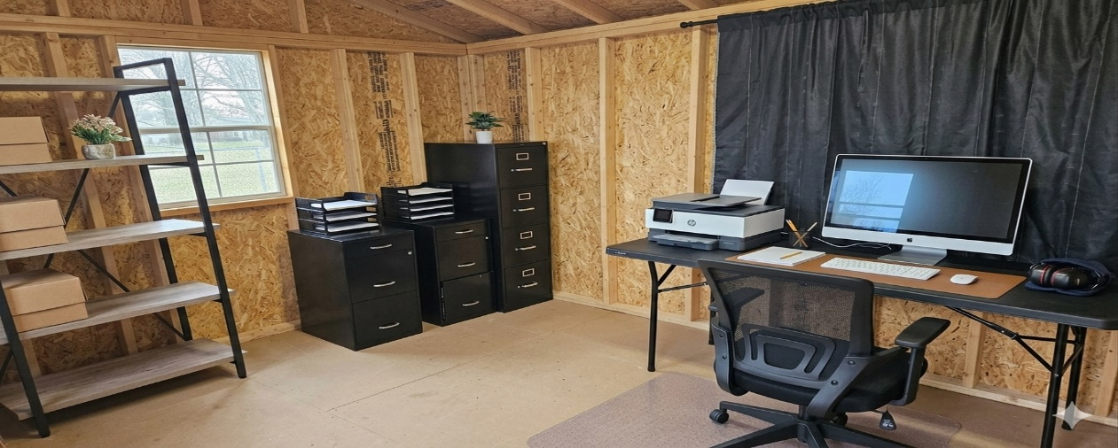
This shows the ~200 Ft Utility Building used as an office. Double this space is available due to the loft built within the structure
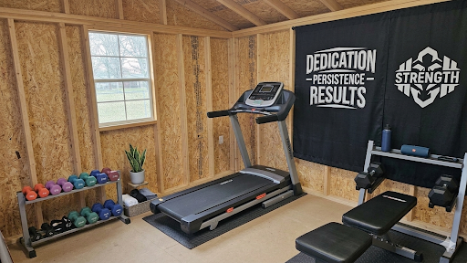
Here Utility Building is set up as a gym, exercise space away from the house
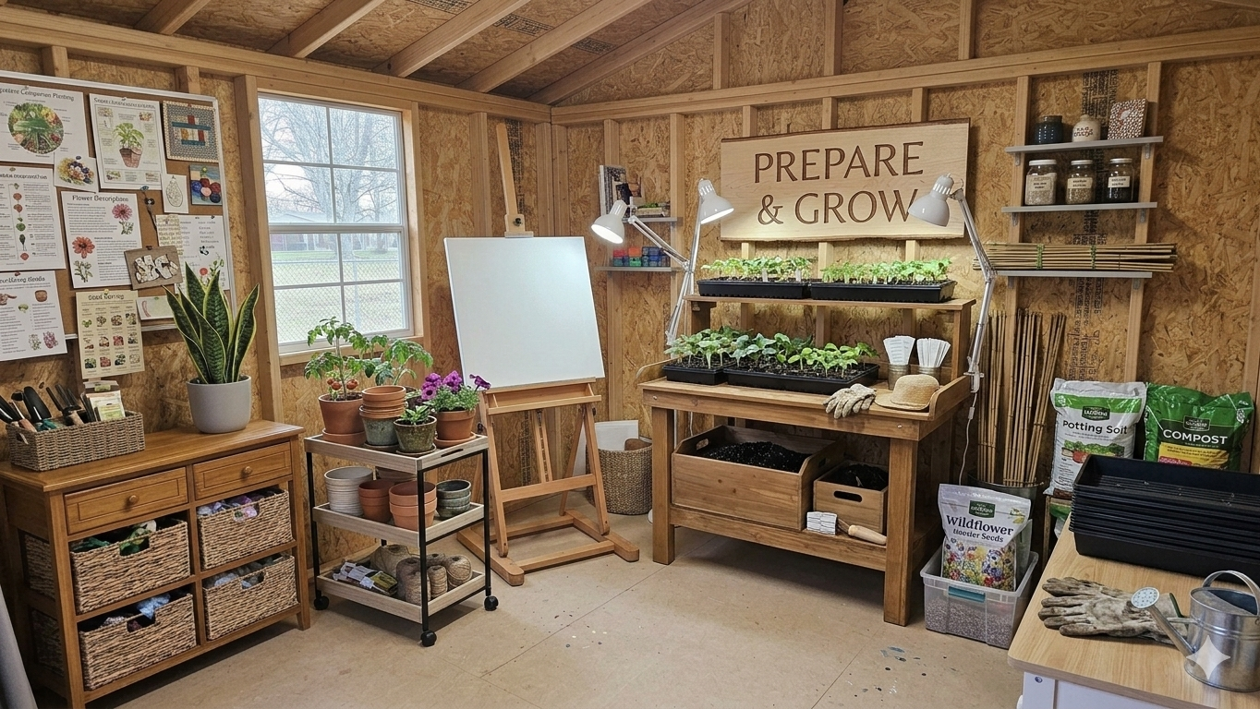
This is being used as a Gardening workshop. The large useable lot allows for many projects

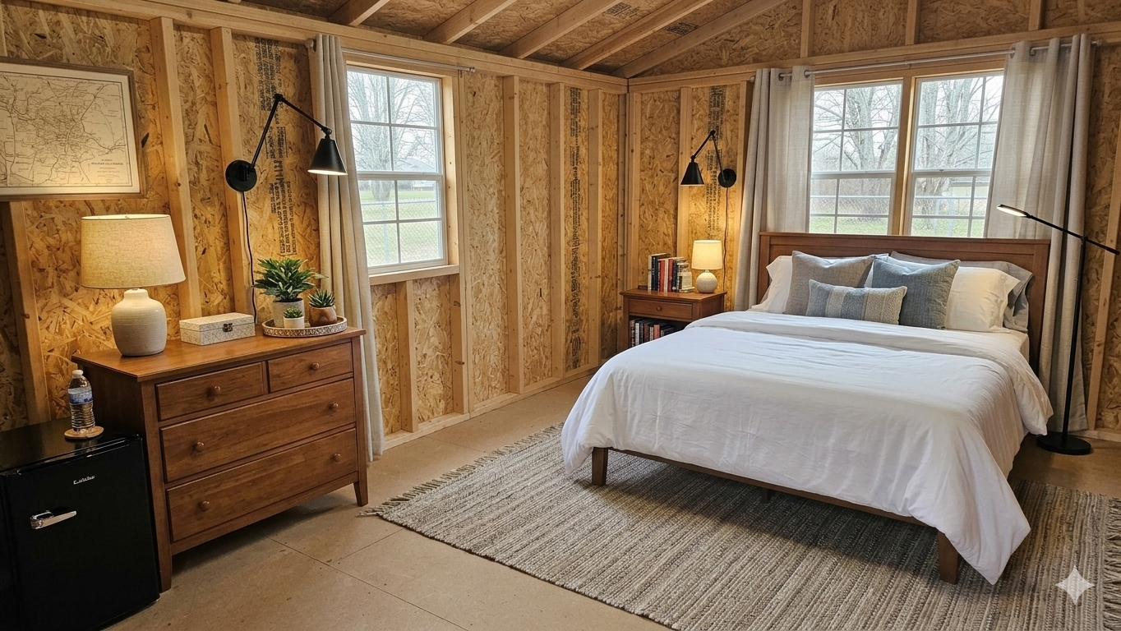
Need a fourth bedroom?

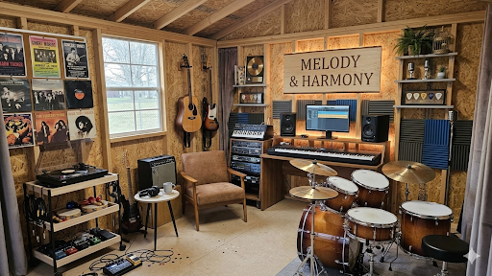
A Music Room and finally a place for your set of drums.
Above is a loft for added storage
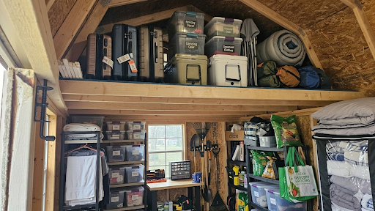
All of this personalproperty can be included the price of your hoe.

Additional Features
Digital thermostat for scheduled use and lower utilities
Ring doorbell security, System includes both front door coverage, windows and door, and also a motion sensor yard light on the carport
4 Televisions including large screen in Living Room, all included as part of the personal property.
Night lighting incl low voltage
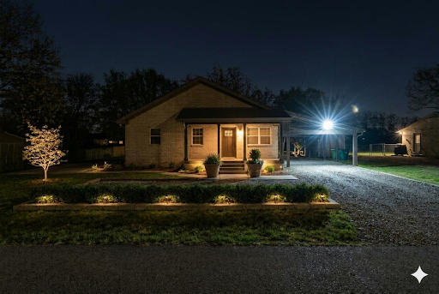
Screened in porch,
Guest pkg & turn around
Gust Parking

Low cost utility living for young home buyers, or Seniors downsizing.

.

Pictures of extensive back yard
Lot allows unlimited possibilities
This could easily become this
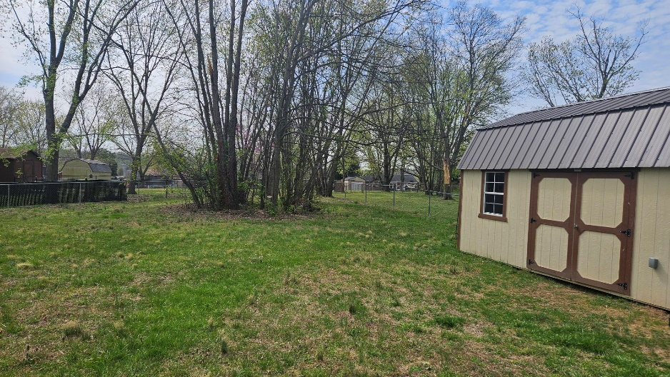
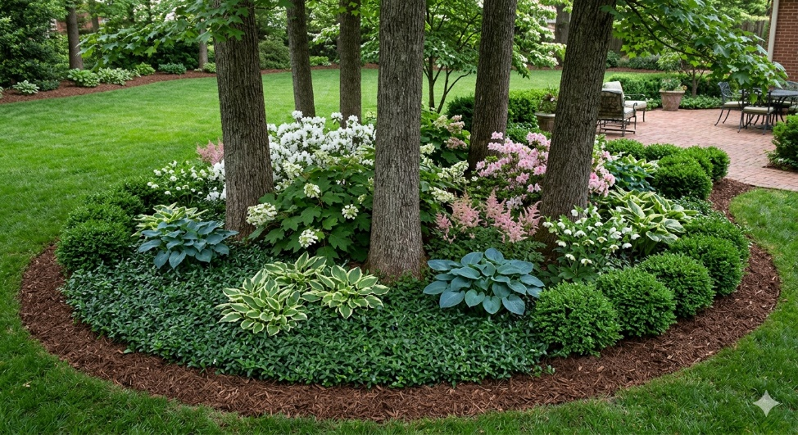
A natural buffer with your neighbors
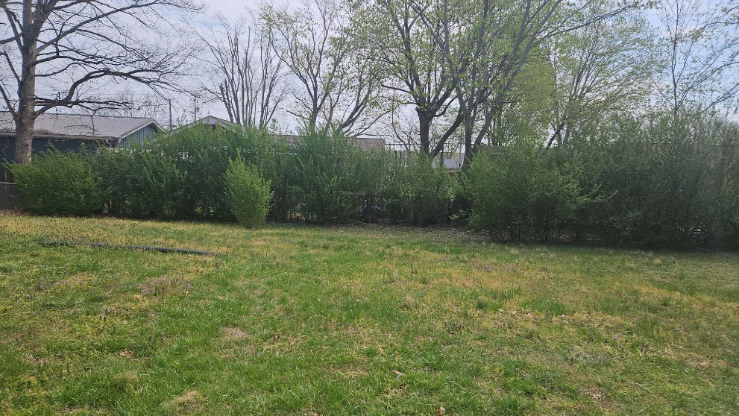

A distant neighbor becomes an English garden o closer inspection
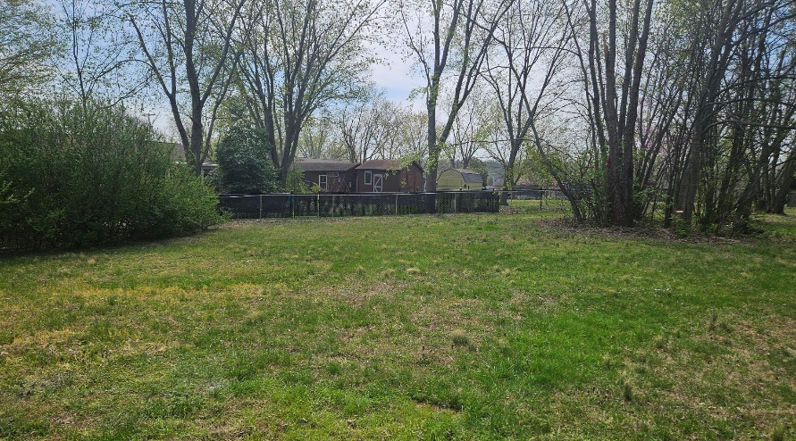
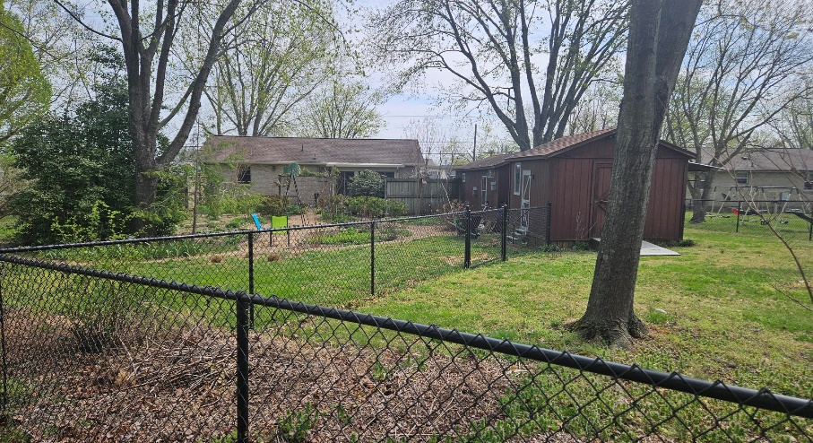
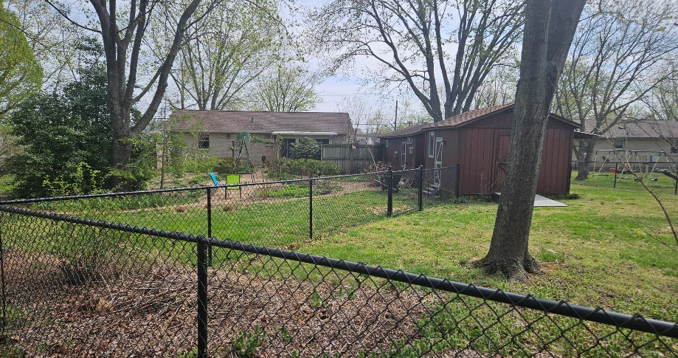
Owners background. I was a managing broker for over 20 years in both CAand TN. More recently I developed several forty acre parcels. Two of them were Valleydale Estates on Hwy 25 in Cross Plains and Mt. Pleasant Acres in Greenbrier, off New Hall Road.
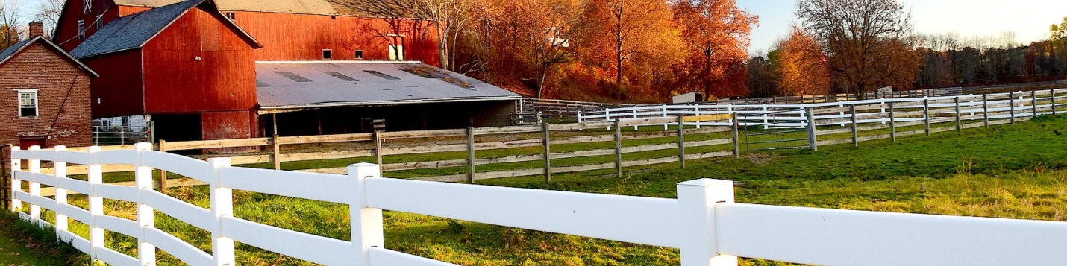
Valleydale Estates, Cross plais TN
Quality of Life
- For me the top 10 factors are:
1. Neighborhood & neighbors. My neighbors are friends. They maintain their properties, and help in times of need.

2. Safety and services. I have lived in this area for over 30 years. White House Police are on the job. Fire and Emergency Services are seconds away. You have a great choice of exceptional churched, Hope Centers. And Schools, public or private. Your city has many parks, walking trails, recreation, etc without HOA fees?
3. Value of your purchase
If you can buy a quality home with these features under $350k, consider it strongly.
4. Cost and worth in the future. When you buy at a reasonable price, your future value is better protected from downturns.
5. Quality of buiding materials. You you have a tankless water heater, solid surface kitchen counters, smart thermostat, security you can monitor from your own phone without monthly costs?
6. Convenience of shopping whether Walmart. Kroger’s. or Publix. Having all three major chains will guarantee you competition, stock and variety.
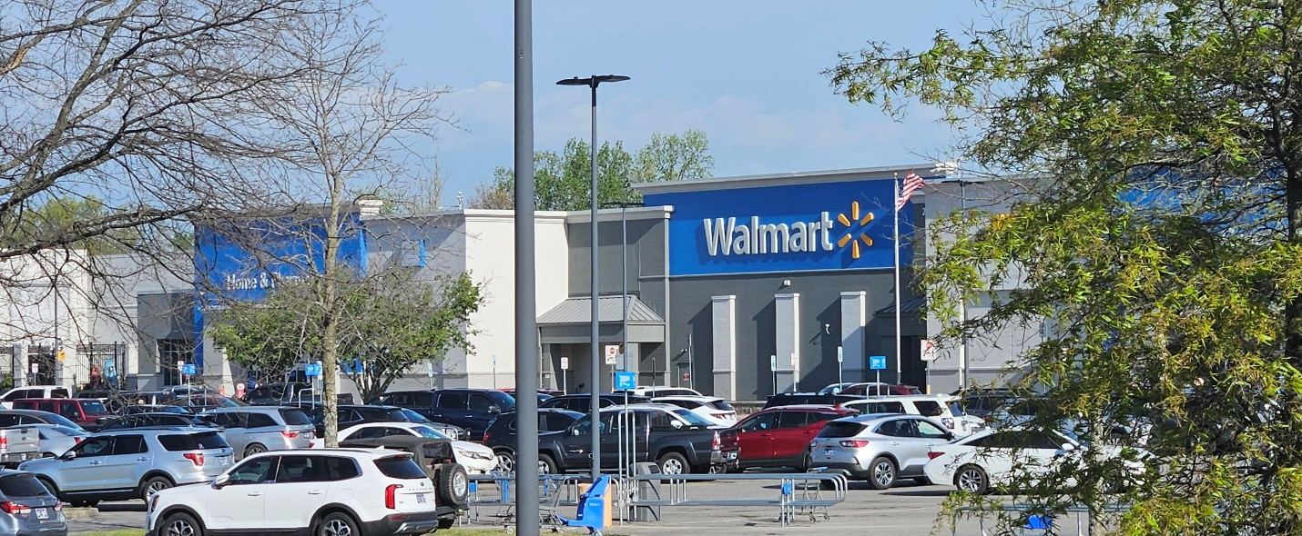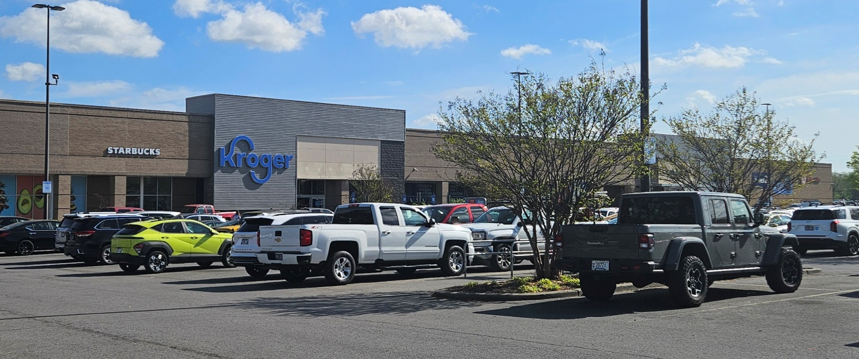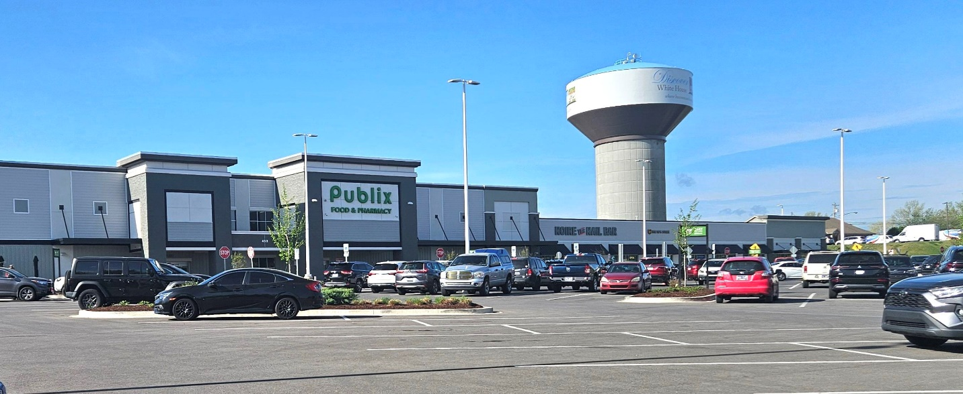
7. Entertainment areas whether with fenced yards, screened patios or treed lots
Having space for friends, BBQs or backyard fun

8. Flex space such as gyms, home office, crafts. Music, etc. Yout utility building is wired. Lit and air conditioned if needed. This is a retreat for you, not connected to your main house.

9. Use of your property
For family, children, animals, etc. Do your children have a safe place to play. If you chose, is your yard fenced for a puppy?
10. Emergency medical facilities within minutes of home.
Exciting things are happening in White House! You are actually seeing not one, but two major emergency medical facilities currently being added to the city. For a long time, residents had to drive 25–35 minutes to Hendersonville or Gallatin for emergency care, so these projects are a big deal for the community.
​Here is the breakdown of what is being built:
​1. TriStar White House ER (TriStar Hendersonville)
​This is the facility you likely see construction on right now near the heart of town.
​Location: Intersection of Raymond Hirsch Parkway and Highway 31W.
​Status: Under construction (Groundbreaking held March 2025).
​Expected Opening: Early 2026.
​Features: An $18.6 million freestanding emergency room with 11 exam rooms, a dedicated trauma room, and full imaging capabilities (CT, X-ray, Ultrasound) available 24/7. 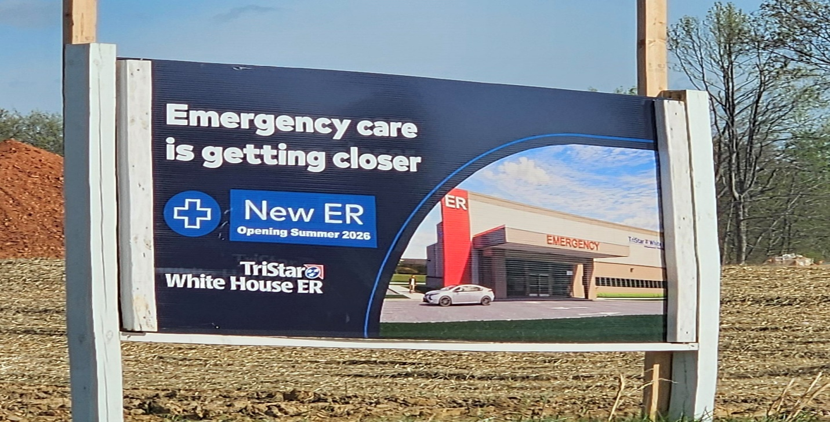
​2. Highpoint Health White House ER (Sumner Regional)
​This second facility is also in the works to serve the western side of the city near the interstate.
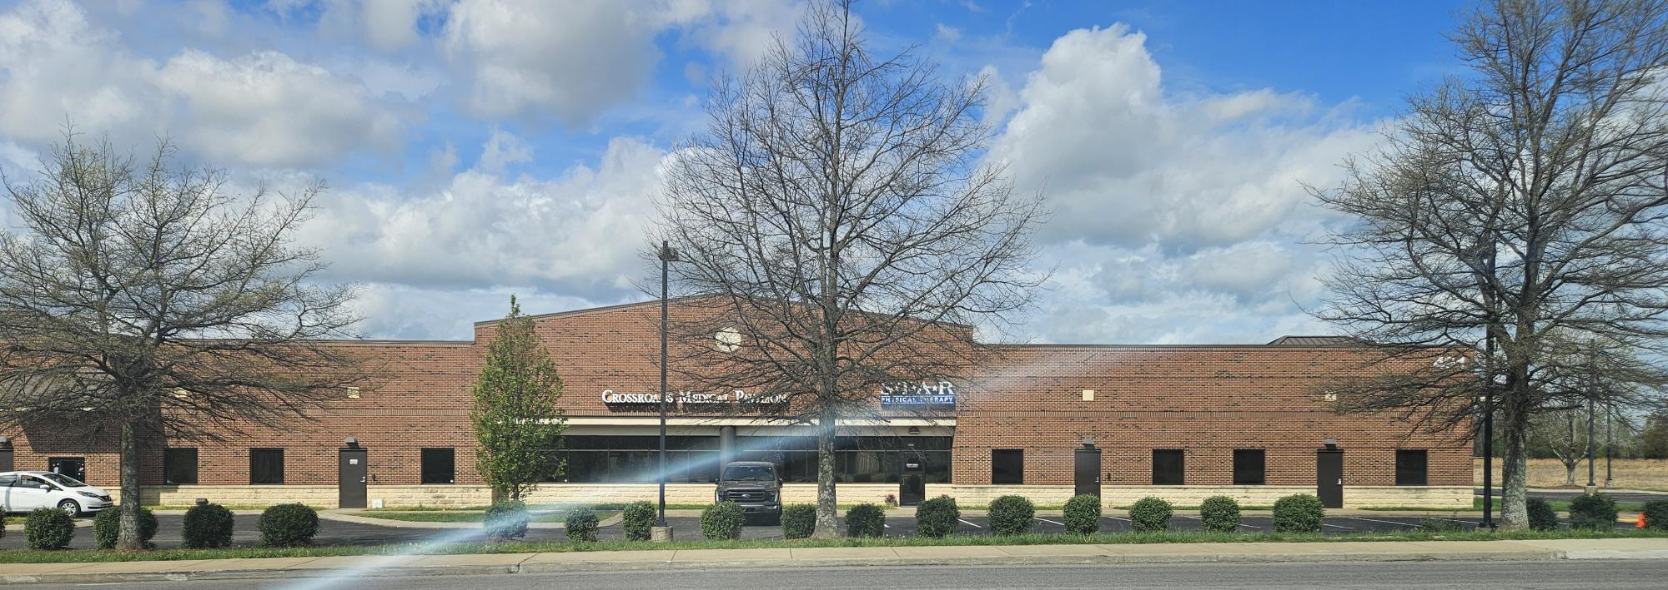
​Location: Near I-65, bounded by Maiden Road and North Sage Road (Robertson County side of White House).
​Status: Approved/Planning phase.
​Expected Opening: Late 2025 or early 2026.
​Features: An $11 million to $20 million facility (estimates varied during the filing) featuring 6 initial treatment rooms, a trauma room, a behavioral health room, and laboratory services.
​Key Differences to Keep in Mind
​Since these are Freestanding Emergency Departments (FSEDs) and not just urgent care clinics, here is what that means for you:
​24/7 Operation: Both will be open 24 hours a day, every day of the year.
​High-Level Care: They are equipped to handle serious emergencies (strokes, heart attacks, trauma) and are staffed by ER doctors and nurses, just like a hospital-based ER.
​Transport: If a patient needs to be admitted to a hospital for surgery or long-term care after being stabilized, they will be transported by ambulance to the main hospital (either TriStar Hendersonville or Sumner Regional).
​It's a huge shift for the area—basically going from zero local emergency options to two competing facilities within a very short timeframe!
Other White House Facilities:
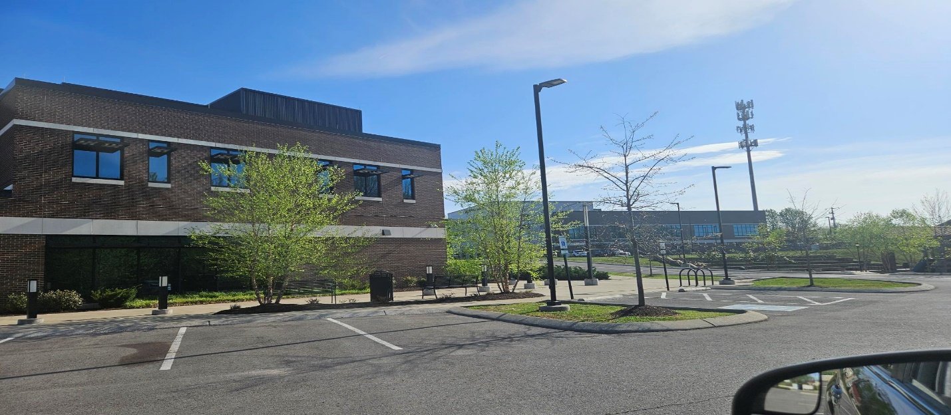
White House Civic Center
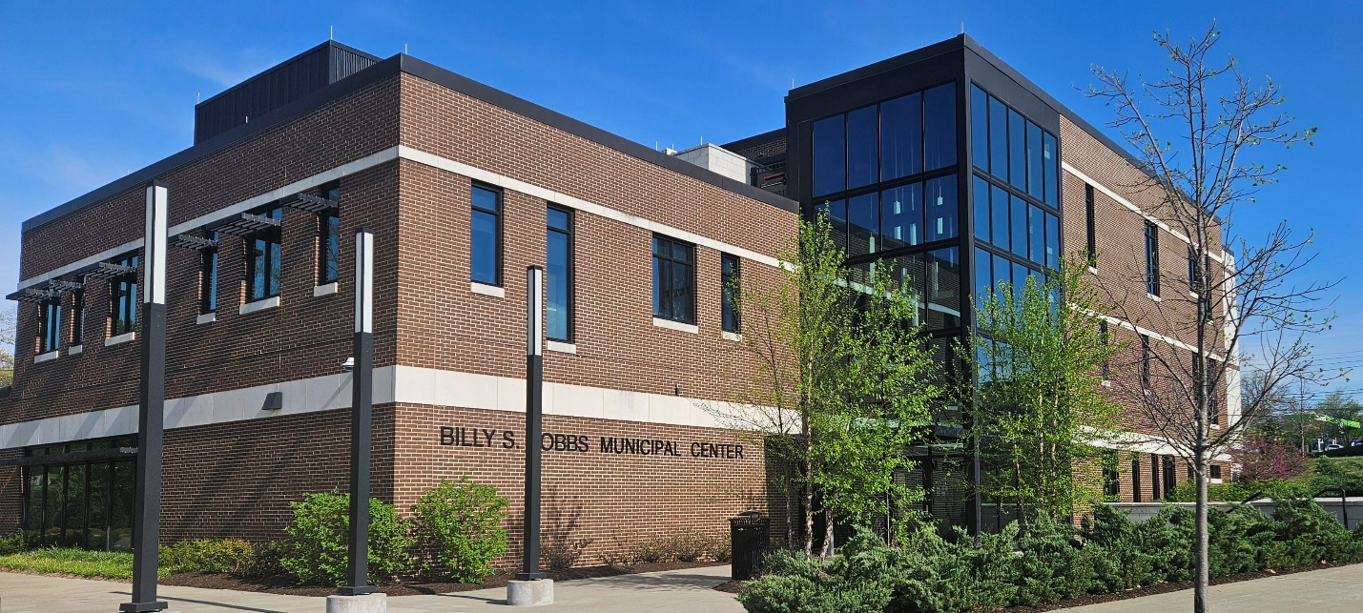
White House Administration and Parks, Senior Center and Meeting Rooms
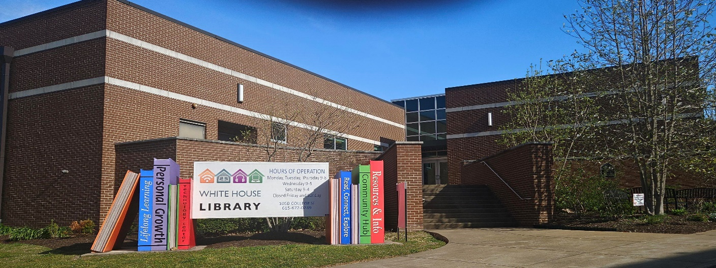
White House Library and Computer Center
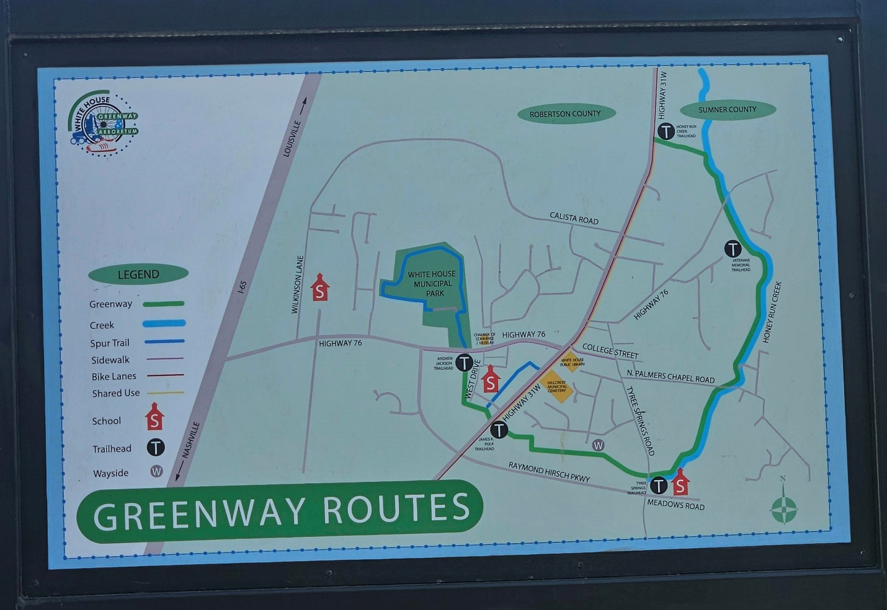
White House Extensive Greenway Routes
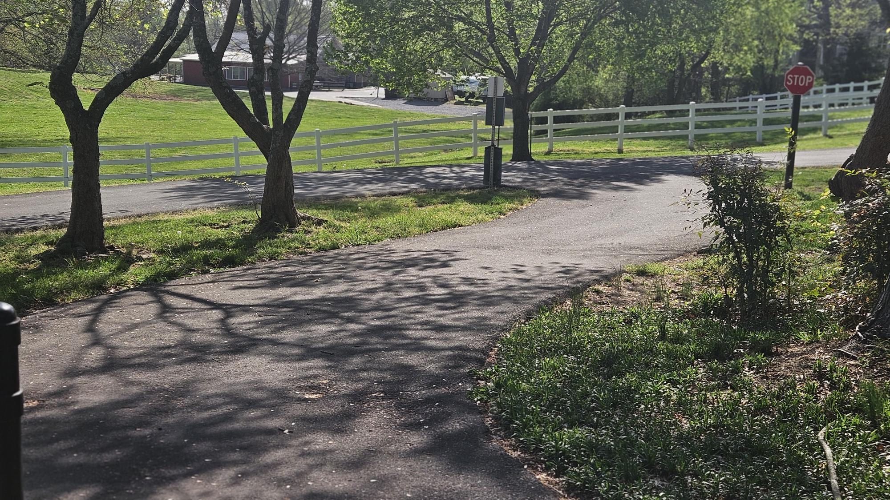
Tree Lined Greenway
White House Restaurants (just a sample of newer spots)
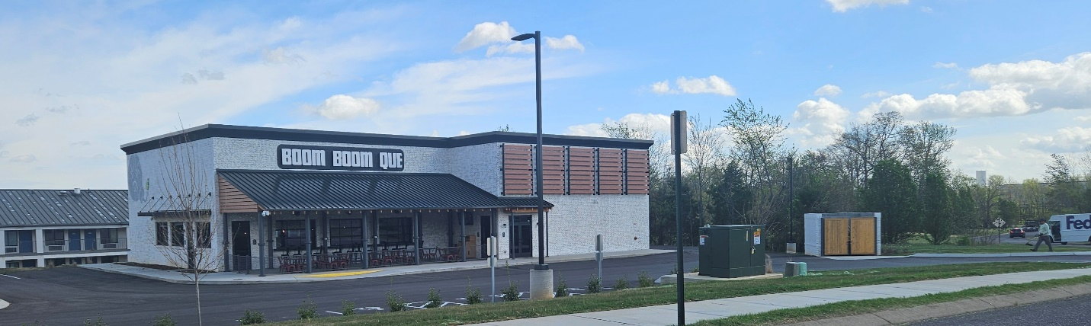
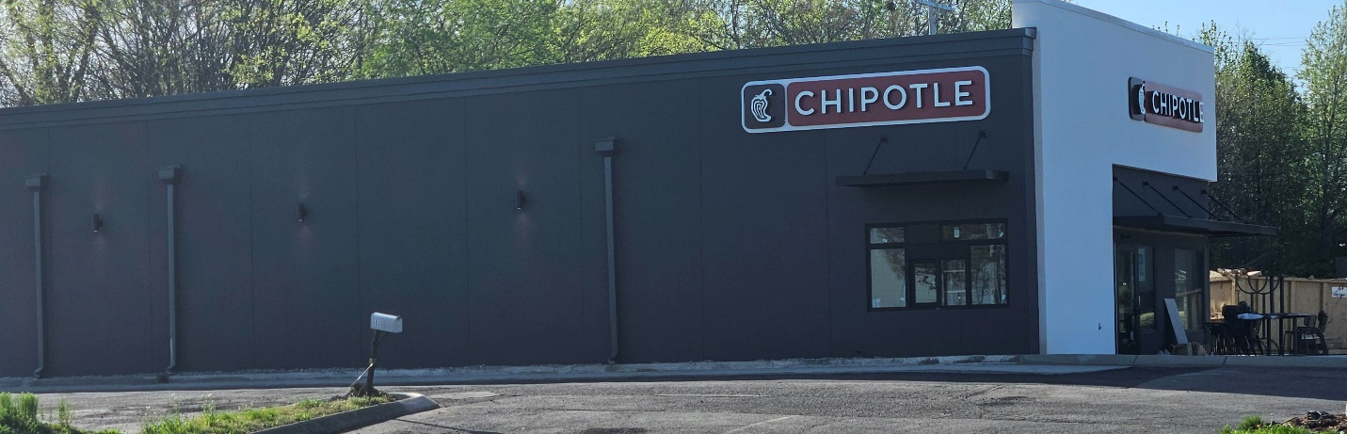
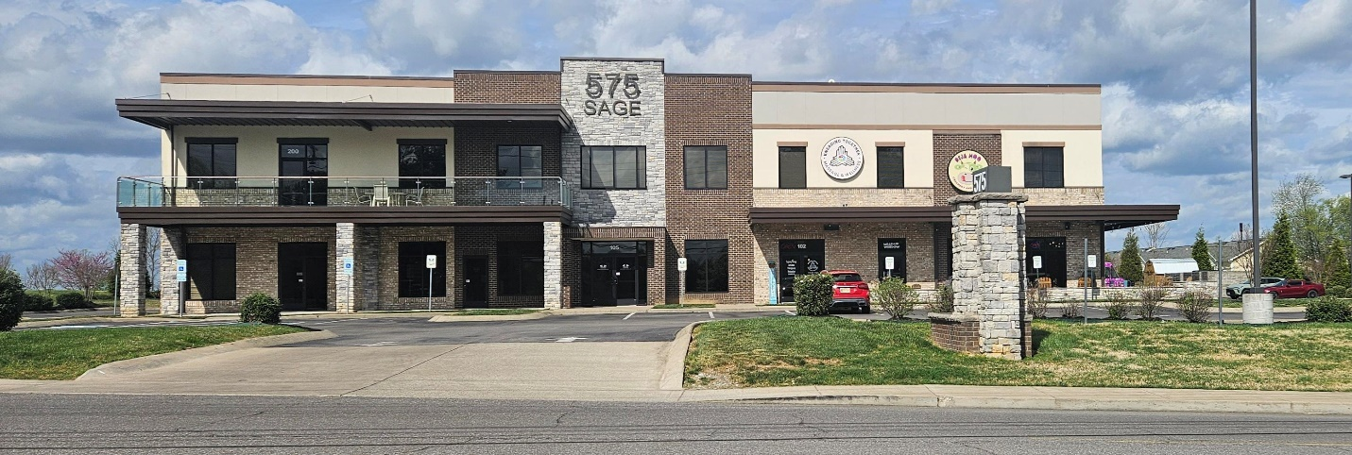
Deja Moo

White House Employers
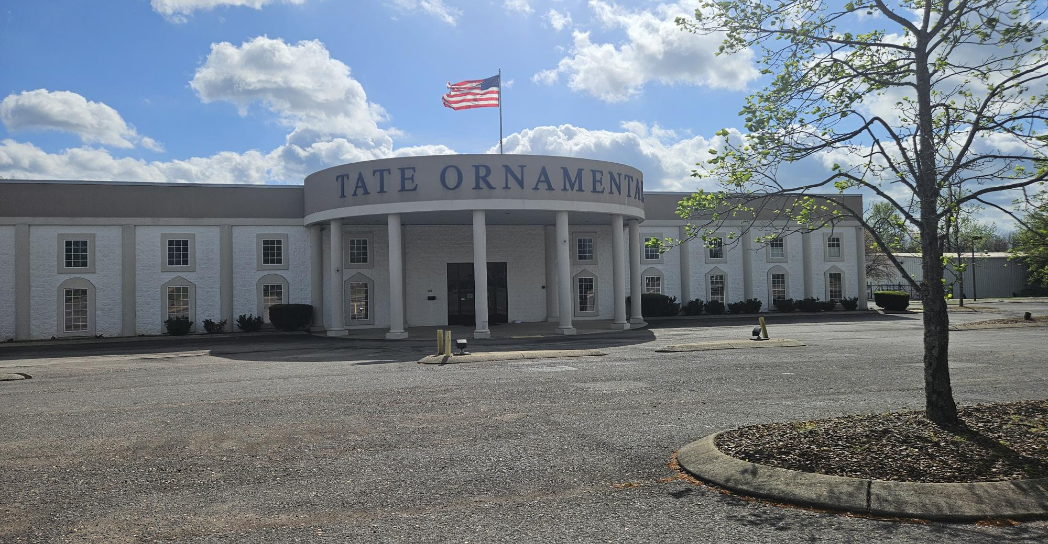
Tate Ornamental with all of its many division, including wood shop, granite and hard surfaces, iron fabrication, custom work even for Washington DC including Museum of the Bible, employees more thana 1200 plus contract labor across the country.
Tate Inc., a manufacturer of data center infrastructure solutions, is significantly expanding its US Operations, with its new Glasgow, Kentucky facility expected to create 400 new full-time job. This expansion is part of a larger ongoing growthj strategy , including a 52 job expansion in Pocahontas, Arkansas, strengthening its data center solutions division.
Other White House Employers with 50 or more eployees
- Sumner County Schools; in addition are a diverse base of growing private schools such as

- City of White House
- Kroger
- Walmart
- Advanex Americas (Mfgr)
- Lowes Improvement
- White House Healthcare
- Tate Ornamental

How we celebrate Easter in White House TN for 2026
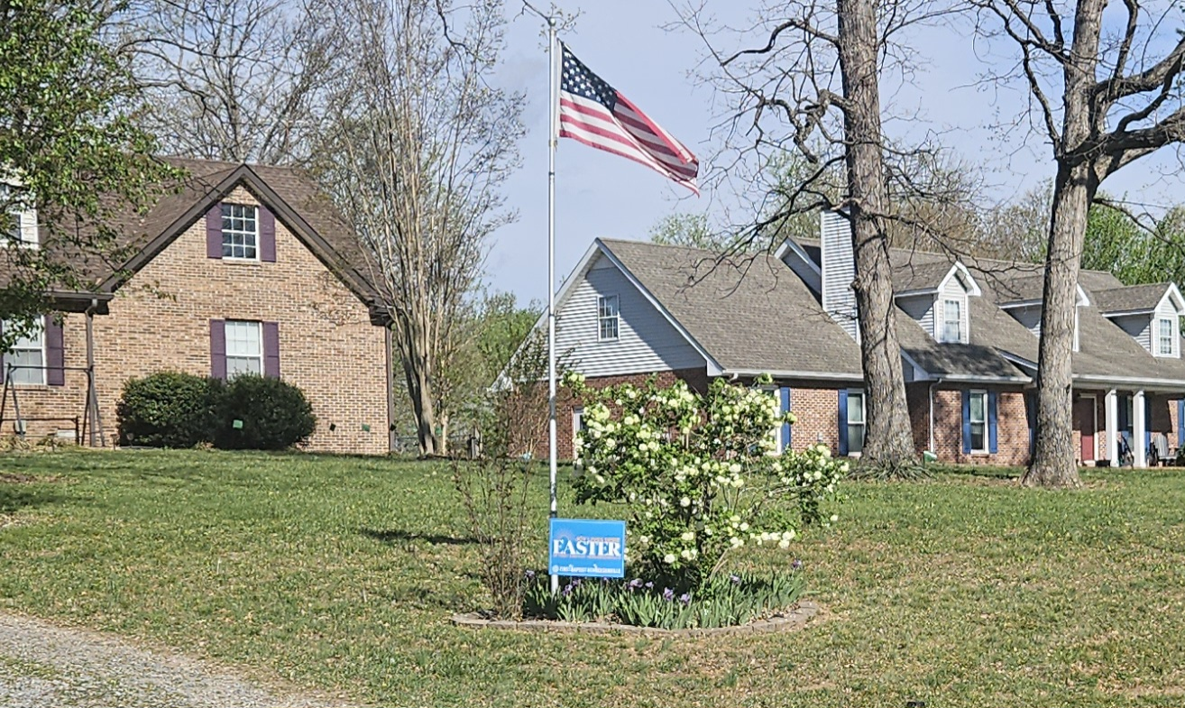

------ ------
One last word..
With my wife of nearly 46 years passing away in Nov. 2025, I no longer have need for so many of the nice pieces we acquired. This home and utility building are not just being staged. but my hopes are that the right family will continue to use and enjoy a wide range of very nice personal property.

