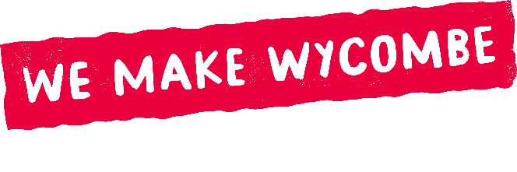
Spotlight Weeks
Expression of Interest Information Form
October 2025

Purpose
Spotlight Weeks are a key part of We Make Wycombe. They are designed to showcase High Wycombe’s creativity in a way that is fresh, inspiring and impossible to ignore.

Spotlight Weeks are available each month from October 2025 – March 2028. Each Spotlight Week runs for one full week (covering 2 weekends) and provides a platform for you to shine a light on your work – raising visibility, engaging the community and creating memorable moments that celebrate the cultural energy of High Wycombe.

We are now inviting Expressions of Interest (EOIs) for upcoming Spotlight Weeks.

What We’re Looking For
Projects supported through Spotlight Weeks must go beyond simply using the hub as a space to display work or perform. To be eligible for funding proposals should:

- Be original - offer something new, original or different – whether it is a new piece of work, a debut exhibition, a new installation, a first-time performance, a new collaboration or a creative experiment not seen before in High Wycombe.
- Be engaging - activity must include an element of participation, interaction or open engagement with the wider community (e.g. workshops, talks, performances, open studios, live demonstrations, discussions). A minimum of one public-facing engagement activity must take place during the week.
- Be inspiring - the programme should aim to draw people in, spark curiosity, capture the attention of the local community, and encourage new audiences to connect with local creativity.
- Be relevant to local audiences – by making the work meaningful and accessible to the people of High Wycombe
- Be impactful – encourage partnership working, new collaborations and sector growth.
- Be distinctive from regular hub use – Spotlight Weeks are funded opportunities; they must clearly stand apart from regular use of the space (e.g. private rehearsals, ongoing exhibitions, individual workspace).

In addition, Spotlight Weeks can serve as a platform or satellite by signposting to a new event/performance/exhibition happening elsewhere, building on the connectivity of the sector, and drawing audiences into new spaces, although this not mandatory as will not apply to all potential applicants.

We also ask that projects:

- Are accessible, inclusive and welcoming to all communities
- Are environmentally conscious, making sustainable choices where possible
- Are well promoted, using We Make Wycombe branding
- Collect feedback and share reflections to help us measure impact

Support
- Funding of £750 - £1000 per Spotlight Week is available at the discretion of the Steering Group
- Marketing and promotion through We Make Wycombe’s channels and partner channels
- Practical support from and guidance from the Project Manager

The Process

- Please send us a short EOI outlining your idea using the EOI form. If completing the application form presents any barriers, please contact us so that we can provide an alternative method of applying.
- The Project Manager will meet with you to review your proposal, ensuring it aligns with the Spotlight Week criteria and offer support to shape your plans if required.
- Your proposal will then be considered by the Steering Group. You may be invited to attend a meeting to present your idea and answer questions.

