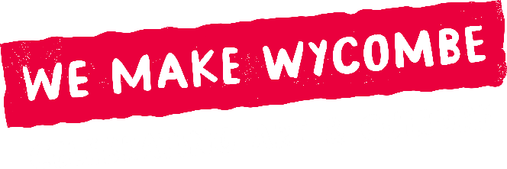
Hub Activity
Expression of Interest (EOI) Form
September 2026

Tell us briefly about your idea for activity at the Hub. At this stage, we only need enough information to understand the idea and how it might best be developed. You do not need to provide a full plan, budget details at this stage.
After receiving your EOI, the Project Manager will contact you to arrange an informal meeting. Together, you can explore the idea, practical requirements and any further information needed.
Please keep your answers short. The form should take around 10–15 minutes to complete.

- About You / Your Organisation

Name and Organisation or creative practice
Contact Details (email / phone)
Website
Instagram
Facebook
Other socials
What is your connection to High Wycombe?
How did you hear about the opportunity?
Date of application

- Your Proposal

What is your idea for activity in the Hub?
In no more than 200 words, please tell us what you would like to do and who would take part:

3. Practical Considerations

When would you ideally like your activity to take place?
Please give a preferred month and/or approximate dates within the next 12 months.

4. What support do you think you may need?

☐ Planning and project development
☐ Introductions to partners / artists Skills / training
☐ Marketing and promotion
☐ Skills / training
☐ Not sure yet, would like to discuss

What happens next?

The Project Manager will contact you to arrange a conversation. The meeting will help develop the idea. The Project Manager will be able to advise if your idea is best suited to a Spotlight Week or Hub takeover and suggest any possible collaborations. If applicable, the Project Manager will work with you to develop a more detailed application for a Spotlight Week that will be submitted to the Steering Group for a decision. Submitting an EOI does not guarantee funding.

Please return this form to: hello@wemakewycombe.org

Thank you for your interest in being part of We Make Wycombe.

