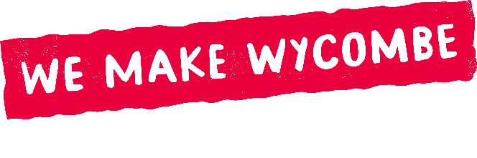
Spotlight Weeks
EOI Application Form
October 2025

Please complete this form to outline your idea for a Spotlight Week. The Project Manager will follow up with you to discuss your proposal, provide support, and ensure it meets the criteria before it goes to the Steering Group for consideration.

For each section, please try to keep your answers brief and within a 250-word limit.

- About You / Your Organisation

Name / Organisation

Contact Details (email / phone)

Website / social media (if applicable)

Please let us know how you heard about the opportunity
Short bio / background:

Date of application

Please attach a jpeg of your logo.

- Your Proposal

Title of your Spotlight Week:

Brief Description:

What makes your proposal original?

How will you engage the public (at least one activity, such as a workshop, talk, performance, demo, discussion)?

How will your project be inspiring to audiences and attract attention?

How will it be relevant and accessible to HW’s communities / or which communities are you targeting and why?

What environmental considerations have you made?

How does your proposal encourage partnerships / collaboration / sector growth?

3. Practical Considerations

Preferred dates for Spotlight Week (by month and year). NB. Must be within 12 months of application date.
Expected times of use / dates of engagement activities

4. Support & Budget

Amount requested (up to £1,000)

How would you use the budget? (please provide quotes if applicable)

What experience do you have of similar activity and what support might you need from the Project Manager or partners?

5. Evaluation & Legacy

How will you measure impact? (eg. Feedback, attendance, media coverage)

How will your Spotlight Week benefit you/your organisation in the longer term?

