Being the Change We Need: ProGoldenRule’s Crash Course to Emotional Intelligence
Understanding Polarization, Escalation, and De-Escalation
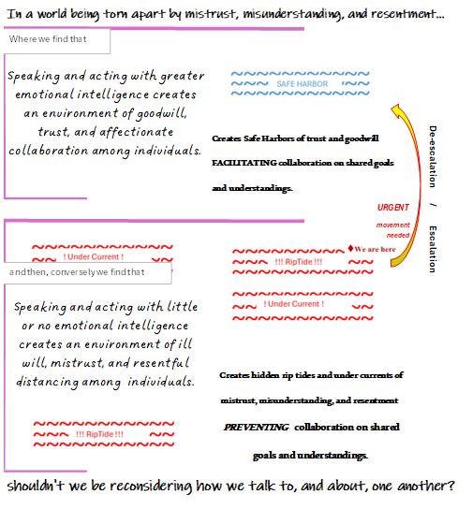
The Core Premise
Emotional intelligence is as essential to humanity’s social-psychological functioning as oxygen is to humanity’s biological functioning.
No analogy is perfect—and this one doesn’t need to be. What matters is the underlying parallel:
- When oxygen in our physical environment is depleted beyond a certain point, biological systems falter and fail.
- When emotional intelligence in our social and psychological environment is depleted beyond a certain point, relationships, communities, and institutions falter and fail.
This comparison helps illuminate two foundational truths:
- Speaking and acting with emotional intelligence cultivates goodwill, trust, and affectionate collaboration.
- Speaking and acting without emotional intelligence fosters ill will, mistrust, polarization, and resentful distancing.

Why This Matters—Right Now
This may sound like a novel hypothesis, but it rests on decades of research across the so-called “soft sciences”: psychology, sociology, child development, mental health, conflict studies, and emotional intelligence. Pieces of this puzzle have long existed.
What may feel new is the urgency.
In families, workplaces, schools, and civic life, we are witnessing what happens when emotional intelligence becomes scarce: rapid escalation, entrenched polarization, and breakdowns in communication that feel irreversible.
Many people intuitively sense that something fundamental has gone missing in how we talk to—and listen to—one another. For those ready to test whether restoring emotional intelligence can change outcomes rather than merely explain them, this work offers a practical path forward.

Defining Emotional Intelligence in Action
If emotional intelligence can meaningfully shape our shared environment, then defining it clearly—and operationally—becomes critical.
In this framework, emotional intelligence is not about being passive, avoiding conflict, or suppressing strong emotions. It is about how emotions are expressed, when difficult conversations occur, and whether dignity and safety are preserved for everyone involved.
Two practical guides anchor this approach:
- The Family Conflict Resolution Playbook — outlining how to engage conflict with clarity, boundaries, and respect.
- The Relationship Recovery and Repair Handbook — outlining how to repair trust and restore connection after missteps, escalation, or emotional harm.
Equally important is recognizing that even the most emotionally intelligent people will fail at times. Recovery is not optional—it is a core skill.
Keeping these guides close to hand and heart, reviewing them often, and practicing intentionally can move us—individually and collectively—toward a healthier, safer, and more humane future.

Emotionally Intelligent, Award-Winning Phrases
Sometimes emotional intelligence is best understood not through theory, but through language that de-escalates, protects dignity, and keeps connection possible.
Here are a few examples:
- “I think this is important to talk about—but this isn’t the right time or way. Let’s set ourselves up for success with clearer ground rules and better timing.”
- “You’re absolutely allowed to talk about your emotions. We just can’t speak to each other in ways that are hurtful or damaging. Could you rephrase that with greater accuracy and using ‘I feel’ statements?”
- “Can you help me understand that you see how and why what you said might feel offensive or concerning to someone else? Let’s revisit this once everyone has had time to calm down and reflect.”
These phrases do not avoid accountability or disagreement. They slow escalation, preserve psychological safety, and keep dialogue possible—even when emotions run high.

A Closing Thought
We do not change the emotional climate of our families, communities, or culture through force or argument alone. We change it the same way we change any environment: by consistently introducing what is essential for life to thrive.
Emotional intelligence is not a luxury. It is the air of our social fabric that we all breathe together.

