HYSTERICAL
CERES GALLERY
JANUARY 4-29 / TUES-SAT 12:00- 6:00 547 WEST 27TH STREET / 2ND FLOOR
NEW YORK CITY, NY 10001
www.ceresgallery.org
-
212-947-6100
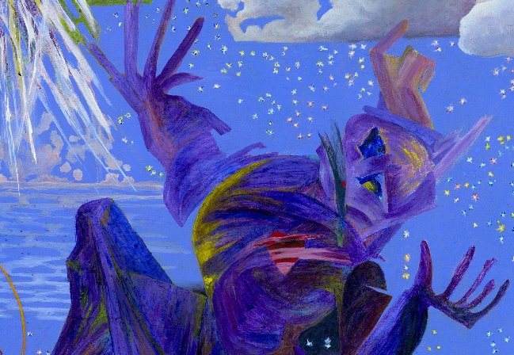 My painting entitled PANDEMIC DREAM has been accepted into this exhibit. I am very excited and honored to be part of this exhibit.-Melanie Hickerson

