Ceres Gallery, 547 West 27th Street, Suite 201, New York, NY 10001.
Hysterical
A group show in the Affiliate space- January 4 – 29, 2022
Curated by Christine Mottau

Feminist Filmmaker Kate Novack will be screening her short film
Hysterical Girl
as part of the exhibition.

My painting entitled PANDEMIC DREAM has been accepted into this exhibit. I am very excited and honored to be part of this exhibit.

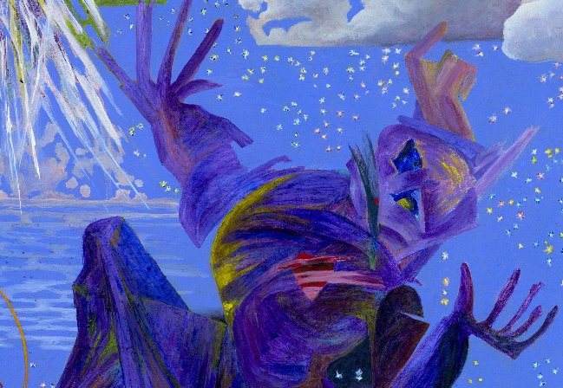
Melanie Hickerson, PANDEMIC (detail), acrylic on canvas, (h)36” x 24”, 2020

