THE TIE THAT BINDS
art by Melanie Hickerson
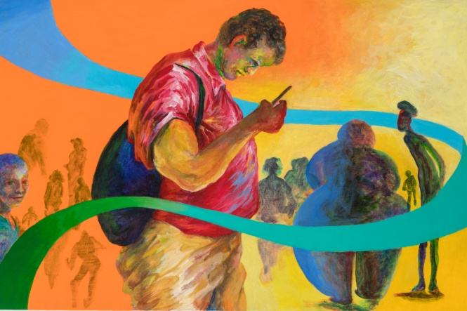
Julia C. Butridge Gallery
Dougherty Art Center,
1110 Barton Springs Road, Austin, TX 78704
Opening Reception: Thursday, January 16, 7-9 PM
January 11, 2020 to February 8, 2020

I grew up in a family that had homemade art; singing, acting, reading, cooking and dancing together. Swimming was a favorite sport. Camping and picnicking meant “leave a place better than you found it.”Human culture, as student and partner, dances with the natural world.
This body of work is about the tie of peoples, individuals and nature as part and parcel of one family. I want to make something instant and slow with a focus on relationships between humans and a healthy planet. A homemade family of all.
Lindsey Smith and The Annual Teaching Artist Exhibit for the DAC staff will be on view, also, at the Dougherty Art Center. We all invite the public to the Reception honoring these exhibits!

The City of Austin is committed to compliance with the Americans with Disabilities Act. Reasonable modifications and equal access to communications will be provided upon request. For assistance please contact (512) 974-3914 or Relay Texas 7-1-1.

