INVESTIGATING THE EXISTENCE OF CLAY BEDS SOURCED BY THE
ABORIGINAL PEOPLE FOR CERAMIC PRODUCTION IN CENTRAL AND SOUTH
FLORIDA

2018, Ted Ehmann
Charlotte Harbor Anthropological Society teddyehmann@earthlink.net

1.

INTRODUCTION

South Florida has been an archaeological enigma from the days when the first archaeologists
ventured there at the end of the Nineteenth Century. Frank Hamilton Cushing and C.B. Moore
recounted in their journals, their disappointment with the lack of ceramics, and the crude nature
nature of the ceramic vessels found while excavating burial mounds in peninsular Florida. The
more than obvious lack of fine earthen ware vessels, on the west coast and from the Cedar Keys
of Levy County to the Florida Keys, caused Moore to hypothesize the absence. Ceramics were
the hallmark of archaeology and its classification and dating were the leading data used to
capture a culture in space and time. It was not till the post-war years and the arrival of John
Goggin that the entire southern portion of the Florida peninsula came to be defined. Goggin, who
grew up in Miami, collecting pottery shards as a young man, based on the evidence, coined the
term Glade to classify the ceramics made by the aboriginals and their culture and region. Goggin,
a recently trained archaeologist was not a geologist. Having a strong background in geology is
almost never truly required when investigating the ceramics of prehistoric cultures. There is
unfortunately, one exception. Goggin and those who followed him failed to research the geology
of south Florida, a large area totally devoid of plastic clays.
Moore’s second hypothesis for the total absence of fine earthen ware vessels in the majority
of the Florida culture regions has ended up being astutely correct. That being “that the finest
vessels of the peninsula were importations.” The geologic record accurately shows that without
clays, importation was the only option available to the aboriginal cultures in those regions.
This article describes my investigation which resulted in the discovery of a fairly large
clay-less environment that is unique to south Florida and the western Gulf Coast below the big
bend. The results of my research impact the archaeological record in that known and classified
ceramic types could not have been produced in the locales and cultural regions as presently
believed. While much more than the clay its mineralogy and geological origins defines a ceramic
type, such as shape, decoration and function, There is no getting around the reality that due to
circumstance, some going back millions of years, beds of clay suitable for ceramics don’t exists
the Eastern Woodland landscape. As with many important natural resources, when researching
clay, there were winners and losers. Northern Florida, as well as many southeastern and
MidAtlantic states owe their abundant clay beds to the Gulf Coastal Plain, that runs from
southern Mexico to New Jersey. The majority of ball clay deposits were laid down during the
Eocene Period, fifty to thirty-five million years ago (Bloomfield). Primary deposits of kaolin
washed down into lakes and lagoons and are still mined and producing in Kentucky and
Tennessee. In Georgia and northern Florida, secondary deposits, also still mined today, washed
down to the coastal plain (fig 1) (Hosterman). A new opportunity for anthropologists is present
due to these findings to analyze the geochemical and mineralogical elements elements in samples
found in these clays less regions in order to determine the raw sources elsewhere. Such research
will provide data necessary to the redefining of cultural regions, chronologies and trade.
2.
Research Methodology
The most important resources necessary for this investigation were the geological surveys of
Florida related to areas of known and measured amounts of kaolin and ball clays. .Kaolin (Al-
Osio-2H2O)is an aluminum silicate. Kaolin is a platy white clay that is chemically inert,
nonabrasive and plastic. Porcelain is an example of a fine kaolin. Ball clay is another term
associated with small particles, plastic and purer kaolin. The only active kaolin mine as of 1997, was in Putnam County (p 150). Archaeologist interested in the chalky-white St.Johns River ceramics will note that location. The Timicua had a debt of gratitude to the Lake Wales Ridge and its abundant formations of Pleistocene kaolin. Other plastic clays used in ceramics have as their mineral components, Aluminum oxide, silicone dioxide and water.clays in Florida, as well as everywhere they can be found exists in different geological levels.A study done in 1991, showed that of the 44 states reporting, Florida ranked number 2 in commercial clay output (p 148). Commercial mining of Florida clays however, has no relevance to my research because of the depth of clay deposits and the technology needed to extract the clay. Also, as geologists White et. al commented, “only a few clay deposits have the proper mineralogy, purity and quantity.” (p 148) to be suitable for exploration. Florida’s aboriginal pottery-makers would not only need a certain quality of clay, but easy access. Clay beds refer to those deposits of readily available quantities of clay found near the lands surface in the banks of rivers, creeks and ponds. White et. al conclude:

“Little has been published on the reserves and resources of clays in Florida. Common clays are
considered abundant in northern Florida. Southern Florida has a deficiency of clays, “(p 150)

this they state is because the clay-like soils lack enough aluminum and too much magnesia. Most
commercial mining of clays in Florida extracted common clays and fuller which could never be
used for ceramics but are economically viable for the petroleum industry, cosmetics and kitty litter. Fire clays also known as common clays refer to course clays that can withstand high
temperatures and are used in making bricks. Fire clays have been mined in the Florida panhandle. Stoneware a mineral rich clay used since the aboriginal cultures for pottery can be
found in more recent glacial formations north and west of the gulf coastal plain.
Exhausting the geological literature of Florida, in print, I contacted the state geology
department in Tallahassee. They assisted me with accessing all the literature base for Florida
geology (Means). The only out-of-print source on Florida clays and kaolin, was produced by
James L.Calver in 1949. Calver’s geological survey is the most complete to date. The official
Survey definitive concludes the kaolin are confined to certain areas of east Florida and a smaller area west of the Apalachicola River in western Florida. (Fig.1) (FGS) This data corresponds to the well-known major prehistoric sophisticated pottery-producing cultures of the Florida peninsula. ( Milanich ) The data also confirms the non-existence of kaolin and common clays suitable for pottery below Polk County (FGS). Therefore, all aboriginal groups from Polk

3.

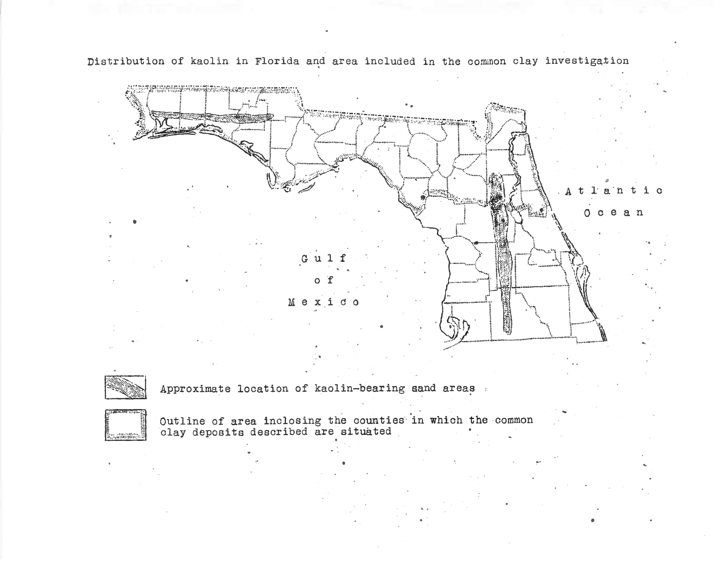
FIGURE 1 Map FGS 1949 Report

County to the Florida Keys and the corresponding Gulf and Atlantic Coasts, could not have had access to clay beds and could not have been the originators of the ceramics that bear their names.
A survey not dated but available online at http/pubs.usg.gov, was also extremely relevant and
helpful. Clays of Florida, Notes on the Clays of Florida, by George C. Matson supports the
survey by Calver. Matson divides the areas of Florida clays by geologic epics. Those clays of the
Florida panhandle are in the Alum Bluff formation, a Miocene event. The clays of northeastern
peninsula Florida, kaolin ball clays are in the Alahua Formation a Pliocene event. (FGS)
An important U.S. geological survey on ball clays written by John W. Hosterman in 1984
stated that 85% of ball clay comes from the Gulf Coastal Plain. The survey confirms that as in
ancient times, The Wilcox Group of the upper Paleocene and lower Eocene within the Gulf
Coastal Plain have the greatest quantities. Geographically these prime deposits are in :Carroll, Henry and Weakly Counties Tennessee, Graves County, Kentucky, Benton and Panola
Counties Mississippi and Cherokee and Rush Counties Texas. (USGS Mineral Industry Survey)

4.

(fig2). The complete geological analysis of the eastern portion of North America supports that
the finer ( kaolin ) clays only found from western Kentucky to northeastern Florida are fifty to
thirty-five million years old (Bloomfield) and a product of the late Pliocene and early Miocene
Epochs. and are only found in the Gulf Coastal Plain. Other clays used by potters and the ceramic industry such as stoneware were deposited and formed during the last Ice Age. This epoch has no relationship to the clays found in the Gulf Coastal Plain.
Finding a map on the Gulf Coastal Plain, I took the states and counties that were primary
Sources of kaolin and marked them as black dots on the map. States with counties no mentioned
in Hosterman’s survey, as well as those in Florida, I used the kaolin mines locators on line, as
well as Calver’s survey. The resulting graphic (fig 3) shows at a glance the kaolin resources
present and only present in the Gulf Coastal Plain.

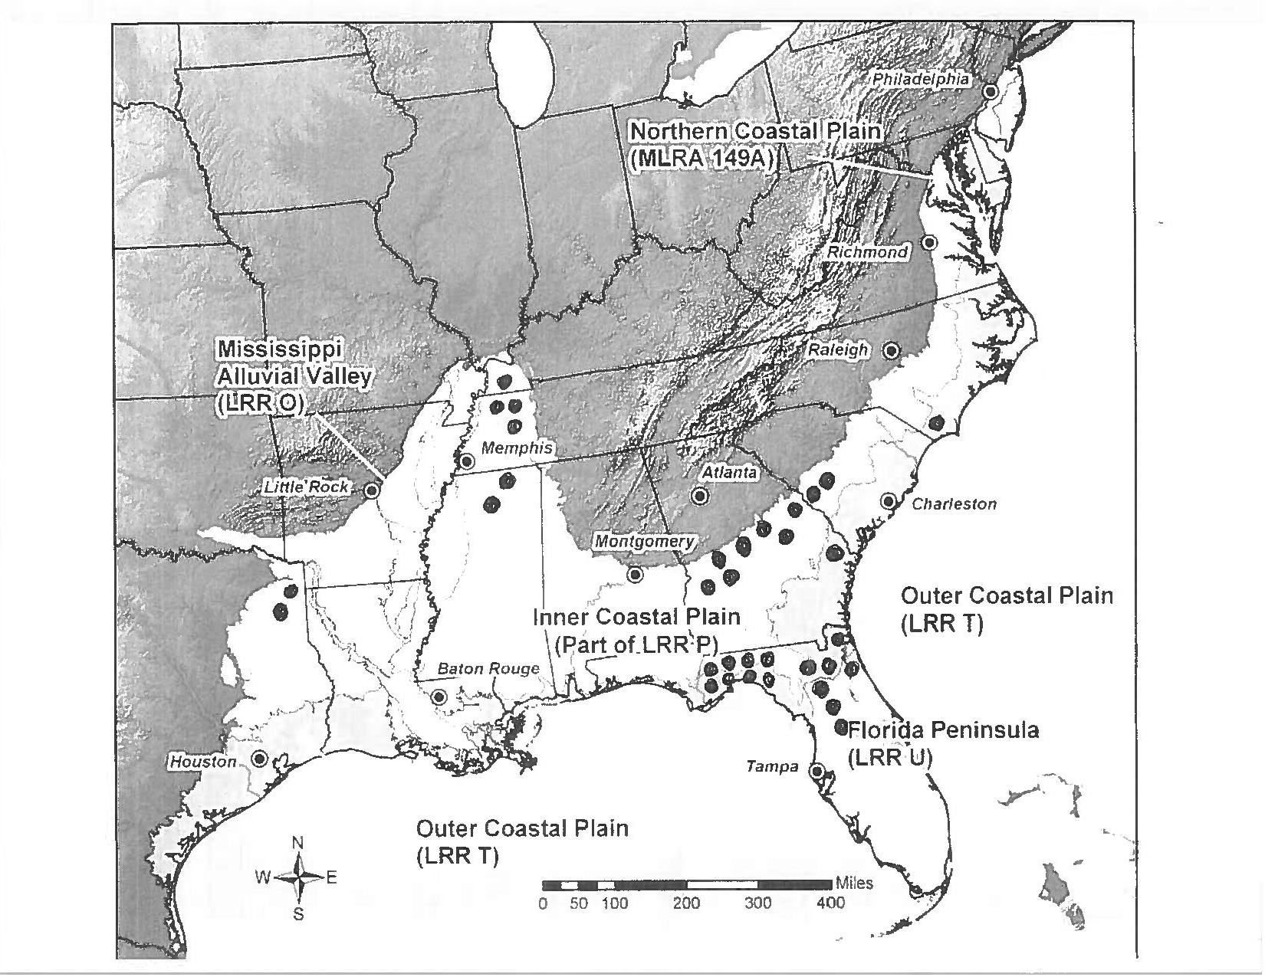

FIGURE 2, Gulf Coastal Plain with key clay mining areas notated

5.

Calver’s Findings Corelate to the Archaeological Record

Calver’s survey of sources of kaolin and clays known, present and mined in Florida as of
1949 correlates with the major ceramic types and chronologies in Florida archaeology. His
map (Fig 1) shows the areas assigned to the Deptford cultural region: Nassua County,
Jefferson, Gadsen, Leon Jackson, Holmes, Wakulla, Liberty, Bay, Washington, Walton, Santa
Rosa and Escambia counties. (FGS) Most instructive is that Calver describes the color and
quality of the clay at each site in that county and the depth. Many clay beds, that is easily accessible sources of local clay in creek and river beds and at pond and lake sights are noted. The
same areas with clay beds were subsequently accessed by the Santa Rosa and Swift Creek cultures, the Weedon Island culture and later in the Fort Walton culture ( Milanich ).This methodology, using current and historical records and surveys of clay deposits and
geographically corelating that data with prehistoric and post-contact culture regions, is
applicable to understanding cultures like the Hopewell and Mississippi or anywhere in North
America for that matter.

Likewise, sites still producing plastic clays suitable for ceramics in the twentieth century
were the sources for the St. John and Alachua cultures? Of particular interest was the available
clay beds in coastal areas. Clay producing areas were available in the Archaic period, since the
shorelines extending far out from their present location. Calver’s map (fig 1) shows this with the
boundary area extending to the Gulf coast right to the big bend. On the Atlantic shoreline the
same availability of coastal clays extends to the Indian River (FGS).
Perhaps the best supporting Florida clay resource is the website, www.us-mining.com. A
simple search by Florida county, list all clay mines at a glance. This updated website, allowed
me to locate the physical locations of clay pits and beds and corelate them to known
archaeological sites in the same area. Referencing the new graphic (fig 3) when you compare it
to the entire Deptford culture region, it matches 100%, with the large dip of non-clay areas in
western South Carolina and northern Georgia and Alabama. The same could be said for the Swift

6.

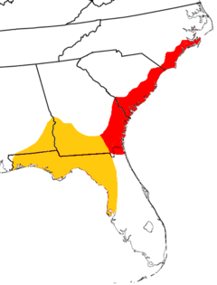
FIGURE 2 Deptford Culture Region, Wikipedia

Creek/Santa Rosa cultures, who occupied the most historically kaolin rich region in the United
States.
The result of that methodology, resulted in the conclusion that well-established ceramic types
were actually obtained through trade. An example is Englewood. The closest source of clay for
Englewood would have been one hundred miles Northeast in present-day Polk County. Likewise,
all Safety Harbor excavated in the Manasota Culture (Mitchem) region traveled a considerable
distance from at least Polk County or possibly farther
In terms of trade, economics and politics, the clay rich northern cultures clearly had an
advantage. Advantages and status, more than likely extended to villages and chiefdoms within
the larger culture regions whose lands had the best quality and abundant amounts of clay.
Recent discoveries and research has shown that pottery became important to hunter-
gatherers. when preferences shifted to marine aquatic resources. A global trend beginning in the
Early Archaic has emerged showing the reliance on pottery for the cooking of fish. (Science
Digest.com) This new research adds greatly to our understanding of Orange ware and the
diffusion of ceramic technology from its originating point at Stallings Island.

Unique Cultural Variations

Unlike most regions in North America, native Americans who occupied more than half of
the Florida peninsula from 1000 B.C. to the Nineteenth Century did so without any local source
for clay. The cultural regions involved were the lands of persistent fishing-hunter-gathers. Their
ways and subsistence at any age did not require pottery. Their burial customs excluded sacred

7.

vessels (Moore), simply because they could not make them. As the Calusa’s material record
illustrates beautifully less plastic but equally valued materials such as shell, bone, wood and
stone can make an impression Cushing). Did the cultures in the central and southern regions?
appreciate pottery? Absolutely, it was great for cooking. Feasting was made easier. However,
such utilitarian uses, did not necessitate anything more than simple, durable, and undecorated
vessels. A review of the archaeology of sites, mounds and middens in these clays less counties,
other than larger regional ceremonial center, proves this out. This is so for those cultures from
Sarasota clear up to Dixie County on the Gulf Coast, were the record shows large caches of
sophisticated and ornate vessels associated with burials of social elites (Cushing ) (Moore) (
Bullen et. al). Such trans-regional burial centers were the exception and not the norm. The
occupying fishing-hunter-gatherers traded for the plain ceramics they needed for subsistence
activities.
Clearly my findings point to a particular trade, born of necessity and found nowhere else.
It appears now, the vast number of coastal people from the Late Archaic to the contact period
relied on villages in the interior for plain sand-tempered pottery bowls and vessels. In exchange,
the aquatic marine villagers could trade shell, shellfish and the bounties of the sea. The
archaeological record clearly shows the persistent occurrence of St. Johns types in these western
and southern regions, (Sears) indicating working trade alliances. Other types found plain or
incised such as: Pinellas, Pasco, Sarasota are not markers of a particular culture such as St. 9.
Fort Walton or Weedon Island. The archaeology and resulting new taxonomy and chronology of
a “Manasota Culture (Almy and Luer) mention a tradition of plain utilitarian ceramic bowls by
that culture, but did not proceed to type these findings as Manasota Plain. They could have,
without petrography, have been produced anywhere. Short of scrambling to find thin examples
for such mineral/chemical testing, it can be reasoned that many of these types originated from
the nearest region that had sufficient amounts of local clays. Economic principles then as now
determine, especially for everyday uses, that required or desired goods be reasonably accessible.

Sand Hill Ceramics North Carolina Study

While the literature reveals a wealth of ceramic compositional analysis (Bishop and Neff),
a research project closer to home, and one that involves very similar prehistoric components was
conducted by Joseph M. Herbert and Michael S. Smith (2004) involving the ceramics recovered
from the Fort Bragg site and other archaeological sites in the North Carolina Sandhill area. As
the name implies, the area is primarily sand and devoid of clays. Their research set out to
determine the source or sources, Piedmont or Coastal for the ceramics found in the Sandhill.
Their initial results from mineralogical groups and geochemical groups were promising,
indicating the majority of test sherds were of ceramics produced a hundred mile southeast in the
Gulf Coastal Plains. (Herbert and Smith).

What About Glade and Belle Glade Pottery?

8.

Understanding the ramifications of my research, I pressed on. Surely the entire southern
“Glade” culture region and “Belle Glade” culture region” could not have been clay less. I
returned to Tallahassee and found an obscure thesis on clays in south Florida. The master’s thesis
by Susan L. Klinging, Florida, 1985 was a survey of a green-grey clay found in the Tamiami
Formation.Klinging referred to the clay as “LaBelle “clay which was found due to wells being
dug in north central Lee County. Klingings survey was exacting and I soon discovered that there
could be no clay beds then and now of this clay since after thorough investigations, the closest
deposits to the surface and few at that level were at a depth of 20 feet. Characteristic of the soils
in south Florida, LaBelle clays are below large amounts of sand. Therefore, even if clays found
in the LaBelle deposits were plastic and of a quality suitable for ceramics, which they are not,
they require deep mining through sand in order to extract them.
I determined that the last remaining source on the existence of or non-existence of clays in
South Florida was the South Florida Water Management District geologists. My request for \
documents came up zero (Bozeman). Only one other source remained, that being construction
companies. I contacted a major construction firm, Eden Construction in Southport, Florida, who
have done major projects around Lake Okeechobee. They would have first-hand experience
pertaining to clay in the basin area. They informed me that they have never encountered any clay
in the area. A survey by the Florida Bureau of Natural Resources on the Lake Okeechobee area
supported Eden’s claims ( Stingfield). So much for Belle Glade pottery.
Being an experience potter since 1998, I have a general knowledge of clay types, colors,
additives and temperatures. In addition, most of my pieces have been hand-built using traditional
native American techniques for construction and decorating. I decided to review all the “types”
of ceramics that archaeologists have assigned to places and cultures in south Florida. I was
amazed at the number of local redware types. Minerals and temperatures determine the color of
the fired vessel. An example is redware. The clay is not red. The color occurs when a clay
containing enough amounts of iron oxide are is fired. Iron oxide is found nowhere in Florida.
In order to have redware in south Florida, the clay had to come from Georgia or a Caribbean
Island like Jamaica. “Painted pottery” refers to a style where the slip has mineral agents. For a
red outer-surface hematite was often used by aboriginal potters. There were several types
catalogued for Florida: Crystal River, Glades, Belle Glades and Biscayne-Dunn Creek redware.
Lacking those exotic minerals, none of the ceramics of that type could have been produced in
Florida. Crystal River could have traded for the mineral, but the southern complexes had to
import the minerals and the clay.
Important for this research was to contact Ann Cordell who is in charge of the ceramic
artifacts at the Florida Museum of Natural History in Gainesville. I needed to know what test on
Glade and Belle Glade ceramics showed. The tests showed quartz, sand and large quantities of
sponge spicules (Cordell). Standing alone, these would characterize the majority of kaolin found
anywhere in the Gulf Coastal Plain. Going forward, a possible method would be to get clay from
the through running through Polk, Lake and Marion Counties, fire it and compare it with the
Glade and Belle Glade samples.

First Accounts

9.

When compiling my research, I remembered the earliest account of mineral-poor south
Florida. The first first-hand account was by Escalante de Fontaneda, the shipwrecked captive of
the Calusa. He recounted in his 1565 memoirs an impression of the Mayaimi people living near
Lake Okeechobee:

“These Indian occupy a very rocky and a very marshy country. They have no product of
mines, or thing that we have in this part of the world.”

Not to read too much into his remark, but this was his first impression. It is easy to infer that
Fortaneda believed that their lack of minerals was a significant point. Similar remarks by the
earliest archaeologists of Calusa sites on the southern Gulf coast focus on the absence of pottery
in burial mounds.
There are also the first accounts, first impressions and in the case of early Nineteenth
Century archaeologist, Clarence B. Moore first hypothesis. After many seasons of excavations
in Florida, Moore wrote:

“Presumably, then, the custom to inter earthenware vessels with the dead obtained but little,
if at all, along the Florida east coast, and the lower half of the west coast of peninsular
Florida.”

Moore in his journals remarks on the large cache of excellent ceramic types excavated by Frank
Hamilton Cushing at a burial mound in Tarpon Springs. His remarks carry weight, due to the
very limited excavations north of Charlotte Harbor on the west coast of Florida. Moore had
excavated many more sites. So, when he called Cushing’s finds as uncharacteristic of the region,
he was correct. Ripley Bullen et. al painstakingly identified each of Cushing’s ceramic types in
1970. The Safford Burial Mound. It now turns out produced the greatest amount and variety of
imported ceramic types ever found in Florida.
Moore, though relying on generalizations, commented further:

“Superior as is the earthen ware of the northwest Florida coast to most of that of the
peninsula, it does not excel a few of the finest specimens met with by us in the mounds of
the St. Johns River.”

To sum up Moore’s experienced assessment of the aboriginal ceramics in Florida, Florida’s
northwest coast has the finest overall, with the exception of a few found in the northeast.
True to science, Moore offers two hypotheses for the absence of fine earthen ware vessels in
burial mounds outside of the northeast and northwest culture regions. First, they had such fine
earthen ware but they chose not to use it in burials and second, the finest these regions had was
imported. My investigation of clay deposits affirms Moore’s second hypothesis, but with a cause.
For peninsular Florida, not only burial vessels, but equally all every-day earthen ware was
imported. Therefore, Moore’s assessment correlates entirely with Calver’s 1949 survey of
Florida kaolin and clays (fig. 1).

Raw Clay as a Trade Good?
10.

Researchers who have never worked with raw clay have suggested that like hard mineral
resources, clays could have been traded to culture regions for pottery production. Christopher Columbus wrote an account of stopping a canoe laden with goods, including raw clay in the Caribbean. While only a single documented instance, it does open the conversation about clay-rich societies trading in clay with their clay -poor neighbors. Clay that is has been hydrated is very heavy. The quantities needed would be virtually impossible to transport over land or by canoe. The aboriginals lacked containers necessary for such transport. Clays can be easily dried, but again containers would be necessary. Dry clay travels poorly by water transport. Once water comes in contact, the transporter is stuck with a slimy mess. Baskets, the kind they must have used for their shell and earthwork constructions could have been used to transport clay. But again, if it was for many miles, the likelihood decreases with long distances. Therefore,
I maintain that only fired and durable, finished ceramic vessels were exchanged.
Mineral additives for ceramics used by the aboriginal pottery-producing cultures of
southeastern region of North America are well documented. Being in dry form, they were very
portable. These additives used in paints, ceramics and burials, were very desirable. In terms of
this article. They are likewise very traceable. Archaeologists often note such imported resources
in their descriptions, but more than often they never ask the important questions. An early
example was C.B. Moore while excavating an unnamed burial mound in Gaspirillo Sound, just
north of Boca Grande, Florida noted hematite, not native to Florida being placed on the floor of
the mound (Moore). Bullen in his investigation of ceramics from Cushing’s excavation of the
Safford Mound, identified micaceous pastes used on the surface of both a Chrystal River, as well
as a Safety Harbor vessel Bullen et. al). The closest source of mica for these cultures was the
Piedmont and Southern Coastal formations on the Florida-Georgia Border.

Assigning Causation for Absence of Pottery in South Florida

Jerald Milanich concluded in his chapter on south Florida in 1994 (p 277):

“Indeed, the lifeways of the pre-Columbian native American Indians, who lived in these
southern regions after 500 B.C. were probably not too different from those practiced by
many northern Florida societies.”

When you read the journals of both Frank Hamilton Cushing and Clarence Moore, first
impressions by both men conclude major observational difference north to south. Because both
men had excavated sites in the Weedon Island region (Crystal River and Tarpon Springs) and
Charlotte Harbor to the Ten Thousand Islands, they drew conclusions based on significant
difference. Clarence Moore was the only archaeologist of his generation to assign a cause for the
lack of pottery in southern mounds. Even if there were geological surveys for the regions, and
there were not, it was not a common process to access geological facts, other than the most
obvious, in their investigations. Moore concluded incorrectly that the southern societies elected
not to use pottery (p 304). Moore’s comments on the differences between northern sites and
southern sites were very detailed:

“As a result of this part of our journey of the season of 1904, we formed certain conclusions,

11.

and fortified others which we had previously expressed in print namely:

- That while the shell deposits of the southwestern coast of Florida are of great interests as
monuments of the aborigines, their contents offer little reward to the investigation.

- That the sand mounds of the southern Florida coast were built mainly for domiciliary
purposes and that such contain burials yield but little pottery, whole vessels being
practically absent.’

This absence of whole vessels was supported by Cushing’s findings at Key Marco. Based on
Marion Gilliland’s eventual published record (1989) of ceramics from the Key Marco
excavations, a total of 34 sherds or pieces of body and rims remain and another 8 cataloged
by Cushing are missing. A detailed curator, Gilliland classified the pieces of pottery as
Glades, Belle Glade, Goodland and one Lake Jackson and one Pinellas plain. (236).
Historically, Cushing was the first to dig up examples of south Florida pottery. He did not
however, make any assumptions about the origins of the pottery excavated. Nor did Cushing
draw any conclusion about the absence of pottery. Clarence Moore did:

- That the failure of the aborigines to place earthenware with the dead, in mounds along
the southern Florida coast, did not arise through lack of its possession, but rather that the
custom of doing so did not obtain there.”

That the irony is that the absence of burial pottery was due to the lack of clay, a matter of
circumstance and not of choice, even today is profound. In hindsight however, the absence of
clay in south Florida, a geological fact of nature, actually provides greater insight into the
ways and material cultures of the woodland Indians adapting to that environment.

Goggin and the Perpetuation of southern Florida Ceramics

Driving the assumption of the existence of available clay beds and a series distinctly
southern Florida taxonomies and chronologies was the work of one man. The history and
circumstances are particularly relevant to the research. John M. Goggin left Florida to
complete his undergraduate work at the University of New Mexico. He was twenty-three
years old when he authored his first article, A Ceramic Sequence in South Florida, 1939.\
In 1940, Goggin published The Distribution of Pottery wares in the Glades Archaeology. He
remained in New Mexico doing research of the pueblo cultures from 1941-1942. One could
conclude that Goggin was determined to be a big fish in a new pond. However, all of his
research on the ceramics of south Florida was from a great distance from the subject area.
Because of his undergraduate interest in ceramics taxonomy and chronology based on
ceramics, it was no accident that Goggin went to Yale to study with Irving Rouse. Influenced
by Rouse, his new cultural historical method, when Dr. Goggin, now thirty-two years of age,
moved back to Florida he had published and had the credentials to make a name for himself.

12.

To assure his reputation, Goggin authored complete taxonomies and chronologies for the
Florida peninsula (Milanich). Before his passing in 1963, John Goggin was the de facto
authority on the ceramics of aboriginal south Florida.

I have noted that the first survey of Florida kaolin and clays was not published till 1949.
The early researchers like Moore and Cushing had no geological data for Florida. Geological
data as well as clay mining was available to Goggin. In fact, the center for Florida
archaeology had shifted to the Florida Museum by the 1950’s. Soon, all of the natural
sciences collaborated with archaeology.
Those anthropologists whose careers were tied to a single cultural region defined by
ceramics, those of the Rouse school, have passed on. With the exception of Jerald Milanich,
Few contemporary anthropologists will be upset by the news of a clay less south. The
majority of anthropologists feel as C.B. Moore did, that there are few rewards in excavating
southern sites. Those anthropologists who have reasoned that the assemblages of note are the
shell and earthworks will continue and will find other ways to date and determine the
chronologies.
I have always felt that the determination of a “Belle Glade” culture and culture region
was premature. The only extensively excavated site, Fort Center, being a regional ceremonial
complex and not a village is not enough to support a “Belle Glade” culture. Establishing that
Belle Glade ceramics I -IV (Sears) (Milanich) were not produced there will force
researchers to rethink the entire archaeology of the region. My findings now prove that
twenty- one separate ceramic types in the south Florida regions were all imports. All were
isomorphic ally similar and none are considered fine or decorative ceramics. Equally
important is what these findings imply for the Safety Harbor culture.

Safety Harbor Redefined One More Time

Unlike the plain and utilitarian pottery credited to the southern culture regions, ceramics
used in burials defined the Safety Harbor culture. At the end of the Twentieth Century,
Jeffrey McClain Mitchem set out to extend the power and influence, the geographic territory
of the Tocobaga by an inventory of Safety Harbor vessels found in Florida. (Mitchem 1989)
By its name sake, the Tampa Bay area has been considered by archaeologists to be the
cultural and political center for the Safety Harbor people. Mitchem’s dissertation Redefining
Safety Harbor, using records of excavated Safety Harbor ceramics extended Citrus County in
the north to Sarasota, Manatee, Hardee and DeSoto counties in the south. Safety Harbor with
their impressive ceramic tradition, based on my geological investigations, had only a
relatively small area clay present on the far eastern border of their projected culture region.
These were the clay beds and pits in the area around Lake Marion in present-day Polk
County. These findings corelate to Mitchem’s conclusions about the Philip Mound on the
eastern side of the lake and the Safety Harbor artifacts found at the burial mounds.
The first to question the validity of the taxonomy and chronology for the Safety Harbor
culture was Randolph Widmer (Widmer 1988). Widmer while discussing the Caloosahatchee
Period IV, commented in the period marked by the increase in decorative trade ceramics in

13.

Calusa burial mounds. He expresses disagreement with Bullen’s (1978) view that Safety
Harbor is the ceramic manifestation of the Tocobaga:

“Bullen has suggested that the Safety Harbor Phase is the archaeological manifestation of
the ethnohistoric group the Tocobaga. This is partly accurate, but this phase, as
represented by its ceramics, is not isomorphic with the Tocobaga., particularly since
Safety Harbor ceramics extend geographically into the Charlotte Harbor area (Bullen
1969:418) which is the the heartland of the Calusa (Goggin and Sturtevant 1964 and also
into southeast Florida (Willey 1949a)… A more reasonable interpretation, the one
suggested here, is that Safety Harbor material culture is typical of both the Tocobaga and
the Calusa.”

I have always felt that post Goggin, archaeologists have been eagerly throwing the baby
out with the bathwater. Researchers advancing the Belle Glade culture felt that it was critical
to remove the Calusa from any significant relationships (Sears 1982). One such academic,
Jerald Milanich, who has been more than happy to reduce the import of the Calusa on the
prehistory of the peninsula, picked up on Widmer’s statements and offered a
response. (Milanich 1994):

“Occasionally, Safety Harbor decorated vessels or sherds are found in sites well beyond
the central Gulf coast, such as in the Caloosahatchee region in southwest Florida
(Widmer 1988:86). But these most likely are items of trade that appear as nonlocal
artifacts in other cultural contexts. The presence of Safety Harbor pottery in
Caloosahatchee mortuary contexts do present a taxonomy dilemma. If the presence of
Safety Harbor pottery in mounds is the basis for defining that culture in the central
peninsular Gulf coast region, why is this also not true on the south west Florida coast?
For now, it is most convenient simply to ignore the anomaly…. leaving future
archaeologists with more data on hand to sort out the situation.” (Milanich 1994:390-
391)

As with Glade and Belle Glade ceramics, compositional analysis test on Safety Harbor
type sherds can be compared with fired clay samples from the area to see if they match in key
elements. Likewise, Englewood and Crystal River Incised, Sarasota, Pinellas and Pasco
Plain need to be compared to fired clay samples from the closest possible sources in Polk,
Lake and Marion Counties.

Sand Hills Ceramics Research Project 2004

While researchers Bishop and Neff have made a career analyzing ceramics in order to
geographically determine their cultural origins, a study done in North Carolina illustrates
the type of study needed in Florida. Herbert and Smith wanted to find out the origins of the
ceramics commonly found in Sand Hills sites, like Fort Bragg in North Carolina. Unlike
Florida, they knew the geology of the Sad Hills and that no clay was present. Similar to

14.

Florida, clay was abundant and used by the prehistoric peoples to the west in the Piedmont,
as well as the clay rich coastal areas to the southeast. Clay from each of the two areas was
collected and tiles were made and fired to match with thin slices of sherds from the Sand Hill
finds. While not conclusive do to not enough samples for testing, the results indicated that
the Sand Hills people relied on the coastal villages for their ceramics.
With similar testing in Florida, we could discover that even farther away, the sources for
most central and southern ceramics was the Florida panhandle and not the north central
peninsula. Even more intriguing would be test on ceramic types associated with very
southern sites in Miami, The Everglades and the Florida Keys. Many Caribbean islands are
rich in clays.

Discussion

The only appropriate response to my findings in rebuttal is to locate clay sources in the
areas investigated. An inappropriate response would be as Milanich stated to “simply ignore”
my findings for convenience. When in the same paragraph, he chose to wait on the Safety
Harbor/Calusa ceramics issue for more data, he was confident that intrusion by the Safety
Harbor culture into the Calusa heartland would be proven. Anyway, I guarantee my data was
not the data he was waiting for. The chances of so many Florida archaeologists being caught
empty-handed is rare. As the geological survey demonstrate few large regions in North
America have a total absence of clays. You would have to travel to the northern Great Plains
to have to deal with the issue. So, the chances were slim indeed that archaeologists in south
Florida would ever need to question the availability of clays for indigenous cultures.
Looking forward, my findings will force archaeologists to conduct the detailed work that
was always required, ethnographic analysis. Researching in order to understand the many
important facets that determine a culture, its region and existence in time. The Calusa and the
Mayaimi flourished for some twenty-five centuries. It was not ceramics that made that
successful adaptation possible. One of the earliest researchers, C.B. Moore was blatantly
honest, when he wrote in his journal that finding fine and complete ceramics was the reward
that made his efforts worthwhile. That generations of archaeologists enter the field and find
themselves lost and disappointed when no ceramics or a few plain sherds are recovered,
speaks poorly of the discipline. I welcome every cultural anomaly that comes my way. South
Florida pre-Columbian research is definitely not for those seeking convenience. I am pleased
to author an inconvenient truth of a clay less region.

Conclusions

In the forward to Patrick Sean Quinn’s textbook Ceramic Petrography; The Interpretation
of Archaeological Pottery and Related Artifacts in Thin Section, the author describe4s the pre-compositional analysis techniques used by all researchers and codified in Irving Rouse’s
method. Those: being simple visual observation of their gross forms, Observation and
classification by surface decoration and even preferred vessel function. All of these
techniques have given us types and periods of Florida ceramics focused on rims, incised

15.

lines, stamped textures. and including tempers in every case the actual clay is not studied, nor
is the availability of the clay resource in the culture area questioned? While in Florida with its lack of exotic minerals, anthropologists commonly research the distant origins for lithic
artifacts, clays that have both lithic and chemical signatures have been assumed to be local
to the areas where the ceramics were found (except for obvious examples of trade goods).
In Florida, we can learn a great deal from Herbert and Smith’s study in North Carolina.
There they were dealing with hunter-gatherers and more importantly a region with haves and
have nots. That is, the study area had several neighboring cultures some with clay and others
without clay. We can also learn a great deal from their conclusions. First the sample size
required for such studies.

“The ability to discriminate between these two sources of variation (cultural or
environmental) requires that we increase the sample size of the pottery from each region
and also expand the dataset by collecting raw clay samples for comparison”

The subject of trade ceramics is well established. There are always the pitfalls of
assigning a ceramic type that is nonlocal to a culture. The chances of making this
mischaracterization increase when the examples are few in number. Correspondingly, the
probability increases with the frequency. As a result of my research there are ten recognized
types of ceramics assigned to central Gulf coast culture regions and twenty-one types
assigned to the entire southern portion of peninsular Florida that could not have been
produced locally. Geological Surveys produced by Florida and the United States Geological
Surveys limit the origins of these thirty-one ceramic types to two areas in northern Florida.
Both areas have secondary deposits of both kaolin and ball clays required for hand-built
ceramic vessels and bowls. Both areas have clays formed in the Gulf Coastal Plain, thirty-
five to fifty million years ago. Utilizing a variety of testing techniques and enough samples,
most of the thirty-one ceramic types can be traced to one or both of the clay areas in Florida.

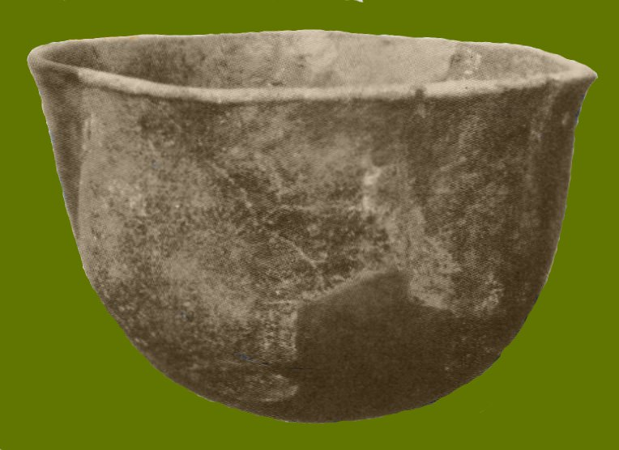

FIGURE 4, Glade Plain Ceramic Bowl, Southern Florida

REFERENCES CITED

Almy, Marion and George Luer

Bloomfield, Linda, Technofile: Geology For Potters, Ceramics, http://
ceramicartsnetwork.org

Bozeman, Juanita, Public Records Request, Documentation of Clays in South Florida Water 1918 Management District, West Palm Beach, Florida

Benson, Carl A., The Philip Mound: A historical Site, The Florida Anthropologist, Vol.20, 1969 Nos. 3-4

Bullen, Ripley P. et al, The Safford Mound, Tarpon Springs, Florida, The Florida
1970 Anthropologist, September 81-118

Calver, James L., Florida Kaolins and Clays, Florida Geological Survey, Special Publication
1949 No. 35, http:// publicfiles.dep.state.fl.us/FGS publications

Cordell, Ann S., Personal Communication, Gainesville, Florida, Florida Museum of Natural 2018 History

Cushing, Frank Hamilton, The Lost Manuscripts of Frank Hamilton Cushing, Edited by
2005 Kolinos and Weisman, Gainesville, Florida, The University Press of Florida

Fontaneda, Escalante de, Memoirs

Gilliland, Marion S., Key Marco Material Culture, Port Salerno, FL, Florida Classic Library, 1989

Goggin, John M. A Ceramic Sequence in South Florida, New Mexico Anthropologist,3:35-1939 40
1940 The Distribution of Pottery Wares in the Glades Archaeological Area of South
Florida, New Mexico Anthropologist 4:22-35

Herbert, Joseph M. and Michael S. Smith,
2004

Hosterman, John W., Ball Clays and Bentonite Deposits of the Coastal and Western Gulf of 1984 Mexico Coastal Plain, United States, Washington, D.C., Geological Survey
Bulletin, 1558-C

Klinging, Susan L. The LaBelle Clays of the Tamiami Formation, masters thesis, The State
1987 University of Florida, Fall Session

Krause, Richard A. A Universal Theory of Pottery Production: Irving Rouse Attributes
2016 Modes and Ethnography, Tuscaloosa, Alabama, The University of Alabama Press

Matson, George C., Clays of Florida, Notes on the Clays of Florida, Washington,
D.C.,United States Geological Survey U.S., Department of the Interior

Means, Guy, Personal Communications, Tallahassee, Florida, Florida Geological Survey,
2018 Florida Department of Environmental Protection

Milanich, Jerald T. Archaeology of Pre-columbian Florida, Gainesville, Florida, The
1994 University Press of Florida

Mitchem, Jeffrey M., Redefining Safety Harbor, Prehistoric / Protohistoric Archaeology in 1989 West Peninsular Florida, Masters Dissertation, University of Florida

Moore, Clarence B., The West and Central Florida Expeditions of Clarence Bloomfield
1989 Moore, Edited by Jeffrey M. Mitchem, Gainesville Florida, The University Press
of Florida

Quinn, Patrick S. Ceramic Petrography: The Interpretation of Archaeological Pottery and Related Artefacts in Thin Sections

Sears, William H. Fort Center, An Archaeological Site In the Lake Okeechobbee Basin,
1982 Florida

Stingfleld, V. T. Ground Water in the Lake Okeechobee Area, Florida
1933

Virta, Robert J., United States Geologic Survey, Mineral Industry Surveys Directory of
2001 Companies Mining Specialty Clays In the United States 2000., Reston, Virginia

White, William A et al, Randazzo, Anthony J. and Douglas s. Jones, Editors, The Geology of 1997 Florida, Gainesville,The University Press of Florida

Widmer, Randolph J., The Evolution of the Calusa, A Nonagricultural Chiefdom on the
1988 Southwest Florida Coast , Tuscaloosa, Alabama, The University of Alabama
Press

Databasr, www.us-mining.com, search of mines by Florida counties

