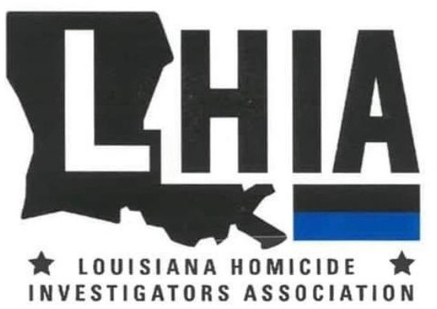

**Louisiana Homicide Investigators’ Association**

**Training Symposium**

**September 08-12, 2025**

**L’Auberge Lake Charles Hotel & Casino**

Registration Form

*(For Commissioned Law Enforcement Officers Only)*

**$175 REGISTRATION FEE PER OFFICER**

**No refunds issued after August 1, 2025. Credits may be issued for future training events.**

***\* 1 Complimentary registration will be provided with every 3 paid registrations per agency.***

This event is approved by POST to satisfy the POST Homicide Investigator Training Requirements (LA RS 40:2405.8).

**Agency Name: ___________________________________________________________**

*Name of Participant: ______________________________________________________*

*Phone: _______________________ Email: _____________________________________*

*Name of Participant: ______________________________________________________*

*Phone: _______________________ Email: _____________________________________*

*(Please make additional copies if you are sending more than two participants from your agency.)*

***Submit registration and payment to: LHIA***

***PO Box 1***

***Port Allen, La 70767***

Attendees are responsible for making their own hotel reservations. To obtain the special conference rate of **$129**, plus applicable taxes and/or resort fees, please call **866-580-7444** and provide code  **SLHI25.**

**These rates will be available until 8/27/25.** Reservation deadline is firm. Reservations made after August 27, 2025, will be accepted based on rate and/or availability.