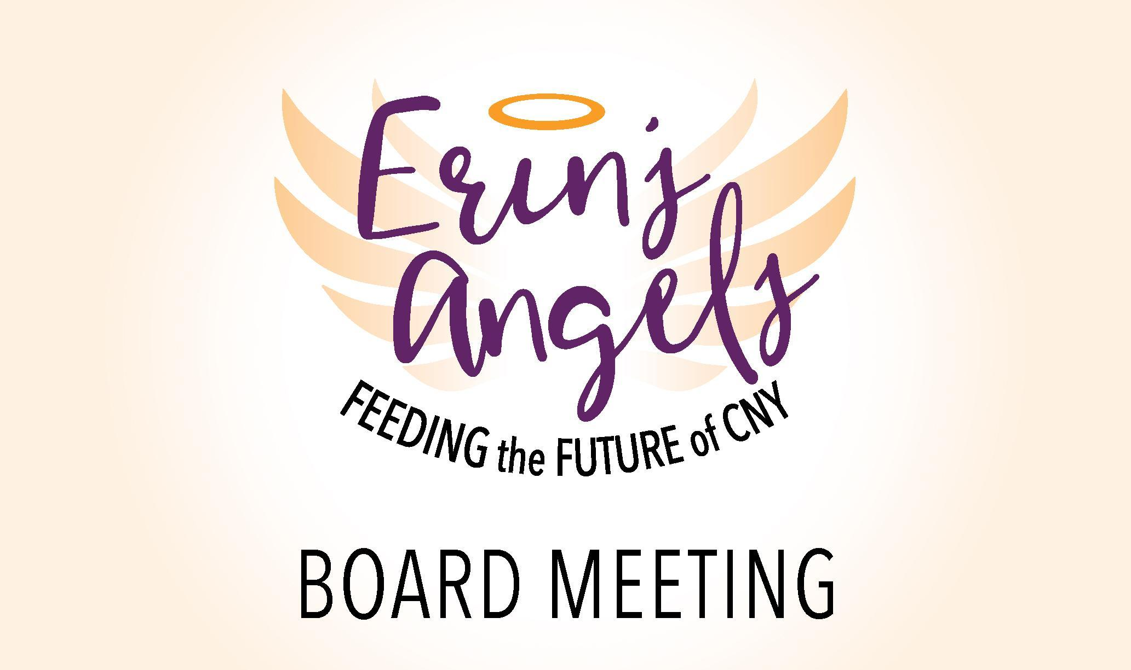

**12.17.2020 6:30 pm**

**Board Meeting Minutes**

**Zoom Meeting**

[**https://us04web.zoom.us/j/79240105290?pwd=VGxvb0FZb1BNTUQvVVR1ZW1Pb3NwQT09**](https://us04web.zoom.us/j/79240105290?pwd=VGxvb0FZb1BNTUQvVVR1ZW1Pb3NwQT09)

**Meeting ID: 792 4010 5290**

**Passcode: 467289**

**OR**

**Dial in by phone**

**+1 929 205 6099 US (New York)**

**Attendance:** Sheila Dion - Founder, Alissa Tubbs - President, Connie Deshaies - Vice President,

Barb Stone- Treasurer, Erica Ward - Secretary, Jennifer Dubovic, Jim Graham, Linda Bulgrien, Jackie Flint

**Absent:** Stephanie Earle

**Call to Order: 6:35 pm** (1st, Connie and 2nd by Jim)

**Approval of Previous Meeting Minutes:** Approved with edit to spelling of Bloomerang

**Treasurer's Report:**

* Barbs Update: Shared screen to show, 3rd and 4th quarter expenses, revenue,deposits etc.
* Current Balance: $122,829.89
* Barb would like to set a threshold for Sheila to be able to make Operational Purchases. But will talk about it in new business.

**Old Business:**

* Emergency Policy and Procedure Update-(on hold this is a reminder so we don’t lose the item)
  + this will be moved to a working document on the google drive
* *Looking for an accountant/CPA to sit on the board* (on hold this is a reminder so we don’t lose the item) *We still have a need. Any ideas or suggestions?* 
  + *This is also being moved to a working document on google drive*
* *Scholarship Criteria revisited - Sheila*
  + *Sheila gathered feedback from the group and will be compiling a draft of eligibility requirements for the next board meeting.*
  + *Areas suggested by board were (2) $250 awardees, Identifying internal and external criteria to evaluate the applicants. Scholarships awarded to, JCB Seniors, Written essay submission required and the potential for the applicant to be a volunteer in the community that correlates back to food insecurity and or an individual that receives assistance from Erin’s Angels.*
  + *Sheila also shared the website is set up for individuals that donate to select the scholarship fund specifically for their donation to be applied too. Alissa asked the Finance committee to be sure these funds are restricted in the bookkeeping end.*

**New Business:**

* Subcommittee Updates:
  + The Finance Committee Update:
    - Committee met in November Link to Notes: <https://docs.google.com/document/d/1yHlrDbRHTvYz7DJ5IlfhPmwsp4Bfvv93qAKeQSnoRZQ/edit>
    - Committee is working to chart and capture expenses, revenues etc to be more detailed.
    - Group Discussion: Parameters of Spending for Regular Operating Expenses
      * Regular operating expenses include but are not limited to Foodbank purchases, supplies and materials for general mailings and daily activities and tasks conducted regularly to maintain the organization.
      * It was voted that Sheila have the ability to spend up to $1500.00 on one invoice without finance committee approvals . (Jim Motioned, Jackie 2nd)
    - **Working on Defining internal controls and responsibilities for individuals making purchases and signing checks.**
      * The Treasurer can sign checks up to $200.00, Checks over $200.00 must be signed by either Sheila (Founder) or Alissa (President)
      * Committee has defined the Organization's fiscal year to be January - December
      * Barb is working to make contact with a local accountant and begin steps to file 990 tax forms.
      * If you need reimbursement for items purchased for Erin’s Angels please scan receipts and email to Barb. She will be able to approve and send a check for reimbursement to you.
  + Fundraising Committee Meeting:
    - Developed an outline of Goals/Fundraising ideas Monthly: Jackie will be gathering this info into a google DOC for access to the entire Board.
    - They identified opportunities for each month of the year, with hope to tentatively plan the work on Cruise for Food to happen this June, will assess COVID guidelines, restrictions along the way.
    - Suggested Video Clip from Board Members to put together a promotional item.

***Strategic Planning:***

**15 minute discussion:**

* **Timeline Updated provided by Alissa:**
  + Outlines of the Board Survey( 9 sections and will take you about 60 min) and The Stakeholder Survey were presented by Alissa.
  + Individuals from the Board were asked to connect with different stakeholders to complete the survey.
  + If someone wants to complete the Survey over the phone, please complete the google form for them.
  + Categories and Assignments: Donors- Jen Shineman and United Way - Sheila Volunteers and local Food Pantry- Connie, School Staff Jackie (Please make sure you’re not connecting with the same people, some individuals may fall into more than one of these categories)
  + **Survey Response should be submitted no later than 1/18/2021**
* **Schedule a Strategic Planning Specific Meeting for January**
  + **Jan 28th @ 6:30pm via Zoom. Please see separate email from Alissa with Calendar Invite.**

**Other:**

* Linda shared that EA is up to 95 families receiving food distribution. Food Supplies are something difficult to come by due to pandemic, but they have been able to fill needs from other stores other than the Food Bank.
* Sheila picked up a $2500.00 donation from Romano Toyota, after a conversation and heartfelt moment, the staff person submitted EA for a Matching Grant for Toyota National.
* Gift Cards were donated by school staff $2000.00 in Aldi and Walmart Cards specific for High School

And $1000.00 in Target Cards for Middle School. School Social Worker told Sheila they have been able to help 38 families with this donation so far.

**Next Meetings:**

1. **Strategic Planning Only Meeting for the entire Board: January 28th @ 6:30 pm via Zoom. Alissa sent a calendar invite.**
2. **BOARD MEETING: February 25th, 2021! @ 6:30pm**

**Meeting Adjournment: 7:38 pm Connie (1st) and Sheila (2nd)**