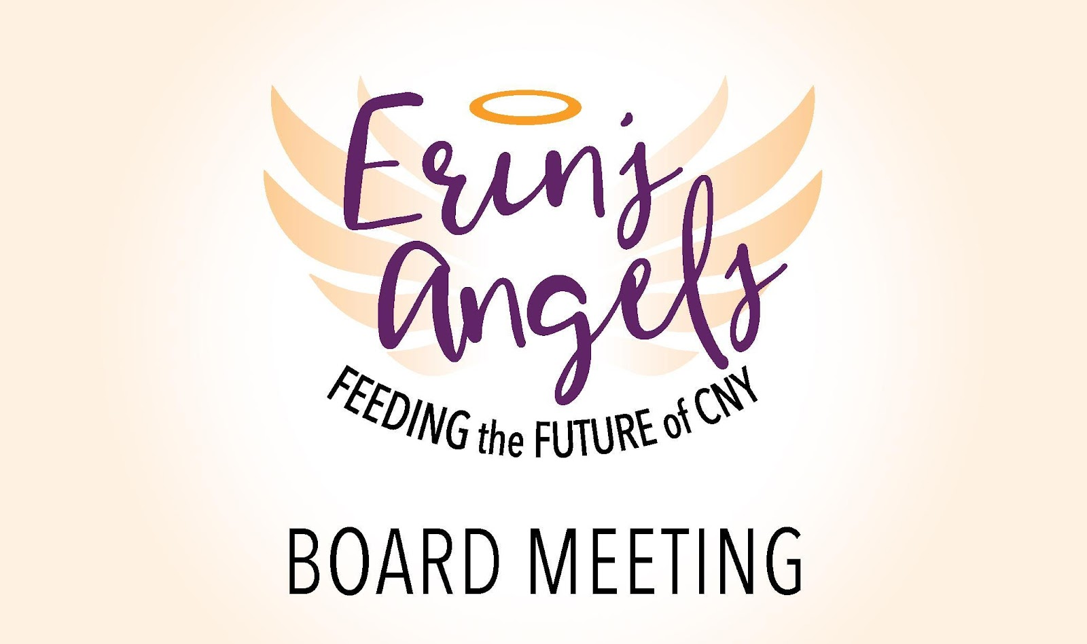

March 20th, 2025

In-Person Meeting

**Attendance:** Sheila Dion, Jackie Flint, Lisa Woodard, Erica Ward, Connie Deshaies, Lu Hart, Maryanne D’addio, Tracy Wimmer, Candy Herbert, Jamie Dix-Currier, Diana Wolgemuth

**Absent:** Stephanie Pestillo

**Call to Order: 6:33pm Time:** 1st – Tracy Wimmer and 2nd – Diane Wolgemuth

**Mission Moment: N/A**

**Approval of Previous Meeting Minutes:** 1st - Lu Hart 2nd - Candy Herbert

**Treasurer's Report:**

* January and February were reconciled by Stephanie Hines, EA Admin.
* Balance: $478.0333.57
* Valentines Day appeal - raised $4,000 First time doing this and will do this again in the future.
* $10,000 Grant coming in from Fidelity
* Applied for Foundation to support staffing. $150,000. EA has made it to the second round of review.

**Board Updates/Logistics:**

* **Secretary Position Nomination and Voting**
  + Review of experience and overview of the current EA roles Marcia already handles.
  + A motion was made to nominate Marcia Grylls as Board Secretary.
  + Vote: 0 – Abstentions All in Favor – 11 votes

**New Business:**

* **Financial and Investment Policy**
  + Tracy put together a sample policy to review. The Board is able to provide feedback at the next meeting prior to voting.
* **Pending items if there is time:**
  + Gift Acceptance policy
    - April Training Session the board will review some of this content during session.
    - Sheila will review and look for the draft policy
    - Board can review, provide feedback and suggestions prior to vote
  + Poverty Simulation (30 minutes is needed)
    - Tabled for next meeting

**Subcommittee Updates:**

Fundraising Committee -Mary Anne

* Appreciation Dinner – In need of a $500 sponsor if anyone has any ideas, please reach out. This is our first year with no new sponsorships.
* Received Vacation Certificates – Lodging is included, you’re responsible for the remainder of the trip. Ideas to utilize these vouchers are: Silent Auction
* International Fest – Details of activities are needed. There is coverage of Board members and volunteers. Sheila will set-up the day prior to the event.
* Local Artisan: Creating and will be selling an Erin’s Angels candle. EA will receive a percentage of each sale.
* Worlds Chocolate – Determined that it’s not cost effective for the return on investment.
* Trivia Night – will allow us to have enough funds to cover next year's scholarships as well.
* Memorial Day Parade - Fans purchased for the parade, fun toys from amazon purchases have been allocated for the parade.
* Tones’ Cones – Special Sundae for just Erin’s Angels - $3 for each sundae. PB&J flavored.
* Jamies Car Club – Will participate in Cruise for Food. Flyer is needed and the Car club is working to help distribute information out to all the car clubs in the area. Needs quick info flyer. A car route will be needed that is shorter and different than the motorcycle route.
* Syracuse Mets – Sept. 10th includes fundraising page, to sell tickets. More info coming soon.

Scholarship Committee- Erica

* April 1st – Meeting to review applications.

Nominating Commitee – Candy

* No updates at this meeting

Advocacy Commitee – Jackie

* The committee is growing. Big push, voting mid-April
* Suggested to bring a sign-in petition clipboard for all events.
* 2 objectives –
  + 1. Healthy school meals to every student for Free (link was sent after the meeting)
  + 2. Erin’s Law

Executive Board – Jackie

* Work on Life Cycles and Bylaws and will provide recommendations. Review and will finalize some details.
* Working on identifying areas of needs

Finance Committee- Tracy

* EW will send a list of Finance people

**Phoenix Backpack Report: - N/A will be available before next meeting.**

**Additional Comments:**

Motion to end meeting: 7:31pm Time: 1st- Diane Wolgemuth 2nd- Connie Deshaies

**Next Meeting:** May 22nd, 2025, 6:30pm

**Meeting Notes - Prepared by: Erica Ward, Secretary**

