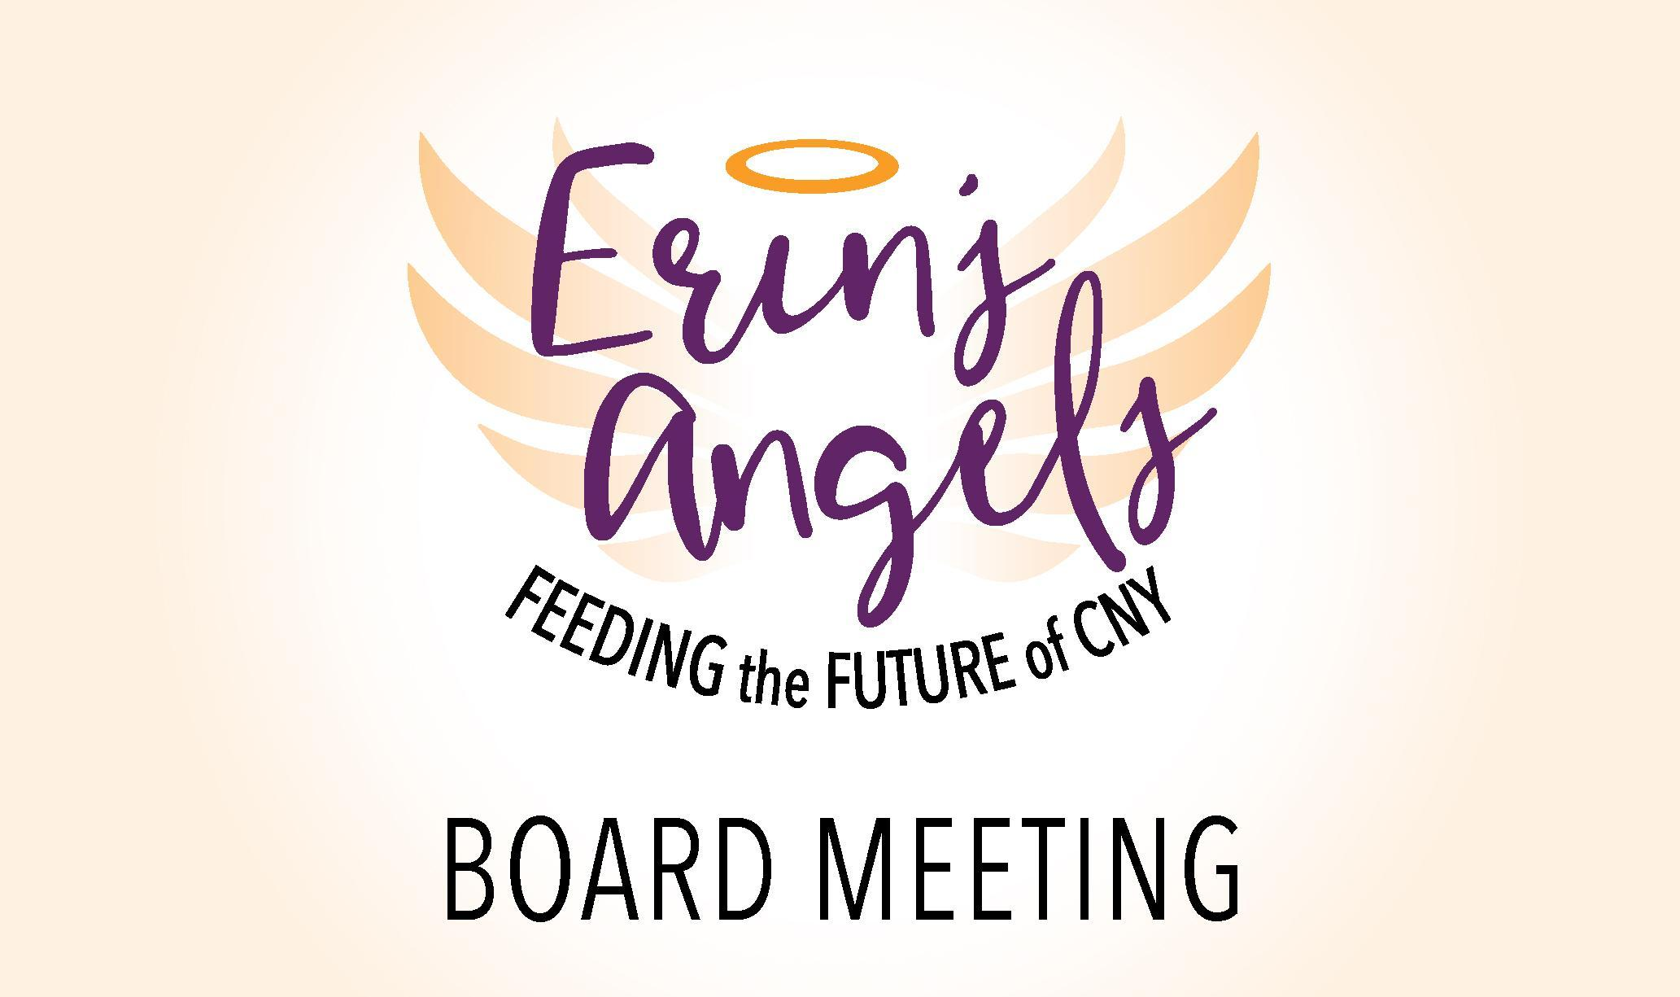

**12.15.2021 6:30 pm**

**Board Meeting - Virtual**

**Join Zoom Meeting**

[**https://us02web.zoom.us/j/81467851541?pwd=WDhydXl3TVJOM25VRjlnVXkwNXc3UT09**](https://us02web.zoom.us/j/81467851541?pwd=WDhydXl3TVJOM25VRjlnVXkwNXc3UT09)

**Attendance:**  Sheila, Erica, Candy, Connie, Jen, Jackie, Kevin, Lisa

**Call to Order:** 6:39 pm Call to order - Kevin

**Approval of Previous Meeting Minutes:**Motion 1st -Jackie, 2nd-Connie

**Treasurer's Report:** Erica Provided an overview of expenditures please see attached document. Total Balance is currently: $ 172,871.08

**New Business:**

* **Redhouse Theatre - For Next Meeting.**
* Volunteer Appreciation Dinner - Mohegan Manor donated space, with an upscale menu. Sheila and Jen are working on this. Payment is covered by Dean and Dan!
  + Guest list is being developed, Connie to let Sheila know about Volunteers.
  + Thursday March 31st is the event, Save the date email and formal invitation to follow.
  + Masks, Vaccination discussion included in the Invite.
  + Thank You gift of shirt and hat choice
  + Food Delivery involves secretary and transportation/Custodians Be sure to include them in the dinner

**Old Business:**

* Mail- is all set and will be picked up on the 10th of each month.
* Scholarship Review-Please review document Sheila sent prior to the meeting.
  + Application was sent for review. Discussion of Edits
  + Is this going to be online? Kevin can do fill-able forms with help from Kristen.
  + Ideally, It's public for January 2022
  + Dollars for Scholars, guidance office, social media and email blast.
  + Jot Forms/Google Forms suggestion for virtual submission. Board will submit an application for the test process.
  + Is it just phoenix?
    - 4 scholarships - 2 Phoenix and 2 Oswego County Motion (Jackie and Jen (2nd) Place $500 dollar amount.
  + Acceptance letter Discussion/Overview - We will try it this way this year, but can revisit in the future. Email to counselors and outreach frame the message to encourage individuals to complete higher education.
  + #4 - We ask them to identify a formal leadership office they held.
  + Email Address to be added
  + 2 recommendations - teachers/administrative staff
    - Sheila will fix the typo.

**Subcommittee Updates:**

* + **Finance Committee Updates: Nothing New a this time**
    - Kevin / Sheila will meet with budget Jan. 12th
  + **Fundraising Committee Meeting: Appreciation Dinner is next - March**
    - Set a date to meet: Tues. Jan. 18th @ 6:30 pm
    - Friendsgiving - Great Time, Lots of Fun, Baskets full of Swag!
    - Candy needs budget: Stewart's application needs Jan. 31st.
      * Working on Grant applications w/Kinney Drugs.
      * NY Health Foundation will have a special grant 1 time per year. Looking for that to come out.
      * Look into Shinneman Foundation; Summer Food, Scholarship stuff

***Strategic Planning: (*15 minute discussion) Kevin - All on Google Drive**

* Date for Next Strategic Planning Meeting: Jan 12th after Finance Meeting 6:30 pm
* Logic Model Overview - Got Through the Problem Statement and Goals
* These can be adjusted overtime.
* Brainstorming session captured on the Overview Tool
* Planned Actions/Interventions:
  + Access expansion
  + School Input
  + Additional Community Based Presentations
  + Marketing
* Next Steps to Narrow Down to 3-5 items we can do and then the action plans/timelines to develop a breakdown
* This will help collect data, to support funding opportunities and Candy’s efforts in the grant application process.
  + Needs to be accessible
  + Is there a spreadsheet on the drive/ Put it on the drive
  + Sarah tracks numbers, does it affect attendance?
  + How many kids per grade and what's given out
  + Generalized Survey to help develop data for funding sources

**Next Meeting: March 2nd, 2022 @ 6:30 PM**

**Meeting Adjournment: 7:41 PM - Candy (1st) Sheila (2nd)**