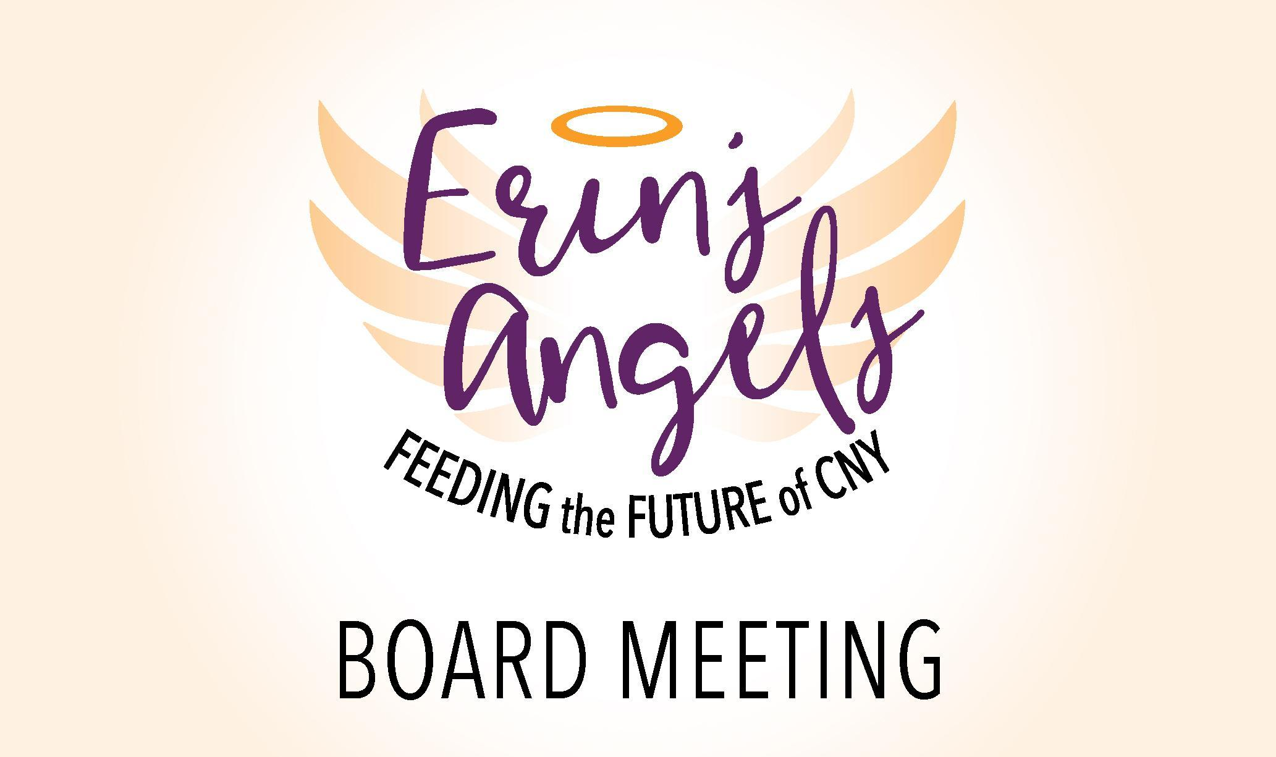

**2.25.2021 6:30 pm**

**Board Meeting**

**Zoom Meeting**

[**https://us04web.zoom.us/j/79240105290?pwd=VGxvb0FZb1BNTUQvVVR1ZW1Pb3NwQT09**](https://us04web.zoom.us/j/79240105290?pwd=VGxvb0FZb1BNTUQvVVR1ZW1Pb3NwQT09)

**Meeting ID: 792 4010 5290**

**Passcode: 467289**

**OR**

**Dial in by phone**

**+1 929 205 6099 US (New York)**

**Attendance:** Stephanie Earle, Jim Graham, Barb Stone, Jen, Jackie, Connie, Erica Ward

**Absent:** Sheila Dion

**Call to Order:** 6:43pm

**Approval of Previous Meeting Minutes:** Motion to approve from Connie, Second by Jim

**Treasurer's Report:** Barb presented the 3rd and 4th quarter. Revenue for the 4th quarter $24,299.07

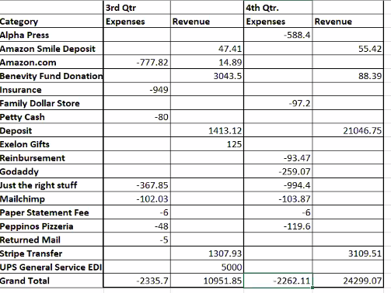

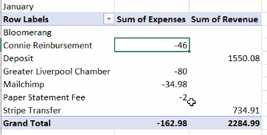

**Current cash on hand $134,747.78**

**Old Business:**

*Looking for an accountant/CPA to sit on the board* (on hold this is a reminder so we don’t lose the item)

* *Sheila is contacting George Powers, and working on a price to assist us.*

Subcommittee Updates:

* + Finance Committee Updates
    - Please provide an update: Meeting Notes are attached
    - Barb shared highlights from [Finance Committee Meeting](https://docs.google.com/document/d/1c5V1Q7U_iqoyQ13ALLVUISkxX8fo3SgyGas-qV3SHeo/edit?usp=drive_web)
  + Fundraising Committee Meeting:
    - Jackie shared highlights from [Meeting in January](https://docs.google.com/document/d/158dfPmGh5W2REA-vHFfjWMC9CxWrZg0eJn5JDcl7G74/edit)

**New Business:**

* Purchase Request -Jackie
  + Apples from Abbotts Farms to Support our local Purpose Farm Fire. Cost is $7 a peck, and all $7 will be going towards the farm. Bags will be packed this week.
  + Board agrees to make the purchase, Jackie and Linda will Coordinate Apples.
* Purchase Request -Linda
  + Requesting 2 carts. Staff and Carts have shifted from school to school. Purchase request image was for $41.86 X 2. Connie’s Cart is at middle school
  + Sheila could approve this without coming to the board.
* Community Eligibility - *Sheila - will address it at the next meeting, or Sheila can send out a message to the group.*

***Strategic Planning: Alissa (*15 minute discussion on Next Steps)**

* Everyone with a task to send out Survey emails, please do so again.
* So far we have responses from:
  + 6-Donors, 4 volunteerism 1 foundation/funder 1 fit all 3 categories, 1 school staff

**Next Meeting: April 22nd, 2021 @ 6:30pm**

**Meeting Adjournment: 1st - Jim 2nd- Jen Meeting ended at 7:21pm**