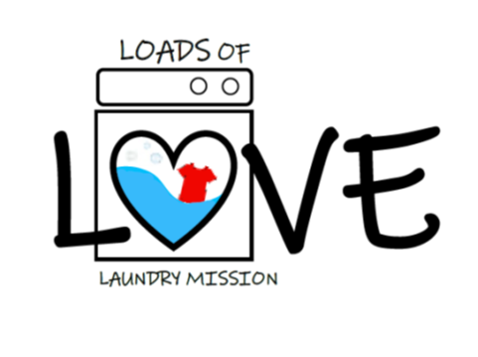

A laundry mission of the

First United Methodist Church of Phoenix

**When:** The last Monday of every month, 5pm-7pm

***HELD SNOW, RAIN OR SHINE!***

**Where:** Canal View Laundromat, Phoenix, NY

**What:** Free laundry washing, drying and folding service to help you stretch your dollars! We provide the funds, detergent and dryer sheets to do your laundry that evening. You sort and load your laundry, and then relax and enjoy light refreshments and Christian fellowship while we do the rest!

Got the kids in tow? No problem! Bring them along! We will have a craft or activity for them!

Please contact Judy Craigmile with questions (315-720-5994) or leave a phone message at the Church Office (315-695-4746).

Email: [fumcphoenixny@gmail.com](mailto:fumcphoenixny@gmail.com), Facebook: First United Methodist Church of Phoenix New York

*“…Let us not love with words or speech, but with actions and in truth.” 1 John 3:18*