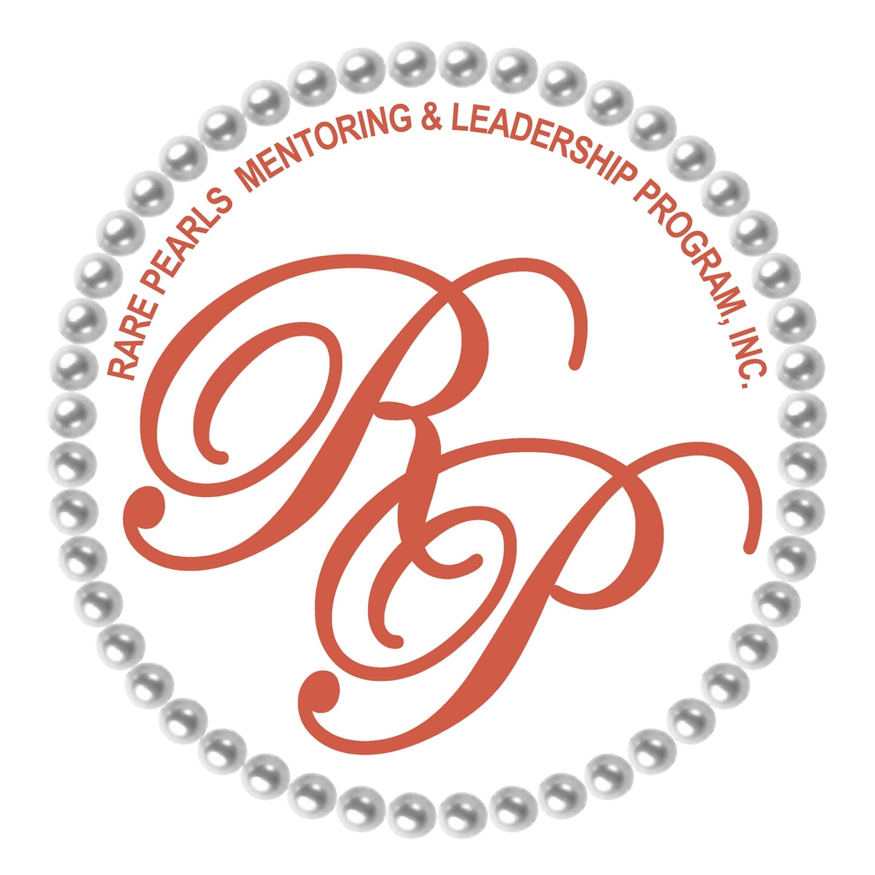
COWETA COUNTY
RARE PEARLS MENTORING & LEADERSHIP PROGRAM FACTSHEET
_________________________________________________________________
Rare Pearls Mentoring and Leadership Program is a 501©3 organization that is 100% focused on developing young girls and women from ages 7-18. The Rare Pearls Mentoring and Leadership Program was founded in 2015 by Mrs. Judy McClendon-Redmond. Our headquarters is located in Douglasville GA. We are a 501©3 organization that is 100% focused on developing young girls and women from ages 7-18. At the time of inception, The Child and Adult Success by Urban Institute 2015 stated that:
- 1 in four girls will not finish high school
- 1 in five girls will be a victim of childhood sexual abuse
- 1 in five girls will run away from home and become homeless
- 3 in 10 girls will become pregnant before the age of 20
We are dedicated to protecting our girls from these statistics. Mentoring is a matter of trust and trust is gained though relationships. Rare Pearl mentors are loving, caring, accountable and mature individuals with the ability to communicate with girls from diverse backgrounds. Girls that are “mentored” have increased graduation rates and healthier relationships and lifestyle choices. Our monthly mentee meetings open in prayer, and the workshops are power-packed! The topics are led by community leaders, business owners and professional mentors range from self-care, child sex trafficking, stem education, civic duty and financial literacy just to name a few.
Mentoring is a matter of trust and trust is gained though relationships. Rare Pearl mentors are loving, caring, accountable and mature individuals with the ability to communicate with girls from diverse backgrounds. Girls that are “mentored” have increased graduation rates and healthier relationships and lifestyle choices. Our monthly mentee meetings open in prayer, and the workshops are power-packed! The topics led by community leaders, business owners and professional mentors range from self-care, child sex trafficking, stem education, civic duty, financial literacy and life skills just to name a few.
Our Mission: Our mission is to empower and enrich girls and women through encouragement, education, training and by example while serving in the community. To provide a safe harbor forum to help them grow while learning respect for themselves and others.

Meeting dates: 2ND Saturday
Time: 9:50 am – 1:00 pm
Location: Howard Warner Boys & Girls Club

Contact Info: cowetararepearls@yahoo.com
Facebook: Rare Pearls Coweta
Donations: cashapp $rpcoweta
Mail: POB 361, Turin GA 30289
www.rarePearlsmentoringandleadership.org
Our Video:
https://www.youtube.com/watch?v=zYbwScpj6kE&feature=youtu.be 4/8/2025

