COMMUNITY FUN DAY & RECRUITMENTS

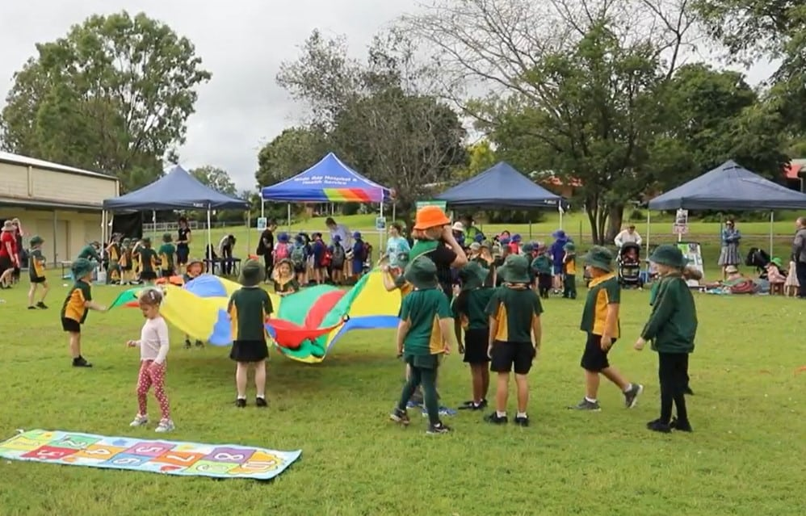

DATE: AUGUST 9, 2025

LOCATION: LOCAL PARK (Newnan Utilities) , Madras, CJ Smith,

**RAIN PLAN: BG CLUB – 55 SAVANNAH STREET**

TABLES FOR:

* APPLICATIONS/INFORMATION/HANDOUTS
* RAFFLES
* SNACKS

ACTIVITIES:

* HOPSTOTCH
* JUMP ROPE
* ZUMBA
* FACE PAINTING
* ETC

TEAM: CAROLYN, DEB, LYSHONDA, WILLENE, ALEXIS