Rare Pearls
Mentoring and Leadership
of Coweta County

(845) 549-9057 Direct
cowetararepearls@yahoo.com
www.rarepearlsmentoringandleadership.org
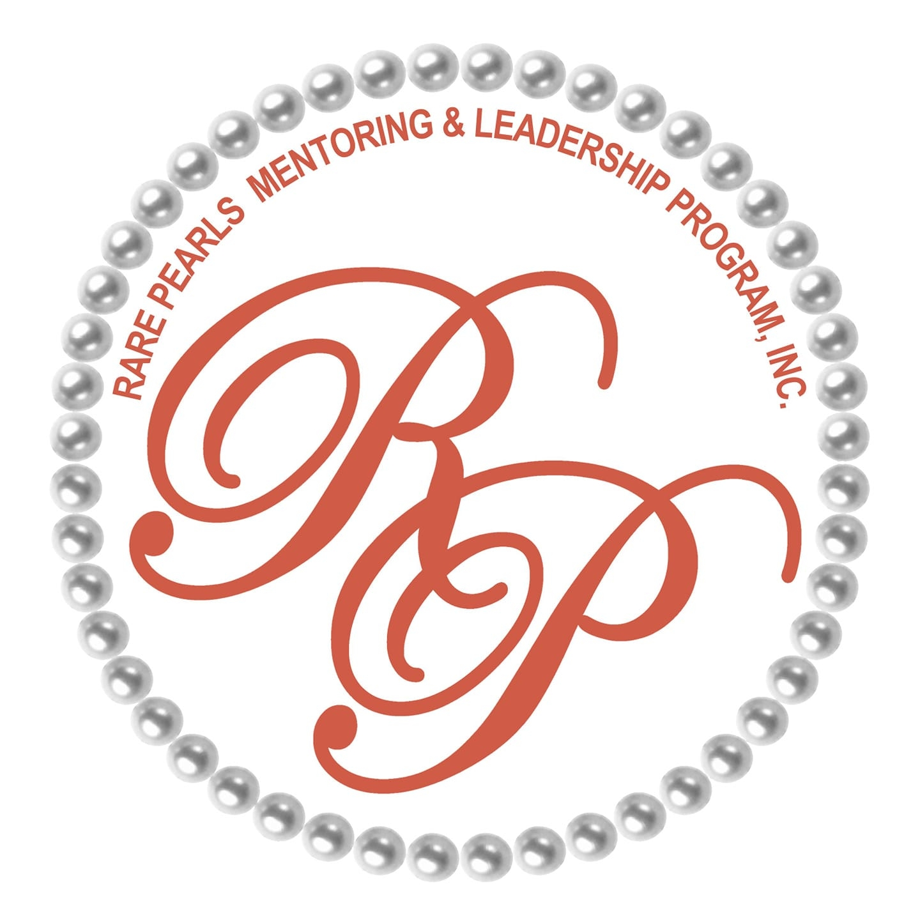

Handbook/Guideline for
Parents 2025

EMPOWERING AND ENRICHING THE LIVES OF GIRLS THROUGH ENCOURGEMENT, EDUCATION, TRAINING & COMMUNITY SERVICE

Ready, Set, Grow!”

INDEX

- MEET THE COWETA LEADERS
- MANDATED ATTENDANCE POLICY
- FACTSHEET
- ATTIRE/EVENTS/CALENDAR AND MEETING LOCATION
- YOUTH JOURNAL
- CURRICULUM/MENTEE APPLICATION (TRAVEL PERMISSION SLIP)
- COMMUNICATION METHODS/ PARENT INVOLVEMENT
- COMMITTEES

DISCLAIMER: This handout is just a quick informative reference to our group. For more detailed information or clarification please contact Executive Director Ms. Cheryl at 845 549 9057

Thank You.

ATTENDANCE MANDATES

- For legal reasons youth must be checked in and checked out for each meeting by yourself or you're appointed authorized representative listed on the application. Please instruct your child to wait until you enter the building before trying to leave or go to the parking lot to meet you. Rare Pearls is responsible for your child until your child has been signed out from the day’s activity and safe with you.
- If your child will be absent, kindly inform us… so that we don’t prepare for 30 girls and only 7 show up.
- “No show” (is absent without informing RP) vs “informed absence”
  - if your child is a “no show” you will get a phone call and that will be counted as the first absence occurrence.
  - After the second “consecutive” No Show absence occurrence you will get another phone call and letter
  - after the 3rd consecutive No Show absence your child’s status will be changed to “non active” and you must reapply when your child is able to participate fully and the application will then be reconsidered. Automatic re-enrollment is not guaranteed. Please understand that when we prepare activities and supplies we account for every child on our current roster.
- Keep in mind, unlike other youth programs, we do not charge monthly membership fees for your child to participate. Therefore we cannot nor realistically it wouldn’t be fair for us to continually put out resources and supplies for a child that does not attend.
- CELL PHONES – must be left at the hospitality table or with you. You can call any of the leaders if you must contact your child.
Phone calls will be coming from the executive board.
- 4 -
MEET THE LEADERS

NAME/POSITION | PHONE | EMAIL
EXECUTIVE BOARD |  | cowetararepearls@yahoo.com
President  Sherita Brown | 678-522-4993 | Sheritabrown67@gmail.com
Vice President  Ercelene Kinnebrew | 404-775-9671 | Ercele.kinnebrew@gmail.com
Executive Director,  Cheryl Glenn | 845-549-9057 | cowetararepearls@yahoo.com
Directors:

 | Debbie Chester -  Sheila Ware -  Jackie McCullough -  Mary McGhee  LyShonda Thomas | Community Outreach  Fundraising & Grants  Parent Liaison  Volunteer Liaison  Administrator

Volunteers

Angela Calhoun
Carolyn Tennie
Charley Kerley
Grace Haynes
Jackie Cruver
Jenny Perez
Kisha Thompson
LaQuinta Woods

Tara Shropshire
Tiffany Johnson-Stevens
Veronica Darensbourg
Willene Heflin
-3-

COWETA COUNTY
FACTSHEET
_________________________________________________________________
The Rare Pearls Mentoring and Leadership Program was founded in 2015 by Mrs. Judy McClendon-Redmond. Our headquarters is located in Douglasville GA. We are a 501©3 organization that is 100% focused on developing young girls and women from ages 7-18. Mentoring is a matter of trust and trust is gained though relationships. Rare Pearl mentors are loving, caring, accountable and mature individuals with the ability to communicate with girls from diverse backgrounds. Girls that are “mentored” have increased graduation rates and healthier relationships and lifestyle choices. Our monthly mentee meetings open in prayer, and the workshops are power-packed! The topics are led by community leaders, business owners and professional mentors range from self-care, child sex trafficking, stem education, civic duty and financial literacy just to name a few.
Our Mission: To empower and enrich the lives of our young ladies and women. To provide a safe harbor forum to help them grow while learning respect for themselves and others.
Our Vision: is focused on individual self-esteem, character, competence, and integrity.
Our Goal: is to meet our mentees where they are, to help them develop leadership skills by offering support, training, encouragement, and empowerment, while allowing them to be the person they were created to be. We give encouragement for the mentees to become self-sufficient, forward thinking, positive, leaders and entrepreneurs.

Email Info: cowetararepearls@yahoo.com
Facebook: Rare Pearls Coweta
Donations: cashapp $RPcoweta
Zelle cowetararepearls@yahoo.com
Mail: POB 361, Turin GA 30289
Phone: 845-549-9057
Our Video:
https://www.youtube.com/watch?v=zYbwScpj6kE&feature=youtu.be

WEBSITE: rarepearlsmentoringandleadership.org
ATTIRE
-5-

Meetings: Girls wear Rare Pearls t-shirt and jeans., pearls .

Trips: Girls wear Rare Pearls t-shirt, black jeans or pants, white pearls

Special Occasions: Unless otherwise mentioned, Black Dress, White Blouse with black pants or black skirt with … remember the pearls!

EVENTS
- holiday Dinner
- Sneaker Ball
- Year End Tea Party Celebration
- Annual luncheon
- Chapter launches
- Trips
- Church fellowship
---------------------------------------------------------------------------------------------------------------------
CALENDAR & MEETING LOCATION

Dates: 2nd Saturday of month TIME: 9:50 -1:00

MEETING PLACE: Howard Warner Boys & Girls Club
Community Bldg in back
55 Savanah Street
Newnan, GA

Our personal intranet (for parents and volunteers only) is where we communicate all information. Please review it frequently. There are age related scholarships there as well even for middle school youth. Most answers can be found at this site;
-6-

COWETAPARENTS.COM
YOUTH JOURNAL

Open arriving back home from a Rare Pearl meeting or event, your child should write down how they participated and learnt that day. Keep this information in the journal provided. If necessary we will help her complete her entry. This book will show all her accomplishments over the year and help her remember community service for school and work opportunities in the future.

Name of event or activity:

Date: location:

Community service organization done for:

Task:

How was this done:

Why was this done:

MEET MY SISTER PEARL!

Girls will interview each other, and keep the interview notes in their binders. If chosen they will introduce her pearl sister to the entire group. This activity will help with interview skills, and getting to make new friends.
-7-
Rare Pearls 2025 Curriculum At-A-Glance
September 13, 2025 – Empowerment  Theme: CPR  ----------------------------------  RP Stations Begin  - Life Skills  - Personal Development  - Cooking  - Creativity | November 8, 2025 – Enrichment  FRIENDSGIVING  Community Service Project:  DATE: NOVEMBER 27, 2025  Serving dinner  TIME: 10:00 - 3:00  CHURCH: Mt Sinai MBC  Rev. Antoine S. Martin, Pastor  ADDRESS: 6 Lovelace Street, Newnan
October 11, 2025 – Enrichment  Theme: Social Action & Community Service – Giving and Receiving are One  Charity: TBD | December 13, 2025 –  DOUGLASVILLE  Holiday Event
OCTOBER 18th - 6:00 pm  We are invited guests of RP parent Mrs. Debbie Chester for "Family and Friends Day' at:  Address: Sasser Grove BC  100 Carl Williams Road  Senoia, GA | *DECEMBER 27, 2025 – SNEAKER BALL  2-6pm  Clay Wood Center  $10 per guest
PERMISSION FORM AND MENTEE APPLICATION

-8-

COMMUNICATION METHODS (duplicate messages happen when there is no response indicating you have received the message)
- BROADCAST PHONE MESSAGES so that we could all be on the same page and receive the same information at the same time we have put in place broadcast options. You may be prompted to say yes or no during these calls, there may be an e-mail that will follow up this call. Calls may come from a (408) corporate area code.
- TEXT MESSAGES sent to everybody at the same time. please reply to sender personally not to the group so that we know you received the information. also reply personally if you have any questions
- E-MAIL MESSAGES usually will have attachments that you should print out and keep in a separate book
- ZOOM - our number remains the same. Please save this number
It is: 381-819-3832 Password = Pearls
REMEMBER TO PLEASE READ & LISTEN TO ENTIRE MESSAGE AND RESPOND!!

PARENT INVOLVEMENT
Here are several ways you can be involved:
- Suggest Grants & fundraiser ideas and support them
- Help with photography! Share photos on facebook
- Donate time, talent, *refreshments (see committee request), funds
- Stay responsive to emails and texts from leaders… Read and reply- with limited funds, we shouldnot plan for youth who will not be attending meetings– please keep us informed. Report absences, changes in youth commitment level or other change(s) that may affect future participation.
- Select a Sunday to invite us to your church for fellowship. As a Christian based organization, we look forward to worshiping with you, your church, the mentees and other Rare Pearl leaders.
- Suggest Grant opportunities you may be aware of from your employer, sorority or utility company - 9 -

COMMITTEE HELP NEEDED:
- FOOD/REFRESHMENT 

Parents, we have always provided a lunch for the girls after the meeting. Unfortunately because of limited funding we have to cut back. We are asking the parents to provide lunch /refreshments. Please know this will be a great benefit to us all.

The committee will be run exclusively by the parents. For your convenience the committee will have access to our reserved Zoom meeting conference line. RP leaders Ms. Debbie and Ms. Sandra will be a part of your committee; report to the executive board and will set up the refreshments at each meeting for you. They will know about dietary restrictions and other concerns that parents make us aware of.

- SPECIAL PROJECTS
This committee has two primary functions: A. Fundraising and 2. Special events

- TRAINING & EDUCATION

This committee is responsible for implementing and enhancing the curriculum with speakers, presenters and trainers. Planning of trips, events and fun activities are part of this committee.

If you want to be on any of these committees, please notify the executive board right away.

Thank You
-10-

